UNITED STATES
SECURITIES AND EXCHANGE COMMISSION
WASHINGTON, D.C. 20549

FORM 8-K

CURRENT REPORT
Pursuant to Section 13 or 15(d) of the Securities Exchange Act of 1934
Date of Report (Date of earliest event reported): February 21, 2024

REMITLY GLOBAL, INC.
(Exact Name of Registrant as Specified in Its Charter)

Delaware |  |  | 001-40822 |  |  | 83-2301143
(State or Other Jurisdiction  of Incorporation) |  |  | (Commission File Number) |  |  | (IRS Employer  Identification No.)
1111 Third Avenue, Suite 2100
Seattle, WA 98101
(Address of Principal Executive Offices and Zip Code)
(888) 736-4859
(Registrant’s Telephone Number, Including Area Code)
Not Applicable
(Former Name or Former Address, if Changed Since Last Report)

Check the appropriate box below if the Form 8-K filing is intended to simultaneously satisfy the filing obligation of the registrant under any of the following provisions (see General Instructions A.2. below):
☐ Written communications pursuant to Rule 425 under the Securities Act (17 CFR 230.425)
☐ Soliciting material pursuant to Rule 14a-12 under the Exchange Act (17 CFR 240.14a-12)
☐ Pre-commencement communications pursuant to Rule 14d-2(b) under the Exchange Act (17 CFR 240.14d-2(b))
☐ Pre-commencement communications pursuant to Rule 13e-4(c) under the Exchange Act (17 CFR 240.13e-4(c))
Securities registered pursuant to Section 12(b) of the Act:
Title of each class: |  |  |  |  |  | Trading Symbol(s): |  |  |  |  |  | Name of each exchange on which registered:
Common Stock, par value $0.0001 per share |  |  |  |  |  | RELY |  |  |  |  |  | NASDAQ
Indicate by check mark whether the registrant is an emerging growth company as defined in Rule 405 of the Securities Act of 1933 (§230.405 of this chapter) or Rule 12b-2 of the Securities Exchange Act of 1934 (§240.12b-2 of this chapter).
Emerging growth company ☐
If an emerging growth company, indicate by check mark if the registrant has elected not to use the extended transition period for complying with any new or revised financial accounting standards provided pursuant to Section 13(a) of the Exchange Act. ☐

1

Item 2.02 Results of Operations and Financial Condition.
On February 21, 2024, Remitly Global, Inc. (the “Company”) issued a press release announcing its financial results for the fiscal quarter and full fiscal year ended December 31, 2023. A copy of the press release is furnished as Exhibit 99.1 hereto and is incorporated by reference herein.

Item 7.01 Regulation FD Disclosure.
On February 21, 2024, the Company provided an investor presentation that will be made available on the investor relations section of the Company’s website at https://ir.remitly.com/. The investor presentation is furnished as Exhibit 99.2 to this Current Report on Form 8-K and is incorporated by reference herein.
The information in Items 2.02 and 7.01 of this Current Report, including the accompanying Exhibit 99.1 and Exhibit 99.2, is being furnished and shall not be deemed “filed” for the purposes of Section 18 of the Securities Exchange Act of 1934, as amended (the “Exchange Act”), or otherwise subject to the liabilities of Section 18. The information in Items 2.02 and 7.01 of this Current Report, including the accompanying Exhibit 99.1 and Exhibit 99.2, shall not be incorporated by reference into any registration statement or other document filed pursuant to the Securities Act of 1933, as amended, or the Exchange Act, regardless of any general incorporation language contained in such filing.

Item 9.01 Financial Statements and Exhibits.
(d) Exhibits
Exhibit No. |  |  | Description
99.1 |  |  | Press Release dated February 21, 2024
99.2 |  |  | Investor Presentation dated February 21, 2024
104 |  |  | Cover page interactive data file (embedded with the inline XBRL document)

2

SIGNATURES
Pursuant to the requirements of the Securities Exchange Act of 1934, the registrant has duly caused this report to be signed on its behalf by the undersigned thereunto duly authorized.
 |  |  | Remitly Global, Inc.
Date: February 21, 2024 |  |  | By: |  |  | /s/ Hemanth Munipalli
 |  |  |  |  |  | Hemanth Munipalli
 |  |  |  |  |  | Chief Financial Officer
 |  |  |  |  |  | (Principal Financial Officer)
Date: February 21, 2024 |  |  | By: |  |  | /s/ Gail Miller
 |  |  |  |  |  | Gail Miller
 |  |  |  |  |  | Chief Accounting Officer
 |  |  |  |  |  | (Principal Accounting Officer)

3

Remitly Reports Fourth Quarter and Full Year 2023 Results
Active customers up 41% year over year
Send volume up 38% year over year
Revenue up 39% year over year

SEATTLE, WA / February 21, 2024 / GlobeNewswire / - Remitly Global, Inc. (NASDAQ: RELY), a trusted provider of digital financial services that transcend borders, reported results for the fourth quarter and full year ended December 31, 2023.

“Our strong fourth quarter and full year 2023 performance is the direct result of delighting our customers with a reliable and fast cross-border payments experience,” said Matt Oppenheimer, co-founder and Chief Executive Officer, Remitly. “We see significant opportunities ahead to continue driving strong customer growth and sustainably improving our profitability.”

Fourth Quarter 2023 Highlights and Key Operating Data
(All comparisons relative to the fourth quarter of 2022)
•Active customers increased to 5.9 million, from 4.2 million, up 41%.
•Send volume increased to $11.1 billion, from $8.1 billion, up 38%.
•Revenue totaled $264.8 million, compared to $191.0 million, up 39%.
•Net loss was $35.0 million, compared to a net loss of $19.4 million.
•Adjusted EBITDA was $8.2 million, compared to $7.5 million.

Full Year 2023 Highlights and Key Operating Data:
(All comparisons relative to the full year 2022)
•Send volume increased to $39.5 billion, from $28.6 billion, up 38%.
•Revenue totaled $944.3 million, compared to $653.6 million, up 44%.
•Net loss was $117.8 million, compared to a net loss of $114.0 million.
•Adjusted EBITDA was $44.5 million, compared to $(13.6) million.

2024 Financial Outlook
For fiscal year 2024, Remitly currently expects:
•Total revenue in the range of $1,225 million to $1,250 million, representing a growth rate of 30% to 32% year over year.
•To remain in a GAAP net loss position for 2024 and for Adjusted EBITDA to be in the range of $75 million to $90 million.

Reconciliation of GAAP to Non-GAAP Financial Measures
A reconciliation of GAAP to non-GAAP financial measures has been provided in the financial statement tables included in this earnings release. An explanation of these measures is also included below under the heading “Non-GAAP Financial Measures.” We have not provided a quantitative reconciliation of forecasted Adjusted EBITDA to forecasted GAAP net income (loss) or to forecasted GAAP income (loss) before income taxes within this earnings release because we cannot, without unreasonable effort, calculate certain reconciling items with confidence due to the variability, complexity, and limited visibility of the adjusting items that would be excluded from forecasted Adjusted EBITDA. These items include, but are not limited to, income taxes and stock-based compensation expense, which are directly impacted by unpredictable fluctuations in the market price of our common stock. The variability of these items could have a significant impact on our future GAAP financial results.

Note: All percentage changes described within this press release are calculated using amounts in the Company’s Annual Reports on Form 10-K and Quarterly Reports on Form 10-Q filed with the Securities and Exchange Commission (the “SEC”), for which revenue and active customers are presented in thousands and send volume is presented in millions. Rounding differences may occur when individually calculating percentages or totals from rounded amounts included within the press release body as compared to the amounts included with the Company’s SEC filings.
1

Webcast Information
Remitly will host a webcast at 5:00 p.m. Eastern time on Wednesday, February 21, 2024 to discuss its fourth quarter and full year 2023 financial results. The live webcast and investor presentation will be accessible on Remitly’s website at https://ir.remitly.com. A webcast replay will be available on our website at https://ir.remitly.com following the live event.

We have used, and intend to continue to use, the Investor Relations section of our website at https://ir.remitly.com as a means of disclosing material nonpublic information and for complying with our disclosure obligations under Regulation FD.

Non-GAAP Financial Measures
Some of the financial information and data contained in this earnings release, such as Adjusted EBITDA and non-GAAP operating expenses, have not been prepared in accordance with United States generally accepted accounting principles (“GAAP”).
We regularly review our key business metrics and non-GAAP financial measures to evaluate our performance, identify trends affecting our business, prepare financial projections, and make strategic decisions. We believe that these key business metrics and non-GAAP financial measures provide meaningful supplemental information for management and investors in assessing our historical and future operating performance. Adjusted EBITDA and non-GAAP operating expenses are key output measures used by our management to evaluate our operating performance, inform future operating plans, and make strategic long-term decisions, including those relating to operating expenses and the allocation of internal resources. Remitly believes that the use of Adjusted EBITDA and non-GAAP operating expenses provides additional tools to assess operational performance and trends in, and in comparing Remitly’s financial measures with, other similar companies, many of which present similar non-GAAP financial measures to investors. Remitly’s non-GAAP financial measures may be different from non-GAAP financial measures used by other companies. The presentation of non-GAAP financial measures is not intended to be considered in isolation or as a substitute for, or superior to, financial measures determined in accordance with GAAP. Because of the limitations of non-GAAP financial measures, you should consider the non-GAAP financial measures presented herein in conjunction with Remitly’s financial statements and the related notes thereto. Please refer to the non-GAAP reconciliations in this press release for a reconciliation of these non-GAAP financial measures to the most comparable financial measure prepared in accordance with GAAP.

We calculate Adjusted EBITDA as net loss adjusted by (i) interest (income) expense, net, (ii) provision for income taxes, (iii) noncash charge of depreciation and amortization, (iv) gains and losses from the remeasurement of foreign currency assets and liabilities into their functional currency, (v) noncash charges associated with our donation of common stock in connection with our Pledge 1% commitment, (vi) noncash stock-based compensation expense, net, and (vii) certain acquisition, integration, restructuring costs, and related costs. We calculate non-GAAP operating expenses as our GAAP operating expenses adjusted by (i) noncash stock-based compensation expense, net, (ii) noncash charges associated with our donation of common stock in connection with our Pledge 1% commitment, as well as (iii) certain acquisition, integration, restructuring costs, and related costs.

2
Forward-Looking Statements
This press release contains forward-looking statements within the meaning of the Private Securities Litigation Reform Act of 1995. All statements other than statements of historical fact are forward-looking statements. These statements include, but are not limited to, statements regarding our future operating results and financial position, including our fiscal year 2024 financial outlook, including forecasted fiscal year 2024 revenue and Adjusted EBITDA, anticipated future expenses and investments, expectations relating to certain of our key financial and operating metrics, our business strategy and plans, market growth, our market position and potential market opportunities, and our objectives for future operations. The words “believe,” “may,” “will,” “estimate,” “potential,” “continue,” “anticipate,” “intend,” “expect,” “could,” “would,” “project,” “plan,” “target,” and similar expressions are intended to identify forward-looking statements. Forward-looking statements are based on management’s expectations, assumptions, and projections based on information available at the time the statements were made. These forward-looking statements are subject to a number of risks, uncertainties, and assumptions, including risks and uncertainties related to our ability to successfully execute our business and growth strategy, our ability to achieve and maintain future profitability, our ability to further penetrate our existing customer base and expand our customer base in existing and new corridors, our ability to expand into broader financial services, our ability to expand internationally, the effects of seasonal trends on our results of operations, the current inflationary environment, our expectations concerning relationships with third parties, including strategic, banking, and disbursement partners, our ability to obtain, maintain, protect, and enhance our intellectual property and other proprietary rights, our ability to keep data and our technology platform secure, the success of any acquisitions or investments that we make, our ability to compete effectively, our ability to stay in compliance with applicable laws and regulations, our ability to buy foreign currency at generally advantageous rates, and the effects of changes to immigration laws, macroeconomic conditions, and geopolitical forces on our customers and business operations. It is not possible for our management to predict all risks, nor can we assess the impact of all factors on our business or the extent to which any factor, or combination of factors, may cause actual results to differ materially from those contained in any forward-looking statements we may make. In light of these risks, uncertainties, and assumptions, our actual results could differ materially and adversely from those anticipated or implied in the forward-looking statements. Further information on risks that could cause actual results to differ materially from forecasted results is included in our annual report on Form 10-K for the year ended December 31, 2023 to be filed with the SEC, and within our annual report on Form 10-K for the year ended December 31, 2022 filed with the SEC, which are or will be available on our website at https://ir.remitly.com and on the SEC’s website at www.sec.gov. Except as required by law, we assume no obligation to update these forward-looking statements, or to update the reasons if actual results differ materially from those anticipated in the forward-looking statements.

3
About Remitly
Remitly is a trusted provider of digital financial services that transcend borders. Remitly helps customers across the globe send money home in a safe, reliable, and transparent manner. Its digitally native, cross-border remittance app eliminates the long wait times, complexities, and fees typical of traditional remittance processes. Building on its strong foundation, Remitly is expanding its suite of products to further its vision and transform lives around the world.

Contacts

Media:
Kendall Sadler
kendall@remitly.com

Investor Relations:
Stephen Shulstein
stephens@remitly.com

4
REMITLY GLOBAL, INC.
Condensed Consolidated Statements of Operations
(unaudited)

 |  |  | Three Months Ended December 31, |  |  |  |  |  |  |  |  |  |  |  | Twelve Months Ended December 31,
(in thousands, except share and per share data) |  |  | 2023 |  |  |  |  |  | 2022 |  |  |  |  |  | 2023 |  |  |  |  |  | 2022
Revenue |  |  | $ | 264,758 |  |  |  |  | $ | 191,032 |  |  |  |  | $ | 944,285 |  |  |  |  | $ | 653,560
Costs and expenses
Transaction expenses(1) |  |  | 89,118 |  |  |  |  |  | 71,866 |  |  |  |  |  | 329,113 |  |  |  |  |  | 258,827
Customer support and operations(1) (2) |  |  | 19,917 |  |  |  |  |  | 19,239 |  |  |  |  |  | 82,521 |  |  |  |  |  | 68,106
Marketing(1) (2) |  |  | 75,343 |  |  |  |  |  | 43,163 |  |  |  |  |  | 234,417 |  |  |  |  |  | 170,970
Technology and development(1) (2) |  |  | 59,240 |  |  |  |  |  | 42,883 |  |  |  |  |  | 219,939 |  |  |  |  |  | 138,719
General and administrative(1) (2) |  |  | 48,657 |  |  |  |  |  | 34,895 |  |  |  |  |  | 179,372 |  |  |  |  |  | 131,250
Depreciation and amortization |  |  | 3,484 |  |  |  |  |  | 1,854 |  |  |  |  |  | 13,118 |  |  |  |  |  | 6,724
Total costs and expenses |  |  | 295,759 |  |  |  |  |  | 213,900 |  |  |  |  |  | 1,058,480 |  |  |  |  |  | 774,596
Loss from operations |  |  | (31,001) |  |  |  |  |  | (22,868) |  |  |  |  |  | (114,195) |  |  |  |  |  | (121,036)
Interest income |  |  | 2,247 |  |  |  |  |  | 2,274 |  |  |  |  |  | 7,447 |  |  |  |  |  | 4,149
Interest expense |  |  | (786) |  |  |  |  |  | (327) |  |  |  |  |  | (2,352) |  |  |  |  |  | (1,302)
Other (expense) income, net |  |  | (64) |  |  |  |  |  | 1,092 |  |  |  |  |  | (2,838) |  |  |  |  |  | 5,213
Loss before provision for income taxes |  |  | (29,604) |  |  |  |  |  | (19,829) |  |  |  |  |  | (111,938) |  |  |  |  |  | (112,976)
Provision (benefit) for income taxes |  |  | 5,417 |  |  |  |  |  | (434) |  |  |  |  |  | 5,902 |  |  |  |  |  | 1,043
Net loss |  |  | $ | (35,021) |  |  |  |  | $ | (19,395) |  |  |  |  | $ | (117,840) |  |  |  |  | $ | (114,019)
Net loss per share attributable to common stockholders:
Basic and diluted |  |  | $ | (0.19) |  |  |  |  | $ | (0.11) |  |  |  |  | $ | (0.65) |  |  |  |  | $ | (0.68)
Weighted-average shares used in computing net loss per share attributable to common stockholders:
Basic and diluted |  |  | 186,343,078 |  |  |  |  |  | 171,505,584 |  |  |  |  |  | 180,818,399 |  |  |  |  |  | 167,774,123
(1) Exclusive of depreciation and amortization, shown separately, above.
(2) Includes stock-based compensation expense, net. The consolidated financial statements for the twelve months ended December 31, 2022 include an adjustment of $4.4 million to stock-based compensation expense and additional paid-in capital, to correct for an error identified by management during the preparation of the financial statements for the three and six months ended June 30, 2022. This adjustment relates to the understatement of stock-based compensation expense during prior periods. Management has determined that this error was not material to the historical financial statements in any individual period or in the aggregate and did not result in the previously issued financial statements being materially misstated. Substantially all of the cumulative adjustment was related to share-based compensation for personnel who support our general and administrative functions and was recorded to 'General and administrative expenses' in the three months ended June 30, 2022.

5
REMITLY GLOBAL, INC.
Condensed Consolidated Balance Sheets
(unaudited)

 |  |  | December 31, |  |  |  |  |  | December 31,
(in thousands) |  |  | 2023 |  |  |  |  |  | 2022
Assets
Current assets
Cash and cash equivalents |  |  | $ | 323,710 |  |  |  |  | $ | 300,635
Disbursement prefunding |  |  | 195,848 |  |  |  |  |  | 158,055
Customer funds receivable, net |  |  | 379,417 |  |  |  |  |  | 191,402
Prepaid expenses and other current assets |  |  | 33,143 |  |  |  |  |  | 19,327
Total current assets |  |  | 932,118 |  |  |  |  |  | 669,419
Property and equipment, net |  |  | 16,010 |  |  |  |  |  | 11,546
Operating lease right-of-use assets |  |  | 9,525 |  |  |  |  |  | 8,675
Goodwill |  |  | 54,940 |  |  |  |  |  | —
Intangible assets, net |  |  | 16,642 |  |  |  |  |  | —
Other noncurrent assets, net |  |  | 7,071 |  |  |  |  |  | 6,313
Total assets |  |  | $ | 1,036,306 |  |  |  |  | $ | 695,953
Liabilities and Stockholders’ Equity
Current liabilities
Accounts payable |  |  | $ | 35,051 |  |  |  |  | $ | 6,794
Customer liabilities |  |  | 177,473 |  |  |  |  |  | 111,075
Short-term debt |  |  | 2,481 |  |  |  |  |  | —
Accrued expenses and other current liabilities |  |  | 145,802 |  |  |  |  |  | 87,752
Operating lease liabilities |  |  | 6,032 |  |  |  |  |  | 3,521
Total current liabilities |  |  | 366,839 |  |  |  |  |  | 209,142
Operating lease liabilities, noncurrent |  |  | 4,477 |  |  |  |  |  | 5,674
Long-term debt |  |  | 130,000 |  |  |  |  |  | —
Other noncurrent liabilities |  |  | 5,653 |  |  |  |  |  | 1,050
Total liabilities |  |  | $ | 506,969 |  |  |  |  | $ | 215,866
Commitments and contingencies
Stockholders’ equity
Common stock |  |  | $ | 19 |  |  |  |  | $ | 17
Additional paid-in capital |  |  | 1,020,286 |  |  |  |  |  | 854,276
Accumulated other comprehensive income (loss) |  |  | 335 |  |  |  |  |  | (743)
Accumulated deficit |  |  | (491,303) |  |  |  |  |  | (373,463)
Total stockholders’ equity |  |  | 529,337 |  |  |  |  |  | 480,087
Total liabilities and stockholders’ equity |  |  | $ | 1,036,306 |  |  |  |  | $ | 695,953

6
REMITLY GLOBAL, INC.
Condensed Consolidated Statements of Cash Flows
(unaudited)
 |  |  |  |  |  | Year Ended December 31,
(in thousands) |  |  |  |  |  | 2023 |  |  |  |  |  | 2022
Cash flows from operating activities
Net loss |  |  |  |  |  | $ | (117,840) |  |  |  |  | $ | (114,019)
Adjustments to reconcile net loss to net cash used in operating activities:
Depreciation and amortization |  |  |  |  |  | 13,118 |  |  |  |  |  | 6,724
Stock-based compensation expense, net |  |  |  |  |  | 136,967 |  |  |  |  |  | 95,293
Donation of common stock |  |  |  |  |  | 4,600 |  |  |  |  |  | 1,972
Other |  |  |  |  |  | 713 |  |  |  |  |  | 356
Changes in operating assets and liabilities:
Disbursement prefunding |  |  |  |  |  | (31,778) |  |  |  |  |  | (38,428)
Customer funds receivable |  |  |  |  |  | (183,422) |  |  |  |  |  | (126,942)
Prepaid expenses and other assets |  |  |  |  |  | (13,035) |  |  |  |  |  | (4,598)
Operating lease right-of-use assets |  |  |  |  |  | 5,186 |  |  |  |  |  | 3,763
Accounts payable |  |  |  |  |  | 27,559 |  |  |  |  |  | 5,535
Customer liabilities |  |  |  |  |  | 61,718 |  |  |  |  |  | 42,979
Accrued expenses and other liabilities |  |  |  |  |  | 47,357 |  |  |  |  |  | 22,782
Operating lease liabilities |  |  |  |  |  | (4,733) |  |  |  |  |  | (4,073)
Net cash used in operating activities |  |  |  |  |  | (53,590) |  |  |  |  |  | (108,656)
Cash flows from investing activities
Purchases of property and equipment |  |  |  |  |  | (2,857) |  |  |  |  |  | (3,679)
Capitalized internal-use software costs |  |  |  |  |  | (6,247) |  |  |  |  |  | (3,382)
Cash paid for acquisition, net of acquired cash, cash equivalents, and restricted cash |  |  |  |  |  | (40,933) |  |  |  |  |  | (248)
Net cash used in investing activities |  |  |  |  |  | (50,037) |  |  |  |  |  | (7,309)
Cash flows from financing activities
Proceeds from exercise of stock options |  |  |  |  |  | 14,288 |  |  |  |  |  | 11,554
Proceeds from issuance of common stock in connection with ESPP(1) |  |  |  |  |  | 6,132 |  |  |  |  |  | 3,516
Proceeds from revolving credit facility borrowings |  |  |  |  |  | 764,000 |  |  |  |  |  | —
Repayments of revolving credit facility borrowings |  |  |  |  |  | (634,000) |  |  |  |  |  | —
Taxes paid related to net share settlement of equity awards |  |  |  |  |  | (6,702) |  |  |  |  |  | (99)
Repayment of assumed indebtedness |  |  |  |  |  | (17,068) |  |  |  |  |  | (384)
Net cash provided by financing activities |  |  |  |  |  | 126,650 |  |  |  |  |  | 14,587
Effect of foreign exchange rate changes on cash, cash equivalents, and restricted cash |  |  |  |  |  | 1,272 |  |  |  |  |  | (1,201)
Net increase (decrease) in cash, cash equivalents, and restricted cash |  |  |  |  |  | 24,295 |  |  |  |  |  | (102,579)
Cash, cash equivalents, and restricted cash at beginning of period |  |  |  |  |  | 300,734 |  |  |  |  |  | 403,313
Cash, cash equivalents, and restricted cash at end of period |  |  |  |  |  | $ | 325,029 |  |  |  |  | $ | 300,734
Reconciliation of cash, cash equivalents, and restricted cash
Cash and cash equivalents |  |  |  |  |  | $ | 323,710 |  |  |  |  | $ | 300,635
Restricted cash included in prepaid expenses and other current assets |  |  |  |  |  | 774 |  |  |  |  |  | —
Restricted cash included in other noncurrent assets, net |  |  |  |  |  | 545 |  |  |  |  |  | 99
Total cash, cash equivalents, and restricted cash |  |  |  |  |  | $ | 325,029 |  |  |  |  | $ | 300,734
(1) Beginning with the fourth quarter of 2023, the Company changed the presentation of shares purchased under the Employee Stock Purchase Plan ("ESPP") to reflect an operating cash outflow for compensation paid to employees and a financing cash inflow for cash paid by employees in exchange for shares. Previously such activity was treated and disclosed as noncash activity in the amount of $3.5 million for the year ended December 31, 2022.

7

REMITLY GLOBAL, INC.
Reconciliation of GAAP to Non-GAAP Financial Measures
(unaudited)

Reconciliation of net loss to Adjusted EBITDA:
 |  |  |  |  |  | Three Months Ended December 31, |  |  |  |  |  |  |  |  |  |  |  | Twelve Months Ended December 31,
(in thousands) |  |  |  |  |  | 2023 |  |  |  |  |  | 2022 |  |  |  |  |  | 2023 |  |  |  |  |  | 2022
Net loss |  |  |  |  |  | $ | (35,021) |  |  |  |  | $ | (19,395) |  |  |  |  | $ | (117,840) |  |  |  |  | $ | (114,019)
Add:
Interest (income) expense, net |  |  |  |  |  | (1,461) |  |  |  |  |  | (1,947) |  |  |  |  |  | (5,095) |  |  |  |  |  | (2,847)
Provision (benefit) for income taxes |  |  |  |  |  | 5,417 |  |  |  |  |  | (434) |  |  |  |  |  | 5,902 |  |  |  |  |  | 1,043
Depreciation and amortization |  |  |  |  |  | 3,484 |  |  |  |  |  | 1,854 |  |  |  |  |  | 13,118 |  |  |  |  |  | 6,724
Foreign exchange (gain) loss |  |  |  |  |  | (8) |  |  |  |  |  | (1,090) |  |  |  |  |  | 2,603 |  |  |  |  |  | (5,261)
Donation of common stock |  |  |  |  |  | — |  |  |  |  |  | — |  |  |  |  |  | 4,600 |  |  |  |  |  | 1,972
Stock-based compensation expense, net |  |  |  |  |  | 35,960 |  |  |  |  |  | 27,413 |  |  |  |  |  | 136,967 |  |  |  |  |  | 95,293
Acquisition, integration, restructuring, and related costs(1) |  |  |  |  |  | (193) |  |  |  |  |  | 1,077 |  |  |  |  |  | 4,197 |  |  |  |  |  | 3,462
Adjusted EBITDA |  |  |  |  |  | $ | 8,178 |  |  |  |  | $ | 7,478 |  |  |  |  | $ | 44,452 |  |  |  |  | $ | (13,633)
(1) Acquisition, integration, restructuring, and related costs for the three and twelve months ended December 31, 2023 consists of expenses related to the acquisition and integration of Rewire (O.S.G.) Research and Development Ltd ("Rewire"), as well as restructuring charges incurred. Acquisition and integration expenses for the three and twelve months ended December 31, 2023 were $(0.2) million and $2.8 million, respectively. These acquisition and integration expenses primarily included the change in the fair value of the holdback liability of $(0.8) million and $1.1 million, respectively, and professional fees incurred for acquisition and integration costs of $0.6 million and $1.7 million, respectively. Restructuring charges incurred for the three months ended December 31, 2023 were immaterial. Restructuring charges incurred for the twelve months ended December 31, 2023 were $1.4 million. Acquisition, integration, restructuring, and related costs for the three and twelve months ended December 31, 2022 primarily represent expenses related to the acquisition of Rewire.

8
Reconciliation of operating expenses to non-GAAP operating expenses:
 |  |  |  |  |  | Three Months Ended December 31, |  |  |  |  |  |  |  |  |  |  |  | Twelve Months Ended December 31,
(in thousands) |  |  |  |  |  | 2023 |  |  |  |  |  | 2022 |  |  |  |  |  | 2023 |  |  |  |  |  | 2022
Customer support and operations |  |  |  |  |  | $ | 19,917 |  |  |  |  | $ | 19,239 |  |  |  |  | $ | 82,521 |  |  |  |  | $ | 68,106
Excluding: Stock-based compensation expense, net |  |  |  |  |  | 394 |  |  |  |  |  | 220 |  |  |  |  |  | 1,404 |  |  |  |  |  | 816
Excluding: Acquisition, integration, restructuring, and related costs |  |  |  |  |  | — |  |  |  |  |  | — |  |  |  |  |  | 739 |  |  |  |  |  | —
Non-GAAP customer support and operations |  |  |  |  |  | $ | 19,523 |  |  |  |  | $ | 19,019 |  |  |  |  | $ | 80,378 |  |  |  |  | $ | 67,290
 |  |  |  |  |  | Three Months Ended December 31, |  |  |  |  |  |  |  |  |  |  |  | Twelve Months Ended December 31,
 |  |  |  |  |  | 2023 |  |  |  |  |  | 2022 |  |  |  |  |  | 2023 |  |  |  |  |  | 2022
Marketing |  |  |  |  |  | $ | 75,343 |  |  |  |  | $ | 43,163 |  |  |  |  | $ | 234,417 |  |  |  |  | $ | 170,970
Excluding: Stock-based compensation expense, net |  |  |  |  |  | 3,930 |  |  |  |  |  | 3,363 |  |  |  |  |  | 16,165 |  |  |  |  |  | 10,512
Non-GAAP marketing |  |  |  |  |  | $ | 71,413 |  |  |  |  | $ | 39,800 |  |  |  |  | $ | 218,252 |  |  |  |  | $ | 160,458
 |  |  |  |  |  | Three Months Ended December 31, |  |  |  |  |  |  |  |  |  |  |  | Twelve Months Ended December 31,
 |  |  |  |  |  | 2023 |  |  |  |  |  | 2022 |  |  |  |  |  | 2023 |  |  |  |  |  | 2022
Technology and development |  |  |  |  |  | $ | 59,240 |  |  |  |  | $ | 42,883 |  |  |  |  | $ | 219,939 |  |  |  |  | $ | 138,719
Excluding: Stock-based compensation expense, net |  |  |  |  |  | 19,920 |  |  |  |  |  | 15,461 |  |  |  |  |  | 74,967 |  |  |  |  |  | 46,420
Excluding: Acquisition, integration, restructuring, and related costs |  |  |  |  |  | 700 |  |  |  |  |  | — |  |  |  |  |  | 1,224 |  |  |  |  |  | —
Non-GAAP technology and development |  |  |  |  |  | $ | 38,620 |  |  |  |  | $ | 27,422 |  |  |  |  | $ | 143,748 |  |  |  |  | $ | 92,299
 |  |  |  |  |  | Three Months Ended December 31, |  |  |  |  |  |  |  |  |  |  |  | Twelve Months Ended December 31,
 |  |  |  |  |  | 2023 |  |  |  |  |  | 2022 |  |  |  |  |  | 2023 |  |  |  |  |  | 2022
General and administrative |  |  |  |  |  | $ | 48,657 |  |  |  |  | $ | 34,895 |  |  |  |  | $ | 179,372 |  |  |  |  | $ | 131,250
Excluding: Stock-based compensation expense, net |  |  |  |  |  | 11,716 |  |  |  |  |  | 8,369 |  |  |  |  |  | 44,431 |  |  |  |  |  | 37,545
Excluding: Donation of common stock |  |  |  |  |  | — |  |  |  |  |  | — |  |  |  |  |  | 4,600 |  |  |  |  |  | 1,972
Excluding: Acquisition, integration, restructuring, and related costs |  |  |  |  |  | (893) |  |  |  |  |  | 1,077 |  |  |  |  |  | 2,234 |  |  |  |  |  | 3,462
Non-GAAP general and administrative |  |  |  |  |  | $ | 37,834 |  |  |  |  | $ | 25,449 |  |  |  |  | $ | 128,107 |  |  |  |  | $ | 88,271

8
February 2024 / © 2024 Remitly Inc. 1 Investor Presentation Fourth Quarter 2023 Earnings February 21, 2024

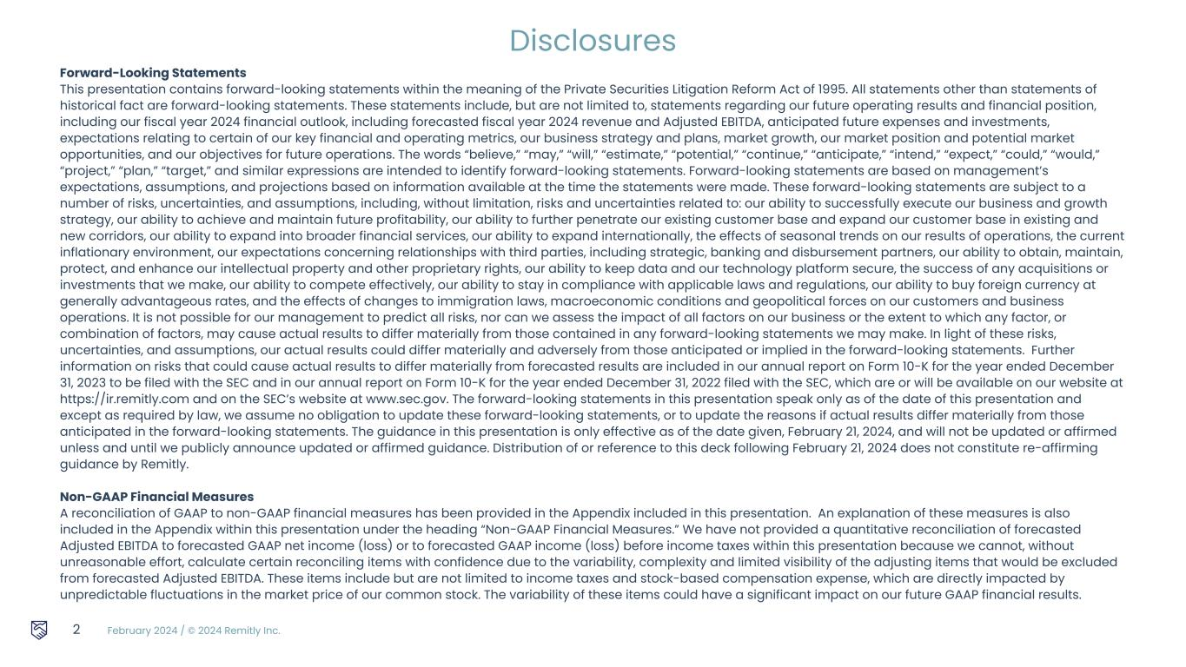
February 2024 / © 2024 Remitly Inc. 2 Disclosures Forward-Looking Statements This presentation contains forward-looking statements within the meaning of the Private Securities Litigation Reform Act of 1995. All statements other than statements of historical fact are forward-looking statements. These statements include, but are not limited to, statements regarding our future operating results and financial position, including our fiscal year 2024 financial outlook, including forecasted fiscal year 2024 revenue and Adjusted EBITDA, anticipated future expenses and investments, expectations relating to certain of our key financial and operating metrics, our business strategy and plans, market growth, our market position and potential market opportunities, and our objectives for future operations. The words “believe,” “may,” “will,” “estimate,” “potential,” “continue,” “anticipate,” “intend,” “expect,” “could,” “would,” “project,” “plan,” “target,” and similar expressions are intended to identify forward-looking statements. Forward-looking statements are based on management’s expectations, assumptions, and projections based on information available at the time the statements were made. These forward-looking statements are subject to a number of risks, uncertainties, and assumptions, including, without limitation, risks and uncertainties related to: our ability to successfully execute our business and growth strategy, our ability to achieve and maintain future profitability, our ability to further penetrate our existing customer base and expand our customer base in existing and new corridors, our ability to expand into broader financial services, our ability to expand internationally, the effects of seasonal trends on our results of operations, the current inflationary environment, our expectations concerning relationships with third parties, including strategic, banking and disbursement partners, our ability to obtain, maintain, protect, and enhance our intellectual property and other proprietary rights, our ability to keep data and our technology platform secure, the success of any acquisitions or investments that we make, our ability to compete effectively, our ability to stay in compliance with applicable laws and regulations, our ability to buy foreign currency at generally advantageous rates, and the effects of changes to immigration laws, macroeconomic conditions and geopolitical forces on our customers and business operations. It is not possible for our management to predict all risks, nor can we assess the impact of all factors on our business or the extent to which any factor, or combination of factors, may cause actual results to differ materially from those contained in any forward-looking statements we may make. In light of these risks, uncertainties, and assumptions, our actual results could differ materially and adversely from those anticipated or implied in the forward-looking statements. Further information on risks that could cause actual results to differ materially from forecasted results are included in our annual report on Form 10-K for the year ended December 31, 2023 to be filed with the SEC and in our annual report on Form 10-K for the year ended December 31, 2022 filed with the SEC, which are or will be available on our website at https://ir.remitly.com and on the SEC’s website at www.sec.gov. The forward-looking statements in this presentation speak only as of the date of this presentation and except as required by law, we assume no obligation to update these forward-looking statements, or to update the reasons if actual results differ materially from those anticipated in the forward-looking statements. The guidance in this presentation is only effective as of the date given, February 21, 2024, and will not be updated or affirmed unless and until we publicly announce updated or affirmed guidance. Distribution of or reference to this deck following February 21, 2024 does not constitute re-affirming guidance by Remitly. Non-GAAP Financial Measures A reconciliation of GAAP to non-GAAP financial measures has been provided in the Appendix included in this presentation. An explanation of these measures is also included in the Appendix within this presentation under the heading “Non-GAAP Financial Measures.” We have not provided a quantitative reconciliation of forecasted Adjusted EBITDA to forecasted GAAP net income (loss) or to forecasted GAAP income (loss) before income taxes within this presentation because we cannot, without unreasonable effort, calculate certain reconciling items with confidence due to the variability, complexity and limited visibility of the adjusting items that would be excluded from forecasted Adjusted EBITDA. These items include but are not limited to income taxes and stock-based compensation expense, which are directly impacted by unpredictable fluctuations in the market price of our common stock. The variability of these items could have a significant impact on our future GAAP financial results.


February 2024 / © 2024 Remitly Inc. 4Q Strategic Overview 3 Matt Oppenheimer Co-Founder & CEO

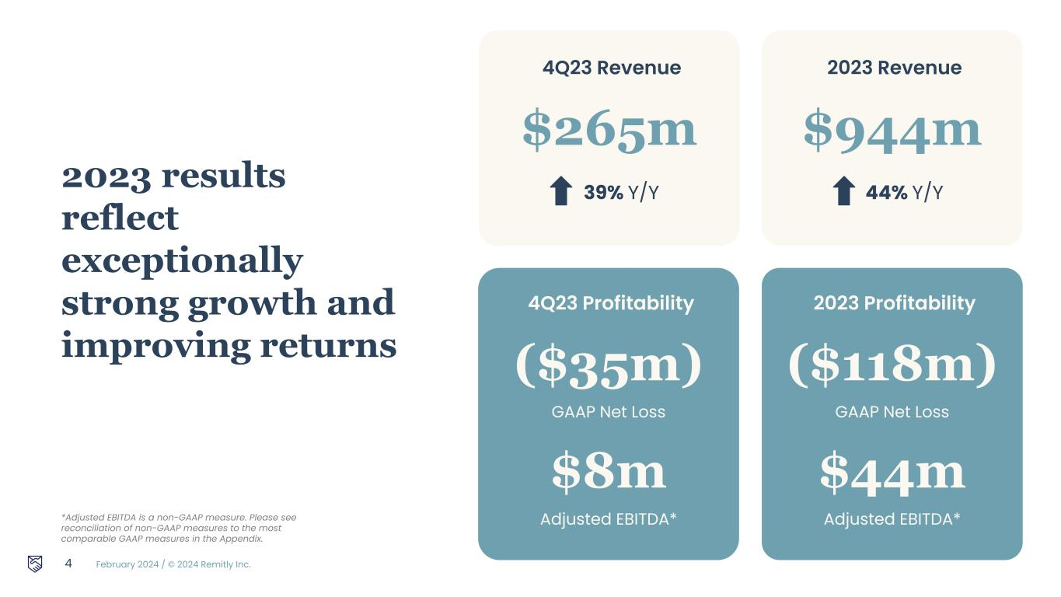
February 2024 / © 2024 Remitly Inc. 4Q23 Revenue $265m 39% Y/Y 4 *Adjusted EBITDA is a non-GAAP measure. Please see reconciliation of non-GAAP measures to the most comparable GAAP measures in the Appendix. 2023 results reflect exceptionally strong growth and improving returns 4Q23 Profitability ($35m) GAAP Net Loss $8m Adjusted EBITDA* 2023 Revenue $944m 44% Y/Y 2023 Profitability ($118m) GAAP Net Loss $44m Adjusted EBITDA*


February 2024 / © 2024 Remitly Inc. 5 Vision Transform lives with trusted financial services that transcend borders

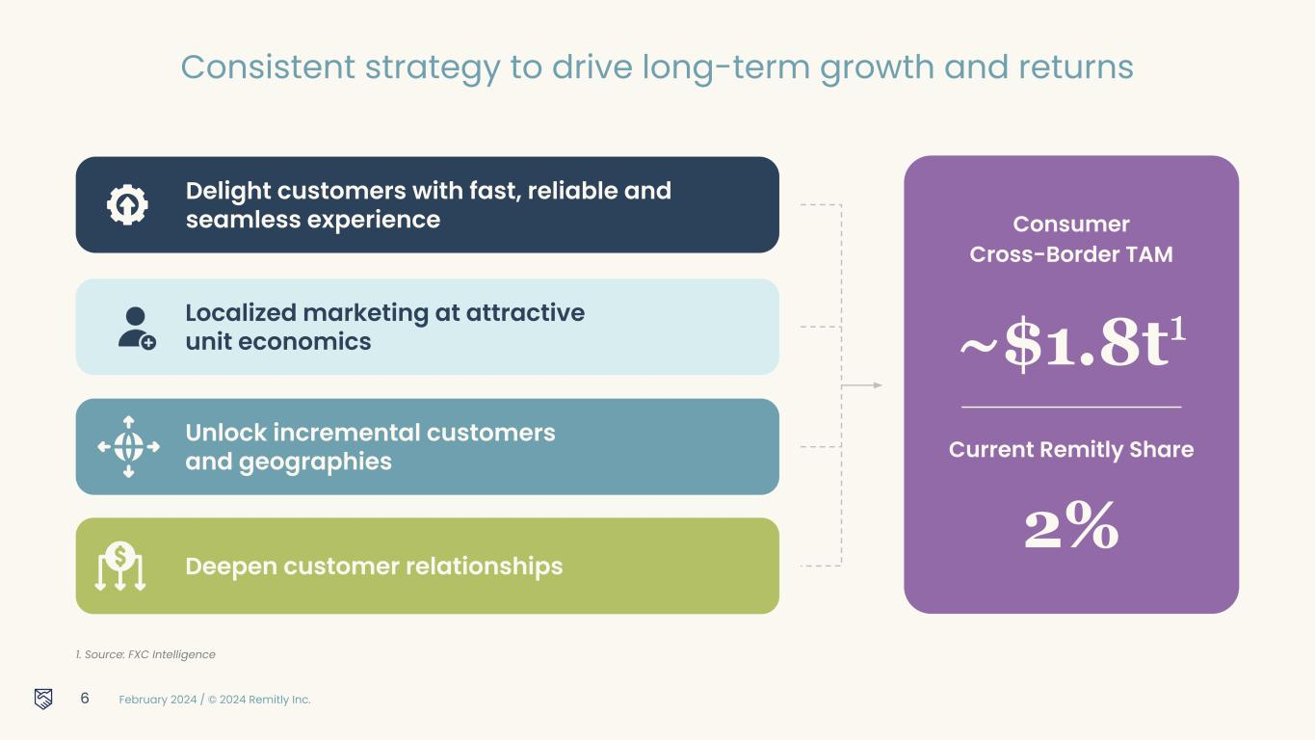
February 2024 / © 2024 Remitly Inc. Localized marketing at attractive unit economics Unlock incremental customers and geographies Delight customers with fast, reliable and seamless experience Deepen customer relationships 6 1. Source: FXC Intelligence Consumer Cross-Border TAM ~$1.8t1 Current Remitly Share 2% Consistent strategy to drive long-term growth and returns

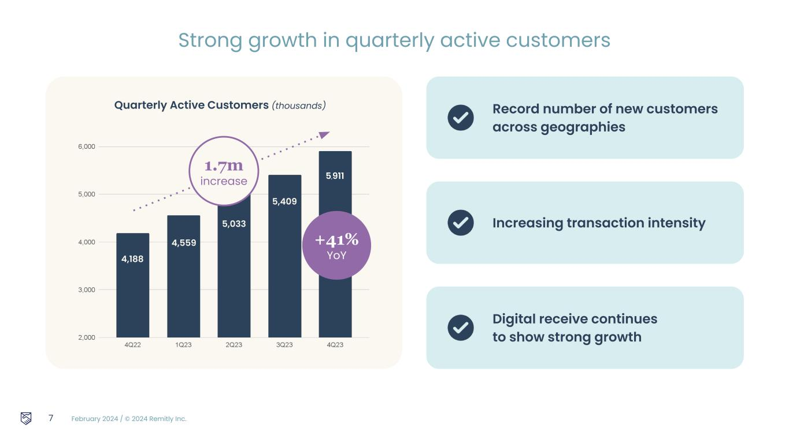
February 2024 / © 2024 Remitly Inc. 7 Quarterly Active Customers (thousands) Strong growth in quarterly active customers 4,188 +41% YoY 4,559 Increasing transaction intensity Digital receive continues to show strong growth 5,033 1.7m increase 5,409 5,911 Record number of new customers across geographies

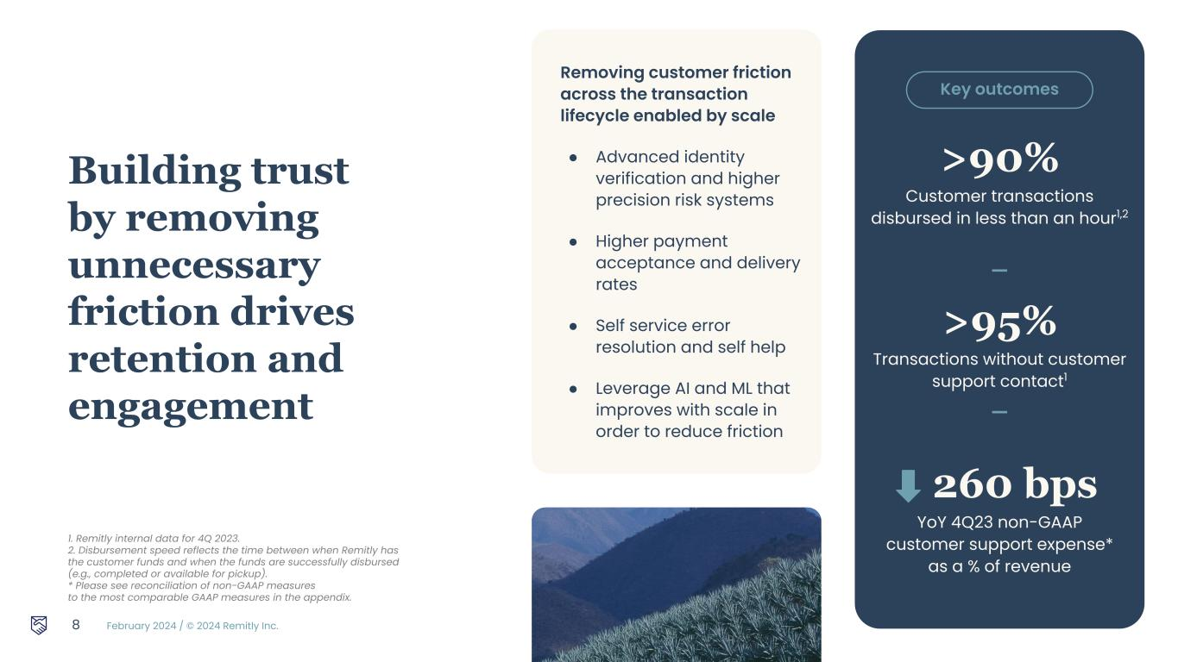
February 2024 / © 2024 Remitly Inc. Building trust by removing unnecessary friction drives retention and engagement 8 1. Remitly internal data for 4Q 2023. 2. Disbursement speed reflects the time between when Remitly has the customer funds and when the funds are successfully disbursed (e.g., completed or available for pickup). * Please see reconciliation of non-GAAP measures to the most comparable GAAP measures in the appendix. >90% Customer transactions disbursed in less than an hour1,2 >95% Transactions without customer support contact1 260 bps YoY 4Q23 non-GAAP customer support expense* as a % of revenue Removing customer friction across the transaction lifecycle enabled by scale ● Advanced identity verification and higher precision risk systems ● Higher payment acceptance and delivery rates ● Self service error resolution and self help ● Leverage AI and ML that improves with scale in order to reduce friction — — Key outcomes

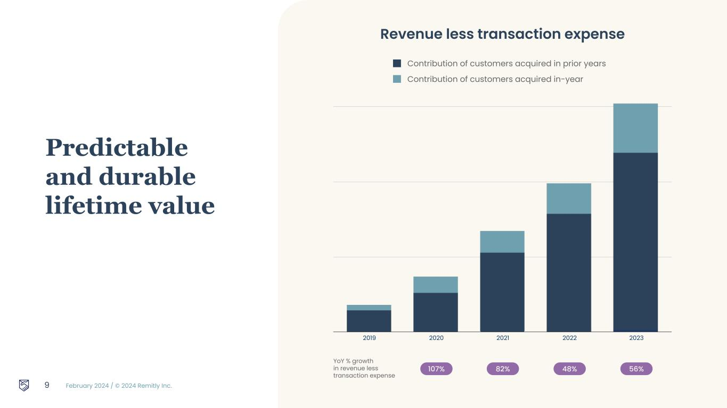
February 2024 / © 2024 Remitly Inc. 9 Predictable and durable lifetime value Contribution of customers acquired in prior years Contribution of customers acquired in-year Revenue less transaction expense 107% 82% 48% 56% YoY % growth in revenue less transaction expense 2019 2020 2021 2022 2023 2019 2020 2021 2022 2023

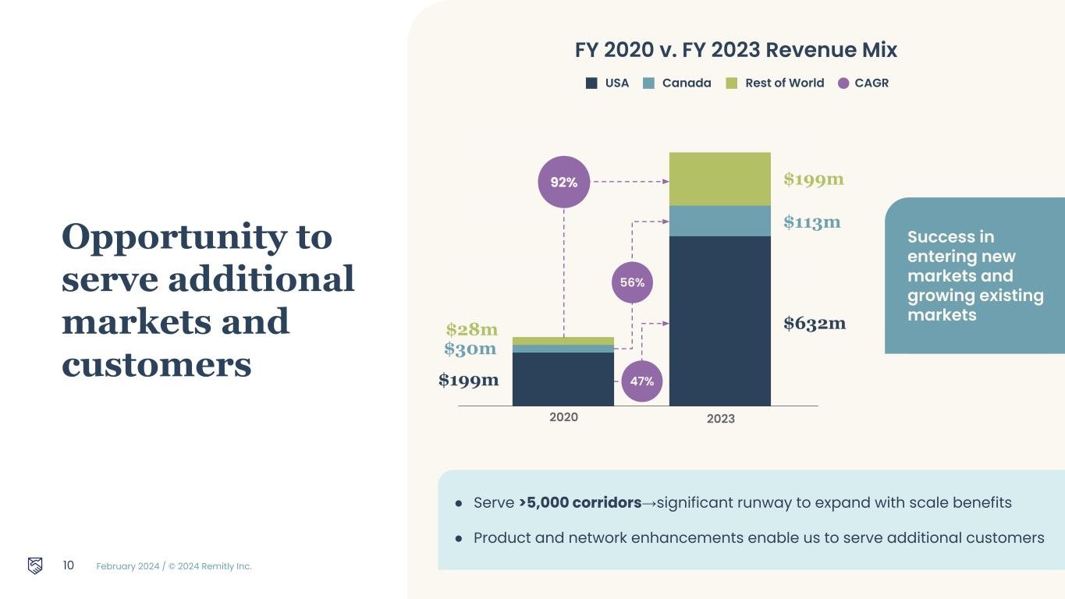
February 2024 / © 2024 Remitly Inc. 10 Opportunity to serve additional markets and customers ● Serve >5,000 corridors→significant runway to expand with scale benefits ● Product and network enhancements enable us to serve additional customers USA Canada Rest of World CAGR FY 2020 v. FY 2023 Revenue Mix 2020 2023 $199m $30m $28m $632m $113m $199m 47% 56% 92% Success in entering new markets and growing existing markets

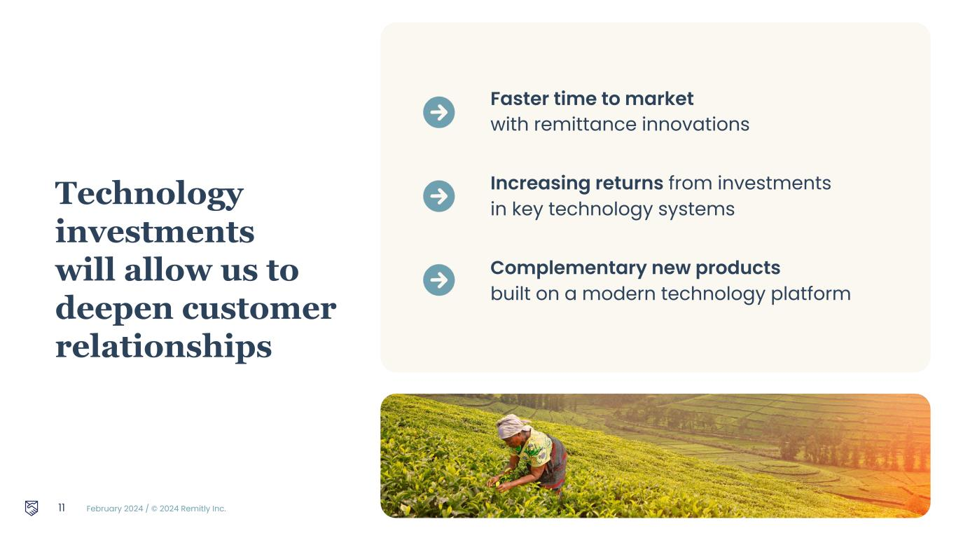
February 2024 / © 2024 Remitly Inc. Technology investments will allow us to deepen customer relationships 11 ● Faster time to market with remittance innovations ● Increasing returns from investments in key technology systems ● Complementary new products built on a modern technology platform


February 2024 / © 2024 Remitly Inc. 12 4Q Financial Results Hemanth Munipalli CFO

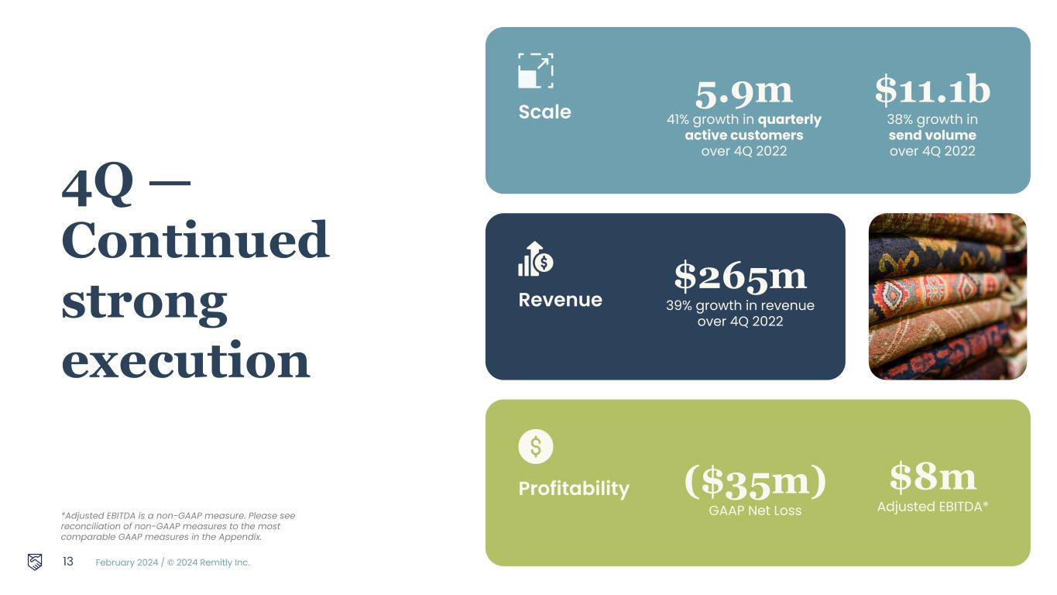
February 2024 / © 2024 Remitly Inc. 4Q — Continued strong execution Scale 5.9m 41% growth in quarterly active customers over 4Q 2022 $11.1b 38% growth in send volume over 4Q 2022 Revenue $265m 39% growth in revenue over 4Q 2022 13 Profitability ($35m) GAAP Net Loss $8m Adjusted EBITDA* *Adjusted EBITDA is a non-GAAP measure. Please see reconciliation of non-GAAP measures to the most comparable GAAP measures in the Appendix.

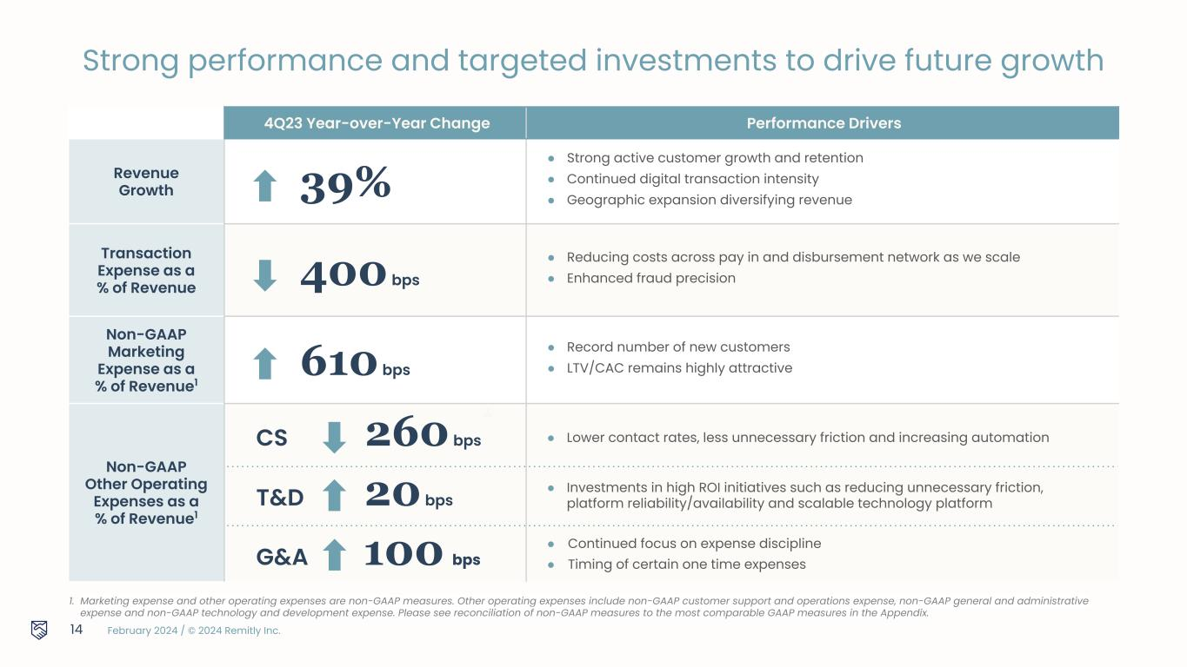
February 2024 / © 2024 Remitly Inc. 1. Marketing expense and other operating expenses are non-GAAP measures. Other operating expenses include non-GAAP customer support and operations expense, non-GAAP general and administrative expense and non-GAAP technology and development expense. Please see reconciliation of non-GAAP measures to the most comparable GAAP measures in the Appendix. 4Q23 Year-over-Year Change Performance Drivers Revenue Growth 39% ● Strong active customer growth and retention ● Continued digital transaction intensity ● Geographic expansion diversifying revenue Transaction Expense as a % of Revenue 400 bps ● Reducing costs across pay in and disbursement network as we scale ● Enhanced fraud precision Non-GAAP Marketing Expense as a % of Revenue1 610 bps ● Record number of new customers ● LTV/CAC remains highly attractive Non-GAAP Other Operating Expenses as a % of Revenue1 14 ● Continued focus on expense discipline ● Timing of certain one time expenses ● Investments in high ROI initiatives such as reducing unnecessary friction, platform reliability/availability and scalable technology platform G&A 100 bps T&D 20 bps CS 260 bps ● Lower contact rates, less unnecessary friction and increasing automation Strong performance and targeted investments to drive future growth

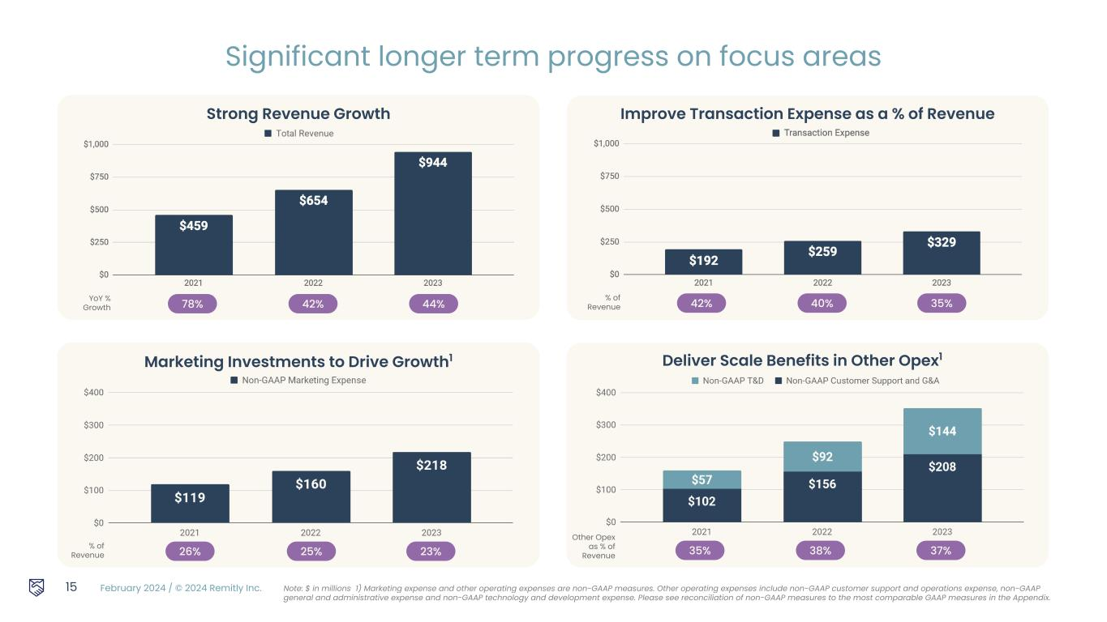
February 2024 / © 2024 Remitly Inc. % of Revenue 26% 25% 23% Marketing Investments to Drive Growth1 15 Note: $ in millions. 1) Marketing expense and other operating expenses are non-GAAP measures. Other operating expenses include non-GAAP customer support and operations expense, non-GAAP general and administrative expense and non-GAAP technology and development expense. Please see reconciliation of non-GAAP measures to the most comparable GAAP measures in the Appendix. Significant longer term progress on focus areas YoY % Growth 78% 42% 44% Strong Revenue Growth % of Revenue 42% 40% 35% Improve Transaction Expense as a % of Revenue Other Opex as % of Revenue 35% 38% 37% Deliver Scale Benefits in Other Opex1

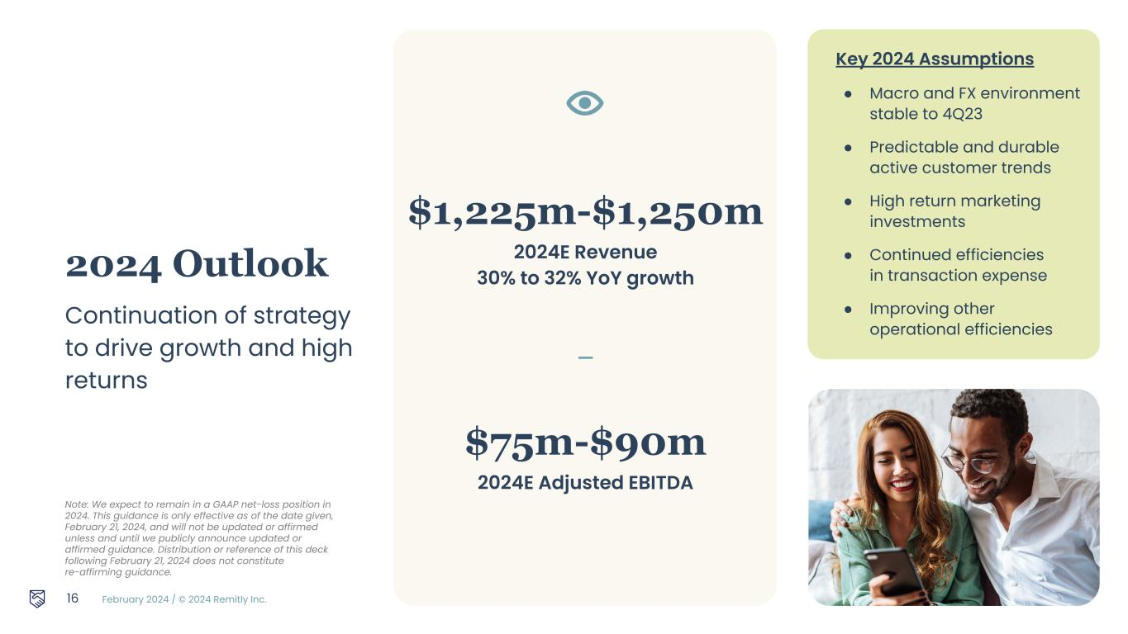
February 2024 / © 2024 Remitly Inc. 2024 Outlook Continuation of strategy to drive growth and high returns Key 2024 Assumptions ● Macro and FX environment stable to 4Q23 ● Predictable and durable active customer trends ● High return marketing investments ● Continued efficiencies in transaction expense ● Improving other operational efficiencies $1,225m-$1,250m 2024E Revenue 30% to 32% YoY growth — $75m-$90m 2024E Adjusted EBITDA 16 Note: We expect to remain in a GAAP net-loss position in 2024. This guidance is only effective as of the date given, February 21, 2024, and will not be updated or affirmed unless and until we publicly announce updated or affirmed guidance. Distribution or reference of this deck following February 21, 2024 does not constitute re-affirming guidance.


February 2024 / © 2024 Remitly Inc. Q & A 17


February 2024 / © 2024 Remitly Inc. “ Alexandra Remitly user since 2023 Sends money from Spain to ColombiaAmazing! It worked as it described it. It's reliable and quick. I'm very happy that I tried it.” 18


February 2024 / © 2024 Remitly Inc. Appendix 19

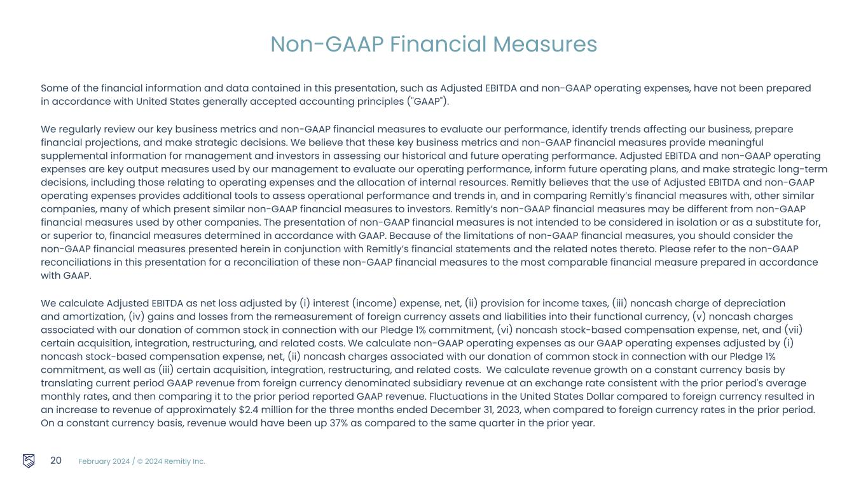
February 2024 / © 2024 Remitly Inc. Some of the financial information and data contained in this presentation, such as Adjusted EBITDA and non-GAAP operating expenses, have not been prepared in accordance with United States generally accepted accounting principles ("GAAP"). We regularly review our key business metrics and non-GAAP financial measures to evaluate our performance, identify trends affecting our business, prepare financial projections, and make strategic decisions. We believe that these key business metrics and non-GAAP financial measures provide meaningful supplemental information for management and investors in assessing our historical and future operating performance. Adjusted EBITDA and non-GAAP operating expenses are key output measures used by our management to evaluate our operating performance, inform future operating plans, and make strategic long-term decisions, including those relating to operating expenses and the allocation of internal resources. Remitly believes that the use of Adjusted EBITDA and non-GAAP operating expenses provides additional tools to assess operational performance and trends in, and in comparing Remitly’s financial measures with, other similar companies, many of which present similar non-GAAP financial measures to investors. Remitly’s non-GAAP financial measures may be different from non-GAAP financial measures used by other companies. The presentation of non-GAAP financial measures is not intended to be considered in isolation or as a substitute for, or superior to, financial measures determined in accordance with GAAP. Because of the limitations of non-GAAP financial measures, you should consider the non-GAAP financial measures presented herein in conjunction with Remitly’s financial statements and the related notes thereto. Please refer to the non-GAAP reconciliations in this presentation for a reconciliation of these non-GAAP financial measures to the most comparable financial measure prepared in accordance with GAAP. We calculate Adjusted EBITDA as net loss adjusted by (i) interest (income) expense, net, (ii) provision for income taxes, (iii) noncash charge of depreciation and amortization, (iv) gains and losses from the remeasurement of foreign currency assets and liabilities into their functional currency, (v) noncash charges associated with our donation of common stock in connection with our Pledge 1% commitment, (vi) noncash stock-based compensation expense, net, and (vii) certain acquisition, integration, restructuring, and related costs. We calculate non-GAAP operating expenses as our GAAP operating expenses adjusted by (i) noncash stock-based compensation expense, net, (ii) noncash charges associated with our donation of common stock in connection with our Pledge 1% commitment, as well as (iii) certain acquisition, integration, restructuring, and related costs. We calculate revenue growth on a constant currency basis by translating current period GAAP revenue from foreign currency denominated subsidiary revenue at an exchange rate consistent with the prior period's average monthly rates, and then comparing it to the prior period reported GAAP revenue. Fluctuations in the United States Dollar compared to foreign currency resulted in an increase to revenue of approximately $2.4 million for the three months ended December 31, 2023, when compared to foreign currency rates in the prior period. On a constant currency basis, revenue would have been up 37% as compared to the same quarter in the prior year. 20 Non-GAAP Financial Measures

February 2024 / © 2024 Remitly Inc. Reconciliation of operating expenses to non-GAAP operating expenses (in thousands) 4Q 2023 4Q 2022 2023 2022 2021 Customer support and operations $19,917 $19,239 $82,521 $68,106 $45,525 Excluding: Stock-based compensation expense, net 394 220 1,404 816 153 Excluding: Acquisition, integration, restructuring, and related costs - - 739 - - Non-GAAP customer support and operations $19,523 $19,019 $80,378 $67,290 $45,372 Marketing $75,343 $43,163 $234,417 $170,970 $120,906 Excluding: Stock-based compensation expense, net 3,930 3,363 16,165 10,512 2,325 Non-GAAP marketing $71,413 $39,800 $218,252 $160,458 $118,581 Technology and development $59,240 $42,883 $219,939 $138,719 $64,093 Excluding: Stock-based compensation expense, net 19,920 15,461 74,967 46,420 6,931 Excluding: Acquisition, integration, restructuring, and related costs 700 - 1,224 - - Non-GAAP technology and development $38,620 $27,422 $143,748 $92,299 $57,162 General and administrative $48,657 $34,895 $179,372 $131,250 $70,941 Excluding: Stock-based compensation expense, net 11,716 8,369 44,431 37,545 7,607 Excluding: Donation of common stock - - 4,600 1,972 6,933 Excluding: Acquisition, integration, restructuring, and related costs (893) 1,077 2,234 3,462 - Non-GAAP general and administrative $37,834 $25,449 $128,107 $88,271 $56,401 21 Non-GAAP Reconciliation

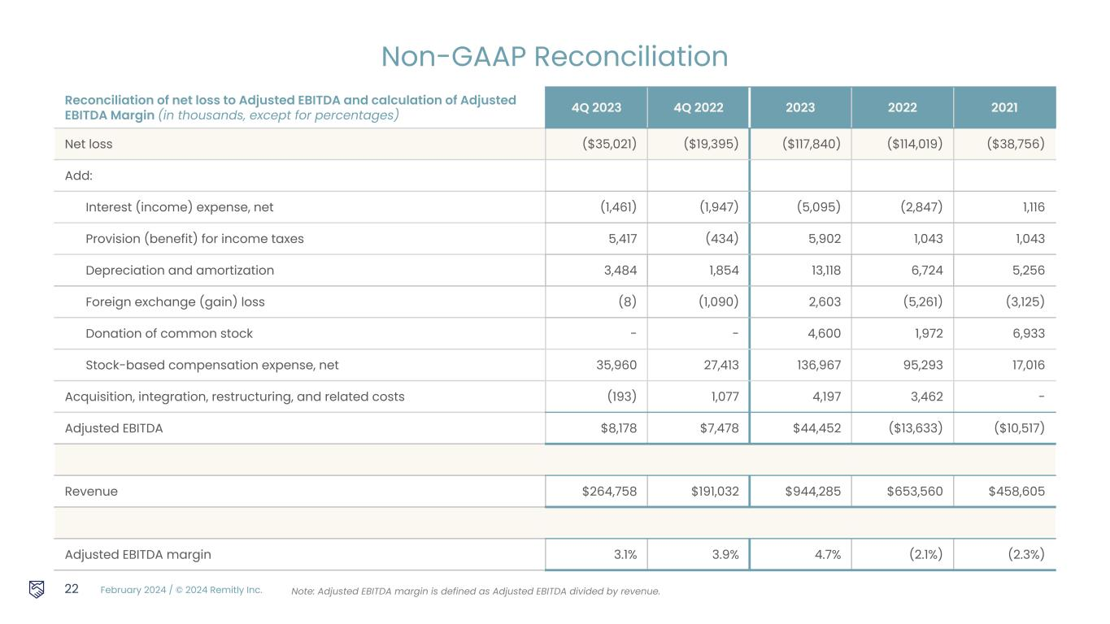
February 2024 / © 2024 Remitly Inc. Reconciliation of net loss to Adjusted EBITDA and calculation of Adjusted EBITDA Margin (in thousands, except for percentages) 4Q 2023 4Q 2022 2023 2022 2021 Net loss ($35,021) ($19,395) ($117,840) ($114,019) ($38,756) Add: Interest (income) expense, net (1,461) (1,947) (5,095) (2,847) 1,116 Provision (benefit) for income taxes 5,417 (434) 5,902 1,043 1,043 Depreciation and amortization 3,484 1,854 13,118 6,724 5,256 Foreign exchange (gain) loss (8) (1,090) 2,603 (5,261) (3,125) Donation of common stock - - 4,600 1,972 6,933 Stock-based compensation expense, net 35,960 27,413 136,967 95,293 17,016 Acquisition, integration, restructuring, and related costs (193) 1,077 4,197 3,462 - Adjusted EBITDA $8,178 $7,478 $44,452 ($13,633) ($10,517) Revenue $264,758 $191,032 $944,285 $653,560 $458,605 Adjusted EBITDA margin 3.1% 3.9% 4.7% (2.1%) (2.3%) 22 Non-GAAP Reconciliation Note: Adjusted EBITDA margin is defined as Adjusted EBITDA divided by revenue.


February 2024 / © 2024 Remitly Inc. Thank you.

