UNITED STATES
SECURITIES AND EXCHANGE COMMISSION
WASHINGTON, D.C. 20549

FORM 8-K

CURRENT REPORT
Pursuant to Section 13 or 15(d) of the Securities Exchange Act of 1934
Date of Report (Date of earliest event reported): May 7, 2025

REMITLY GLOBAL, INC.
(Exact Name of Registrant as Specified in Its Charter)

Delaware |  |  | 001-40822 |  |  | 83-2301143
(State or Other Jurisdiction  of Incorporation) |  |  | (Commission File Number) |  |  | (IRS Employer  Identification No.)
1111 Third Avenue, Suite 2100
Seattle, WA 98101
(Address of Principal Executive Offices and Zip Code)
(888) 736-4859
(Registrant’s Telephone Number, Including Area Code)
Not Applicable
(Former Name or Former Address, if Changed Since Last Report)

Check the appropriate box below if the Form 8-K filing is intended to simultaneously satisfy the filing obligation of the registrant under any of the following provisions (see General Instructions A.2. below):
☐ Written communications pursuant to Rule 425 under the Securities Act (17 CFR 230.425)
☐ Soliciting material pursuant to Rule 14a-12 under the Exchange Act (17 CFR 240.14a-12)
☐ Pre-commencement communications pursuant to Rule 14d-2(b) under the Exchange Act (17 CFR 240.14d-2(b))
☐ Pre-commencement communications pursuant to Rule 13e-4(c) under the Exchange Act (17 CFR 240.13e-4(c))
Securities registered pursuant to Section 12(b) of the Act:
Title of each class: |  |  |  |  |  | Trading Symbol(s): |  |  |  |  |  | Name of each exchange on which registered:
Common Stock, par value $0.0001 per share |  |  |  |  |  | RELY |  |  |  |  |  | NASDAQ
Indicate by check mark whether the registrant is an emerging growth company as defined in Rule 405 of the Securities Act of 1933 (§230.405 of this chapter) or Rule 12b-2 of the Securities Exchange Act of 1934 (§240.12b-2 of this chapter).
Emerging growth company ☐
If an emerging growth company, indicate by check mark if the registrant has elected not to use the extended transition period for complying with any new or revised financial accounting standards provided pursuant to Section 13(a) of the Exchange Act. ☐

1

Item 2.02 Results of Operations and Financial Condition.
On May 7, 2025, Remitly Global, Inc. (the “Company”) issued a press release announcing its financial results for the fiscal quarter ended March 31, 2025. A copy of the press release is furnished as Exhibit 99.1 hereto and is incorporated by reference herein.

As previously announced on February 19, 2025, the Company has updated the presentation of its non-GAAP financial measures to exclude the impact of payroll taxes related to stock-based compensation expense, net. The Company considers this adjustment to improve the usefulness of its non-GAAP financial measures in evaluating underlying operating performance by more completely reflecting the extent of stock-based compensation expense, net, and related impacts. This update has no effect on any of the Company's previously reported U.S. GAAP results for any period. Non-GAAP financial measures reflecting the updated presentation described above for the years ended December 31, 2024 and 2023, including reconciliations to the most directly comparable GAAP measures, are included in the press release furnished as Exhibit 99.1 hereto.

Item 7.01 Regulation FD Disclosure.
On May 7, 2025, the Company provided an investor presentation that will be made available on the investor relations section of the Company’s website at https://ir.remitly.com/. The investor presentation is furnished as Exhibit 99.2 to this Current Report on Form 8-K and is incorporated by reference herein.
The information in Items 2.02 and 7.01 of this Current Report, including the accompanying Exhibit 99.1 and Exhibit 99.2, is being furnished and shall not be deemed “filed” for the purposes of Section 18 of the Securities Exchange Act of 1934, as amended (the “Exchange Act”), or otherwise subject to the liabilities of Section 18. The information in Items 2.02 and 7.01 of this Current Report, including the accompanying Exhibit 99.1 and Exhibit 99.2, shall not be incorporated by reference into any registration statement or other document filed pursuant to the Securities Act of 1933, as amended, or the Exchange Act, regardless of any general incorporation language contained in such filing.

Item 9.01 Financial Statements and Exhibits.
(d) Exhibits
Exhibit No. |  |  | Description
99.1 |  |  | Press Release dated May 7, 2025
99.2 |  |  | Investor Presentation dated May 7, 2025
104 |  |  | Cover page interactive data file (embedded with the inline XBRL document)

2

SIGNATURES
Pursuant to the requirements of the Securities Exchange Act of 1934, the registrant has duly caused this report to be signed on its behalf by the undersigned thereunto duly authorized.
 |  |  | Remitly Global, Inc.
Date: May 7, 2025 |  |  | By: |  |  | /s/ Vikas Mehta
 |  |  |  |  |  | Vikas Mehta
 |  |  |  |  |  | Chief Financial Officer
 |  |  |  |  |  | (Principal Financial Officer)
Date: May 7, 2025 |  |  | By: |  |  | /s/ Luke Tavis
 |  |  |  |  |  | Luke Tavis
 |  |  |  |  |  | Chief Accounting Officer
 |  |  |  |  |  | (Principal Accounting Officer)

3

Remitly Reports First Quarter 2025 Results Above Outlook and Raises Full Year 2025 Outlook
First quarter send volume up 41% and revenue up 34% year over year
First quarter net income was $11.4 million and Adjusted EBITDA was $58.4 million

SEATTLE, WA / May 7, 2025 / GlobeNewswire / - Remitly Global, Inc. (NASDAQ: RELY), a trusted provider of digital financial services that transcend borders, reported results for the first quarter ended March 31, 2025.
“We delivered an outstanding start to the year, significantly exceeding our expectations for the first quarter,” said Matt Oppenheimer, co-founder and Chief Executive Officer, Remitly. “This performance was driven by the deep and growing trust our customers place in us to deliver a fast, reliable, and secure experience. As that trust continues to grow, so does our ability to scale efficiently and profitably. Based on these strong results, we are raising our full year 2025 outlook for both revenue and Adjusted EBITDA.”

First Quarter 2025 Highlights and Key Operating Data
(All comparisons relative to the first quarter of 2024)
•Active customers increased to 8.0 million, from 6.2 million, up 29%.
•Send volume increased to $16.2 billion, from $11.5 billion, up 41%.
•Revenue totaled $361.6 million, compared to $269.1 million, up 34%.
•Net income was $11.4 million, compared to a net loss of $21.1 million.
•Adjusted EBITDA was $58.4 million, compared to $22.8 million, up 157%.

2025 Financial Outlook
For fiscal year 2025, Remitly currently expects:
•Total revenue in the range of $1.574 billion to $1.587 billion, representing a growth rate of 25% to 26% year over year. This outlook reflects an increase from our prior revenue outlook in the range of $1.565 billion to $1.580 billion.
•GAAP net income to be positive for 2025 and for Adjusted EBITDA to be in the range of $195 million to $210 million. This outlook reflects an increase from our prior Adjusted EBITDA outlook in the range of $180 million to $200 million.
For the second quarter of 2025, Remitly currently expects:
•Total revenue in the range of $383 million to $385 million, representing a growth rate of 25% to 26% year over year.
•A GAAP net loss position for the second quarter of 2025 and for Adjusted EBITDA to be in the range of $45 million to $47 million.
As previously announced on February 19, 2025, the Company's non-GAAP financial measures have been updated to exclude the impact of payroll taxes related to stock-based compensation expense, net. The Company considers this adjustment to improve the usefulness of its non-GAAP financial measures in evaluating underlying operating performance by more completely reflecting the extent of stock-based compensation expense, net, and related impacts. This update has no effect on any of the Company's previously reported GAAP results for any period. Non-GAAP financial measures for 2024 and 2023 have been recast to reflect this change, and the financial outlook guidance previously provided on February 19, 2025, was in accordance with this updated presentation. See historical non-GAAP reconciliations included below.
1
Reconciliation of GAAP to Non-GAAP Financial Measures
A reconciliation of accounting principles generally accepted in the United States of America (“GAAP”) to non-GAAP financial measures has been provided in the financial statement tables included in this earnings release. An explanation of these measures is also included below under the heading “Non-GAAP Financial Measures.” We have not provided a quantitative reconciliation of forecasted Adjusted EBITDA to forecasted GAAP net income (loss) or to forecasted GAAP income (loss) before income taxes within this earnings release because we cannot, without unreasonable effort, calculate certain reconciling items with confidence due to the variability, complexity, and limited visibility of the adjusting items that would be excluded from forecasted Adjusted EBITDA. These items include, but are not limited to, income taxes, stock-based compensation expense, and payroll taxes related to stock-based compensation expense, which are directly impacted by unpredictable fluctuations in the market price of our common stock. The variability of these items could have a significant impact on our future GAAP financial results.
Note: All percentage changes described within this press release are calculated using amounts in the Company’s Annual Reports on Form 10-K and Quarterly Reports on Form 10-Q filed with the Securities and Exchange Commission (the “SEC”), for which revenue and active customers are presented in thousands and send volume is presented in millions. Rounding differences may occur when individually calculating percentages or totals from rounded amounts included within the press release body as compared to the amounts included within the Company’s SEC filings.

2
Webcast Information
Remitly will host a webcast at 5:00 p.m. Eastern time on Wednesday, May 7, 2025 to discuss its first quarter 2025 financial results. The live webcast and investor presentation will be accessible on Remitly’s website at https://ir.remitly.com. A webcast replay will be available on our website at https://ir.remitly.com following the live event.
We have used, and intend to continue to use, the Investor Relations section of our website at https://ir.remitly.com as a means of disclosing material nonpublic information and for complying with our disclosure obligations under Regulation FD.

Non-GAAP Financial Measures
Some of the financial information and data contained in this earnings release, such as Adjusted EBITDA and non-GAAP operating expenses, have not been prepared in accordance with GAAP.
We regularly review our key business metrics and non-GAAP financial measures to evaluate our performance, identify trends affecting our business, prepare financial projections, and make strategic decisions. We believe that these key business metrics and non-GAAP financial measures provide meaningful supplemental information for management and investors in assessing our historical and future operating performance. Adjusted EBITDA and non-GAAP operating expenses are key output measures used by our management to evaluate our operating performance, inform future operating plans, and make strategic long-term decisions, including those relating to operating expenses and the allocation of internal resources. Remitly believes that the use of Adjusted EBITDA and non-GAAP operating expenses provides additional tools to assess operational performance and trends in, and in comparing Remitly’s financial measures with, other similar companies, many of which present similar non-GAAP financial measures to investors. Remitly’s non-GAAP financial measures may be different from non-GAAP financial measures used by other companies. The presentation of non-GAAP financial measures is not intended to be considered in isolation or as a substitute for, or superior to, financial measures determined in accordance with GAAP. Because of the limitations of non-GAAP financial measures, you should consider the non-GAAP financial measures presented herein in conjunction with Remitly’s financial statements and the related notes thereto. Please refer to the non-GAAP reconciliations in this press release for a reconciliation of these non-GAAP financial measures to the most comparable financial measure prepared in accordance with GAAP.
We calculate Adjusted EBITDA as net income (loss) adjusted by (i) interest (income) expense, net, (ii) provision for income taxes, (iii) noncash charges of depreciation and amortization, (iv) other income (expense), net, (v) noncash charges associated with our donation of common stock in connection with our Pledge 1% commitment, (vi) noncash stock-based compensation expense, net, (vii) payroll taxes related to stock-based compensation expense, net, and (viii) certain integration, restructuring, and other costs. We calculate non-GAAP operating expenses as our GAAP operating expenses adjusted by (i) noncash stock-based compensation expense, net, (ii) payroll taxes related to stock-based compensation expense, net, (iii) noncash charges associated with our donation of common stock in connection with our Pledge 1% commitment, as well as (iv) certain integration, restructuring, and other costs.

3
Forward-Looking Statements
This press release contains forward-looking statements within the meaning of the Private Securities Litigation Reform Act of 1995. All statements other than statements of historical fact are forward-looking statements. These statements include, but are not limited to, statements regarding our future results of operations and financial position, including our fiscal year and second quarter 2025 financial outlook, including forecasted fiscal year and second quarter 2025 revenue, net income (loss), and Adjusted EBITDA, anticipated future expenses and investments, expectations relating to certain of our key financial and operating metrics, our business strategy and plans, our growth, our position and potential opportunities, and our objectives for future operations. The words such as “anticipate,” “believe,” “continue,” “could,” “estimate,” “expect,” “intend,” “may,” “might,” “likely,” “plan,” “potential,” “predict,” “project,” “seek,” “should,” “target,” “will,” “would,” or similar expressions and the negatives of those terms are intended to identify forward-looking statements. Forward-looking statements are based on management’s expectations, assumptions, and projections based on information available at the time the statements were made. These forward-looking statements are subject to a number of risks, uncertainties, and assumptions, including risks and uncertainties related to our expectations regarding our revenue, expenses, and other operating results; our ability to acquire new customers and successfully retain existing customers; our ability to develop new products and services in a timely manner; our ability to achieve or sustain our profitability; our ability to maintain and expand our strategic relationships with third parties; our business plan and our ability to effectively manage our growth; anticipated trends, growth rates, and challenges in our business and in the market segments in which we operate; our ability to attract and retain qualified employees; uncertainties regarding the impact of geopolitical and macroeconomic conditions, including currency fluctuations, inflation, regulatory changes (including as may be related to immigration, fiscal policy, foreign trade, or foreign investment), or regional and global conflicts or related government sanctions; our ability to maintain the security and availability of our solutions; our ability to maintain our money transmission licenses and other regulatory clearances; our ability to maintain and expand international operations; and our expectations regarding anticipated technology needs and developments and our ability to address those needs and developments with our solutions. It is not possible for our management to predict all risks, nor can we assess the impact of all factors on our business or the extent to which any factor, or combination of factors, may cause actual results to differ materially from those contained in any forward-looking statements we may make. In light of these risks, uncertainties, and assumptions, our actual results could differ materially and adversely from those anticipated or implied in the forward-looking statements. Further information on risks that could cause actual results to differ materially from forecasted results is included in our quarterly report on Form 10-Q for the quarter ended March 31, 2025 to be filed with the SEC, and within our annual report on Form 10-K for the year ended December 31, 2024 filed with the SEC, which are or will be available on our website at https://ir.remitly.com and on the SEC’s website at www.sec.gov. Except as required by law, we assume no obligation to update these forward-looking statements, or to update the reasons if actual results differ materially from those anticipated in the forward-looking statements.

4
About Remitly
Remitly is a trusted provider of digital financial services that transcend borders. With a global footprint spanning more than 170 countries, Remitly’s digitally native, cross-border payments app delights customers with a fast, reliable, and transparent money movement experience. Building on its strong foundation, Remitly is expanding its suite of products to further its vision and transform lives around the world.

Contacts

Media Inquiries:
press@remitly.com

Investor Relations:
Stephen Shulstein
stephens@remitly.com

5
REMITLY GLOBAL, INC.
Condensed Consolidated Statements of Operations
(unaudited)

 |  |  | Three Months Ended March 31,
(in thousands, except share and per share data) |  |  | 2025 |  |  |  |  |  | 2024
Revenue |  |  | $ | 361,624 |  |  |  |  | $ | 269,118
Costs and expenses
Transaction expenses(1) |  |  | 121,393 |  |  |  |  |  | 89,881
Customer support and operations(1) |  |  | 22,573 |  |  |  |  |  | 20,119
Marketing(1) |  |  | 73,349 |  |  |  |  |  | 68,014
Technology and development(1) |  |  | 73,851 |  |  |  |  |  | 63,206
General and administrative(1) |  |  | 52,829 |  |  |  |  |  | 44,173
Depreciation and amortization |  |  | 5,396 |  |  |  |  |  | 3,678
Total costs and expenses |  |  | 349,391 |  |  |  |  |  | 289,071
Income (loss) from operations |  |  | 12,233 |  |  |  |  |  | (19,953)
Interest income |  |  | 1,787 |  |  |  |  |  | 2,226
Interest expense |  |  | (1,299) |  |  |  |  |  | (769)
Other income (expense), net |  |  | 2,221 |  |  |  |  |  | (1,586)
Income (loss) before provision for income taxes |  |  | 14,942 |  |  |  |  |  | (20,082)
Provision for income taxes |  |  | 3,590 |  |  |  |  |  | 998
Net income (loss) |  |  | $ | 11,352 |  |  |  |  | $ | (21,080)
Net income (loss) per share attributable to common stockholders:
Basic |  |  | $ | 0.06 |  |  |  |  | $ | (0.11)
Diluted |  |  | $ | 0.05 |  |  |  |  | $ | (0.11)
Weighted-average shares used in computing net income (loss) per share attributable to common stockholders:
Basic |  |  | 201,744,601 |  |  |  |  |  | 189,848,799
Diluted |  |  | 218,414,823 |  |  |  |  |  | 189,848,799
(1) Exclusive of depreciation and amortization, shown separately.

6
REMITLY GLOBAL, INC.
Condensed Consolidated Balance Sheets
(unaudited)

 |  |  | March 31, |  |  |  |  |  | December 31,
(in thousands) |  |  | 2025 |  |  |  |  |  | 2024
Assets
Current assets
Cash and cash equivalents |  |  | $ | 493,905 |  |  |  |  | $ | 368,097
Disbursement prefunding |  |  | 217,549 |  |  |  |  |  | 288,934
Customer funds receivable, net |  |  | 213,554 |  |  |  |  |  | 193,965
Prepaid expenses and other current assets |  |  | 53,710 |  |  |  |  |  | 46,518
Total current assets |  |  | 978,718 |  |  |  |  |  | 897,514
Property and equipment, net |  |  | 41,456 |  |  |  |  |  | 31,566
Operating lease right-of-use assets |  |  | 11,896 |  |  |  |  |  | 13,002
Goodwill |  |  | 54,940 |  |  |  |  |  | 54,940
Intangible assets, net |  |  | 8,379 |  |  |  |  |  | 10,463
Other noncurrent assets, net |  |  | 5,197 |  |  |  |  |  | 5,386
Total assets |  |  | $ | 1,100,586 |  |  |  |  | $ | 1,012,871
Liabilities and stockholders’ equity
Current liabilities
Accounts payable |  |  | $ | 38,907 |  |  |  |  | $ | 16,159
Customer liabilities |  |  | 192,186 |  |  |  |  |  | 188,984
Short-term debt |  |  | 2,421 |  |  |  |  |  | 2,468
Accrued expenses and other current liabilities |  |  | 114,545 |  |  |  |  |  | 116,652
Operating lease liabilities |  |  | 4,098 |  |  |  |  |  | 4,745
Total current liabilities |  |  | 352,157 |  |  |  |  |  | 329,008
Operating lease liabilities, noncurrent |  |  | 14,728 |  |  |  |  |  | 9,073
Other noncurrent liabilities |  |  | 10,225 |  |  |  |  |  | 9,319
Total liabilities |  |  | 377,110 |  |  |  |  |  | 347,400
Commitments and contingencies
Stockholders’ equity
Common stock |  |  | 20 |  |  |  |  |  | 20
Additional paid-in capital |  |  | 1,240,310 |  |  |  |  |  | 1,195,390
Accumulated other comprehensive income (loss) |  |  | 75 |  |  |  |  |  | (1,658)
Accumulated deficit |  |  | (516,929) |  |  |  |  |  | (528,281)
Total stockholders’ equity |  |  | 723,476 |  |  |  |  |  | 665,471
Total liabilities and stockholders’ equity |  |  | $ | 1,100,586 |  |  |  |  | $ | 1,012,871

7
REMITLY GLOBAL, INC.
Condensed Consolidated Statements of Cash Flows
(unaudited)
 |  |  | Three Months Ended March 31,
(in thousands) |  |  | 2025 |  |  |  |  |  | 2024
Cash flows from operating activities
Net income (loss) |  |  | $ | 11,352 |  |  |  |  | $ | (21,080)
Adjustments to reconcile net income (loss) to net cash provided by (used in) operating activities:
Depreciation and amortization |  |  | 5,396 |  |  |  |  |  | 3,678
Stock-based compensation expense, net |  |  | 35,792 |  |  |  |  |  | 34,088
Donation of common stock |  |  | 959 |  |  |  |  |  | —
Other |  |  | (4) |  |  |  |  |  | 249
Changes in operating assets and liabilities:
Disbursement prefunding |  |  | 71,385 |  |  |  |  |  | (6,194)
Customer funds receivable |  |  | (16,283) |  |  |  |  |  | (59,432)
Prepaid expenses and other assets |  |  | (6,272) |  |  |  |  |  | (10,377)
Operating lease right-of-use assets |  |  | 2,041 |  |  |  |  |  | 1,392
Accounts payable |  |  | 22,182 |  |  |  |  |  | (22,707)
Customer liabilities |  |  | 2,487 |  |  |  |  |  | 14,744
Accrued expenses and other liabilities |  |  | (198) |  |  |  |  |  | 10,429
Operating lease liabilities |  |  | 4,066 |  |  |  |  |  | (1,598)
Net cash provided by (used in) operating activities |  |  | 132,903 |  |  |  |  |  | (56,808)
Cash flows from investing activities
Purchases of property and equipment, and other |  |  | (13,963) |  |  |  |  |  | (945)
Capitalized internal-use software costs |  |  | (2,949) |  |  |  |  |  | (3,369)
Net cash used in investing activities |  |  | (16,912) |  |  |  |  |  | (4,314)
Cash flows from financing activities
Proceeds from exercise of stock options |  |  | 2,392 |  |  |  |  |  | 2,483
Proceeds from issuance of common stock in connection with ESPP |  |  | 5,768 |  |  |  |  |  | 5,004
Proceeds from revolving credit facility borrowings |  |  | 1,059,000 |  |  |  |  |  | 275,000
Repayments of revolving credit facility borrowings |  |  | (1,059,000) |  |  |  |  |  | (255,000)
Taxes paid related to net share settlement of equity awards |  |  | (1,089) |  |  |  |  |  | (1,366)
Net cash provided by financing activities |  |  | 7,071 |  |  |  |  |  | 26,121
Effect of foreign exchange rate changes on cash, cash equivalents, and restricted cash |  |  | 2,728 |  |  |  |  |  | (1,099)
Net increase (decrease) in cash, cash equivalents, and restricted cash |  |  | 125,790 |  |  |  |  |  | (36,100)
Cash, cash equivalents, and restricted cash at beginning of period |  |  | 369,817 |  |  |  |  |  | 325,029
Cash, cash equivalents, and restricted cash at end of period |  |  | $ | 495,607 |  |  |  |  | $ | 288,929
Reconciliation of cash, cash equivalents, and restricted cash
Cash and cash equivalents |  |  | $ | 493,905 |  |  |  |  | $ | 285,997
Restricted cash included in prepaid expenses and other current assets |  |  | 632 |  |  |  |  |  | 2,190
Restricted cash included in other noncurrent assets, net |  |  | 1,070 |  |  |  |  |  | 742
Total cash, cash equivalents, and restricted cash |  |  | $ | 495,607 |  |  |  |  | $ | 288,929

8

REMITLY GLOBAL, INC.
Reconciliation of GAAP to Non-GAAP Financial Measures
(unaudited)

Reconciliation of net income (loss) to Adjusted EBITDA:
 |  |  | Three Months Ended March 31,
(in thousands) |  |  | 2025 |  |  |  |  |  | 2024(2)
Net income (loss) |  |  | $ | 11,352 |  |  |  |  | $ | (21,080)
Add:
Interest income, net |  |  | (488) |  |  |  |  |  | (1,457)
Provision for income taxes |  |  | 3,590 |  |  |  |  |  | 998
Depreciation and amortization |  |  | 5,396 |  |  |  |  |  | 3,678
Other (income) expense, net |  |  | (2,221) |  |  |  |  |  | 1,569
Donation of common stock |  |  | 959 |  |  |  |  |  | —
Stock-based compensation expense, net |  |  | 35,792 |  |  |  |  |  | 34,088
Payroll taxes related to stock-based compensation expense, net |  |  | 3,140 |  |  |  |  |  | 3,515
Integration, restructuring, and other costs(1) |  |  | 908 |  |  |  |  |  | 1,468
Adjusted EBITDA |  |  | $ | 58,428 |  |  |  |  | $ | 22,779
__________
(1) Integration, restructuring, and other costs for the three months ended March 31, 2025 consisted primarily of non-recurring termination benefits. Integration, restructuring, and other costs for the three months ended March 31, 2024 consisted primarily of $0.8 million in restructuring charges incurred, $0.5 million of non-recurring legal charges, and $0.2 million related to the change in the fair value of the holdback liability associated with the acquisition of Rewire (O.S.G.) Research and Development Ltd.
(2) As previously announced on February 19, 2025, the Company's presentation of Adjusted EBITDA now excludes the impact of payroll taxes related to stock-based compensation expense, net. Prior period Adjusted EBITDA has been recast to reflect this change.

9
Reconciliation of operating expenses to non-GAAP operating expenses:
 |  |  | Three Months Ended March 31,
(in thousands) |  |  | 2025 |  |  |  |  |  | 2024(1)
Customer support and operations |  |  | $ | 22,573 |  |  |  |  | $ | 20,119
Excluding: Stock-based compensation expense, net |  |  | 256 |  |  |  |  |  | 353
Excluding: Payroll taxes related to stock-based compensation expense, net |  |  | 8 |  |  |  |  |  | 10
Excluding: Integration, restructuring, and other costs |  |  | — |  |  |  |  |  | 758
Non-GAAP customer support and operations |  |  | $ | 22,309 |  |  |  |  | $ | 18,998
 |  |  | Three Months Ended March 31,
 |  |  | 2025 |  |  |  |  |  | 2024(1)
Marketing |  |  | $ | 73,349 |  |  |  |  | $ | 68,014
Excluding: Stock-based compensation expense, net |  |  | 4,127 |  |  |  |  |  | 3,979
Excluding: Payroll taxes related to stock-based compensation expense, net |  |  | 456 |  |  |  |  |  | 493
Excluding: Integration, restructuring, and other costs |  |  | 490 |  |  |  |  |  | —
Non-GAAP marketing |  |  | $ | 68,276 |  |  |  |  | $ | 63,542
 |  |  | Three Months Ended March 31,
 |  |  | 2025 |  |  |  |  |  | 2024(1)
Technology and development |  |  | $ | 73,851 |  |  |  |  | $ | 63,206
Excluding: Stock-based compensation expense, net |  |  | 21,237 |  |  |  |  |  | 19,627
Excluding: Payroll taxes related to stock-based compensation expense, net |  |  | 1,981 |  |  |  |  |  | 2,012
Non-GAAP technology and development |  |  | $ | 50,633 |  |  |  |  | $ | 41,567
 |  |  | Three Months Ended March 31,
 |  |  | 2025 |  |  |  |  |  | 2024(1)
General and administrative |  |  | $ | 52,829 |  |  |  |  | $ | 44,173
Excluding: Stock-based compensation expense, net |  |  | 10,172 |  |  |  |  |  | 10,129
Excluding: Payroll taxes related to stock-based compensation expense, net |  |  | 695 |  |  |  |  |  | 1,000
Excluding: Donation of common stock |  |  | 959 |  |  |  |  |  | —
Excluding: Integration, restructuring, and other costs |  |  | 418 |  |  |  |  |  | 710
Non-GAAP general and administrative |  |  | $ | 40,585 |  |  |  |  | $ | 32,334
__________
(1) As previously announced on February 19, 2025, the Company's presentation of non-GAAP operating expenses now excludes the impact of payroll taxes related to stock-based compensation expense, net. Prior period non-GAAP operating expenses have been recast to reflect this change.

10
As previously announced on February 19, 2025, the Company's non-GAAP financial measures have been updated to exclude the impact of payroll taxes related to stock-based compensation expense, net. The below reconciliations show the 2024 and 2023 non-GAAP financial measures under the new presentation, which excludes the impact of payroll taxes related to stock-based compensation expense, net.
In future periods, the Company expects to exclude the impact of payroll taxes related to stock-based compensation expense, net, from the Company's non-GAAP financial measures and will not include the 2024 and 2023 recast reconciliations for this update in future filings.
Reconciliation of net income (loss) to Adjusted EBITDA (New Presentation):
 |  |  | Three Months Ended |  |  |  |  |  |  |  |  |  |  |  |  |  |  |  |  |  |  |  |  |  |  |  |  |  |  |  |  |  |  |  |  |  |  |  |  |  |  |  |  |  |  |  |  |  |  |  | Years Ended December 31,
(in thousands) |  |  | Q1 2023 |  |  |  |  |  | Q2 2023 |  |  |  |  |  | Q3 2023 |  |  |  |  |  | Q4 2023 |  |  |  |  |  | Q1 2024 |  |  |  |  |  | Q2 2024 |  |  |  |  |  | Q3 2024 |  |  |  |  |  | Q4 2024 |  |  |  |  |  | 2023 |  |  |  |  |  | 2024
Net income (loss) |  |  | $ | (28,314) |  |  |  |  | $ | (18,850) |  |  |  |  | $ | (35,655) |  |  |  |  | $ | (35,021) |  |  |  |  | $ | (21,080) |  |  |  |  | $ | (12,091) |  |  |  |  | $ | 1,917 |  |  |  |  | $ | (5,724) |  |  |  |  | $ | (117,840) |  |  |  |  | $ | (36,978)
Add:
Interest income, net |  |  | (1,635) |  |  |  |  |  | (776) |  |  |  |  |  | (1,223) |  |  |  |  |  | (1,461) |  |  |  |  |  | (1,457) |  |  |  |  |  | (1,197) |  |  |  |  |  | (1,305) |  |  |  |  |  | (877) |  |  |  |  |  | (5,095) |  |  |  |  |  | (4,836)
Provision (benefit) for income taxes |  |  | 370 |  |  |  |  |  | (143) |  |  |  |  |  | 258 |  |  |  |  |  | 5,417 |  |  |  |  |  | 998 |  |  |  |  |  | 3,290 |  |  |  |  |  | 1,850 |  |  |  |  |  | 589 |  |  |  |  |  | 5,902 |  |  |  |  |  | 6,727
Depreciation and amortization |  |  | 3,029 |  |  |  |  |  | 3,187 |  |  |  |  |  | 3,418 |  |  |  |  |  | 3,484 |  |  |  |  |  | 3,678 |  |  |  |  |  | 3,907 |  |  |  |  |  | 4,655 |  |  |  |  |  | 5,814 |  |  |  |  |  | 13,118 |  |  |  |  |  | 18,054
Other (income) expense, net |  |  | 1,505 |  |  |  |  |  | 1,482 |  |  |  |  |  | (376) |  |  |  |  |  | (8) |  |  |  |  |  | 1,569 |  |  |  |  |  | (5,962) |  |  |  |  |  | (2,274) |  |  |  |  |  | 2,273 |  |  |  |  |  | 2,603 |  |  |  |  |  | (4,394)
Donation of common stock |  |  | — |  |  |  |  |  | — |  |  |  |  |  | 4,600 |  |  |  |  |  | — |  |  |  |  |  | — |  |  |  |  |  | — |  |  |  |  |  | 2,587 |  |  |  |  |  | — |  |  |  |  |  | 4,600 |  |  |  |  |  | 2,587
Stock-based compensation expense, net |  |  | 29,234 |  |  |  |  |  | 35,200 |  |  |  |  |  | 36,573 |  |  |  |  |  | 35,960 |  |  |  |  |  | 34,088 |  |  |  |  |  | 37,157 |  |  |  |  |  | 39,278 |  |  |  |  |  | 41,614 |  |  |  |  |  | 136,967 |  |  |  |  |  | 152,137
Payroll taxes related to stock-based compensation expense, net |  |  | 1,901 |  |  |  |  |  | 1,432 |  |  |  |  |  | 1,355 |  |  |  |  |  | 1,058 |  |  |  |  |  | 3,515 |  |  |  |  |  | 1,144 |  |  |  |  |  | 733 |  |  |  |  |  | 1,047 |  |  |  |  |  | 5,746 |  |  |  |  |  | 6,439
Acquisition, integration, restructuring, and other costs |  |  | 1,173 |  |  |  |  |  | 316 |  |  |  |  |  | 2,901 |  |  |  |  |  | (193) |  |  |  |  |  | 1,468 |  |  |  |  |  | — |  |  |  |  |  | — |  |  |  |  |  | — |  |  |  |  |  | 4,197 |  |  |  |  |  | 1,468
Adjusted EBITDA |  |  | $ | 7,263 |  |  |  |  | $ | 21,848 |  |  |  |  | $ | 11,851 |  |  |  |  | $ | 9,236 |  |  |  |  | $ | 22,779 |  |  |  |  | $ | 26,248 |  |  |  |  | $ | 47,441 |  |  |  |  | $ | 44,736 |  |  |  |  | $ | 50,198 |  |  |  |  | $ | 141,204

11
Reconciliation of operating expenses to non-GAAP operating expenses (New Presentation):
 |  |  | Three Months Ended |  |  |  |  |  |  |  |  |  |  |  |  |  |  |  |  |  |  |  |  |  |  |  |  |  |  |  |  |  |  |  |  |  |  |  |  |  |  |  |  |  |  |  |  |  |  |  | Years Ended December 31,
(in thousands) |  |  | Q1 2023 |  |  |  |  |  | Q2 2023 |  |  |  |  |  | Q3 2023 |  |  |  |  |  | Q4 2023 |  |  |  |  |  | Q1 2024 |  |  |  |  |  | Q2 2024 |  |  |  |  |  | Q3 2024 |  |  |  |  |  | Q4 2024 |  |  |  |  |  | 2023 |  |  |  |  |  | 2024
Customer support and operations |  |  | $ | 19,931 |  |  |  |  | $ | 21,483 |  |  |  |  | $ | 21,190 |  |  |  |  | $ | 19,917 |  |  |  |  | $ | 20,119 |  |  |  |  | $ | 19,999 |  |  |  |  | $ | 21,792 |  |  |  |  | $ | 22,008 |  |  |  |  | $ | 82,521 |  |  |  |  | $ | 83,918
Excluding: Stock-based compensation expense, net |  |  | 205 |  |  |  |  |  | 419 |  |  |  |  |  | 386 |  |  |  |  |  | 394 |  |  |  |  |  | 353 |  |  |  |  |  | 259 |  |  |  |  |  | 278 |  |  |  |  |  | 268 |  |  |  |  |  | 1,404 |  |  |  |  |  | 1,158
Excluding: Payroll taxes related to stock-based compensation expense, net |  |  | 31 |  |  |  |  |  | 14 |  |  |  |  |  | 15 |  |  |  |  |  | 11 |  |  |  |  |  | 10 |  |  |  |  |  | 4 |  |  |  |  |  | 5 |  |  |  |  |  | 3 |  |  |  |  |  | 71 |  |  |  |  |  | 22
Excluding: Acquisition, integration, restructuring, and other costs |  |  | — |  |  |  |  |  | — |  |  |  |  |  | 739 |  |  |  |  |  | — |  |  |  |  |  | 758 |  |  |  |  |  | — |  |  |  |  |  | — |  |  |  |  |  | — |  |  |  |  |  | 739 |  |  |  |  |  | 758
Non-GAAP customer support and operations |  |  | $ | 19,695 |  |  |  |  | $ | 21,050 |  |  |  |  | $ | 20,050 |  |  |  |  | $ | 19,512 |  |  |  |  | $ | 18,998 |  |  |  |  | $ | 19,736 |  |  |  |  | $ | 21,509 |  |  |  |  | $ | 21,737 |  |  |  |  | $ | 80,307 |  |  |  |  | $ | 81,980
 |  |  | Three Months Ended |  |  |  |  |  |  |  |  |  |  |  |  |  |  |  |  |  |  |  |  |  |  |  |  |  |  |  |  |  |  |  |  |  |  |  |  |  |  |  |  |  |  |  |  |  |  |  | Years Ended December 31,
 |  |  | Q1 2023 |  |  |  |  |  | Q2 2023 |  |  |  |  |  | Q3 2023 |  |  |  |  |  | Q4 2023 |  |  |  |  |  | Q1 2024 |  |  |  |  |  | Q2 2024 |  |  |  |  |  | Q3 2024 |  |  |  |  |  | Q4 2024 |  |  |  |  |  | 2023 |  |  |  |  |  | 2024
Marketing |  |  | $ | 44,123 |  |  |  |  | $ | 53,600 |  |  |  |  | $ | 61,351 |  |  |  |  | $ | 75,343 |  |  |  |  | $ | 68,014 |  |  |  |  | $ | 77,056 |  |  |  |  | $ | 74,792 |  |  |  |  | $ | 83,937 |  |  |  |  | $ | 234,417 |  |  |  |  | $ | 303,799
Excluding: Stock-based compensation expense, net |  |  | 2,983 |  |  |  |  |  | 4,727 |  |  |  |  |  | 4,525 |  |  |  |  |  | 3,930 |  |  |  |  |  | 3,979 |  |  |  |  |  | 4,521 |  |  |  |  |  | 4,514 |  |  |  |  |  | 4,595 |  |  |  |  |  | 16,165 |  |  |  |  |  | 17,609
Excluding: Payroll taxes related to stock-based compensation expense, net |  |  | 186 |  |  |  |  |  | 229 |  |  |  |  |  | 217 |  |  |  |  |  | 157 |  |  |  |  |  | 493 |  |  |  |  |  | 236 |  |  |  |  |  | 179 |  |  |  |  |  | 352 |  |  |  |  |  | 789 |  |  |  |  |  | 1,260
Non-GAAP marketing |  |  | $ | 40,954 |  |  |  |  | $ | 48,644 |  |  |  |  | $ | 56,609 |  |  |  |  | $ | 71,256 |  |  |  |  | $ | 63,542 |  |  |  |  | $ | 72,299 |  |  |  |  | $ | 70,099 |  |  |  |  | $ | 78,990 |  |  |  |  | $ | 217,463 |  |  |  |  | $ | 284,930
 |  |  | Three Months Ended |  |  |  |  |  |  |  |  |  |  |  |  |  |  |  |  |  |  |  |  |  |  |  |  |  |  |  |  |  |  |  |  |  |  |  |  |  |  |  |  |  |  |  |  |  |  |  | Years Ended December 31,
 |  |  | Q1 2023 |  |  |  |  |  | Q2 2023 |  |  |  |  |  | Q3 2023 |  |  |  |  |  | Q4 2023 |  |  |  |  |  | Q1 2024 |  |  |  |  |  | Q2 2024 |  |  |  |  |  | Q3 2024 |  |  |  |  |  | Q4 2024 |  |  |  |  |  | 2023 |  |  |  |  |  | 2024
Technology and development |  |  | $ | 49,376 |  |  |  |  | $ | 54,309 |  |  |  |  | $ | 57,014 |  |  |  |  | $ | 59,240 |  |  |  |  | $ | 63,206 |  |  |  |  | $ | 67,554 |  |  |  |  | $ | 68,446 |  |  |  |  | $ | 70,611 |  |  |  |  | $ | 219,939 |  |  |  |  | $ | 269,817
Excluding: Stock-based compensation expense, net |  |  | 16,631 |  |  |  |  |  | 18,588 |  |  |  |  |  | 19,828 |  |  |  |  |  | 19,920 |  |  |  |  |  | 19,627 |  |  |  |  |  | 20,354 |  |  |  |  |  | 21,873 |  |  |  |  |  | 22,527 |  |  |  |  |  | 74,967 |  |  |  |  |  | 84,381
Excluding: Payroll taxes related to stock-based compensation expense, net |  |  | 1,010 |  |  |  |  |  | 745 |  |  |  |  |  | 651 |  |  |  |  |  | 532 |  |  |  |  |  | 2,012 |  |  |  |  |  | 620 |  |  |  |  |  | 351 |  |  |  |  |  | 428 |  |  |  |  |  | 2,938 |  |  |  |  |  | 3,411
Excluding: Acquisition, integration, restructuring, and other costs |  |  | — |  |  |  |  |  | — |  |  |  |  |  | 524 |  |  |  |  |  | 700 |  |  |  |  |  | — |  |  |  |  |  | — |  |  |  |  |  | — |  |  |  |  |  | — |  |  |  |  |  | 1,224 |  |  |  |  |  | —
Non-GAAP technology and development |  |  | $ | 31,735 |  |  |  |  | $ | 34,976 |  |  |  |  | $ | 36,011 |  |  |  |  | $ | 38,088 |  |  |  |  | $ | 41,567 |  |  |  |  | $ | 46,580 |  |  |  |  | $ | 46,222 |  |  |  |  | $ | 47,656 |  |  |  |  | $ | 140,810 |  |  |  |  | $ | 182,025
 |  |  | Three Months Ended |  |  |  |  |  |  |  |  |  |  |  |  |  |  |  |  |  |  |  |  |  |  |  |  |  |  |  |  |  |  |  |  |  |  |  |  |  |  |  |  |  |  |  |  |  |  |  | Years Ended December 31,
 |  |  | Q1 2023 |  |  |  |  |  | Q2 2023 |  |  |  |  |  | Q3 2023 |  |  |  |  |  | Q4 2023 |  |  |  |  |  | Q1 2024 |  |  |  |  |  | Q2 2024 |  |  |  |  |  | Q3 2024 |  |  |  |  |  | Q4 2024 |  |  |  |  |  | 2023 |  |  |  |  |  | 2024
General and administrative |  |  | $ | 41,408 |  |  |  |  | $ | 39,490 |  |  |  |  | $ | 49,817 |  |  |  |  | $ | 48,657 |  |  |  |  | $ | 44,173 |  |  |  |  | $ | 45,889 |  |  |  |  | $ | 50,920 |  |  |  |  | $ | 54,875 |  |  |  |  | $ | 179,372 |  |  |  |  | $ | 195,857
Excluding: Stock-based compensation expense, net |  |  | 9,415 |  |  |  |  |  | 11,466 |  |  |  |  |  | 11,834 |  |  |  |  |  | 11,716 |  |  |  |  |  | 10,129 |  |  |  |  |  | 12,023 |  |  |  |  |  | 12,613 |  |  |  |  |  | 14,224 |  |  |  |  |  | 44,431 |  |  |  |  |  | 48,989
Excluding: Payroll taxes related to stock-based compensation expense, net |  |  | 674 |  |  |  |  |  | 444 |  |  |  |  |  | 472 |  |  |  |  |  | 358 |  |  |  |  |  | 1,000 |  |  |  |  |  | 284 |  |  |  |  |  | 198 |  |  |  |  |  | 264 |  |  |  |  |  | 1,948 |  |  |  |  |  | 1,746
Excluding: Donation of common stock |  |  | — |  |  |  |  |  | — |  |  |  |  |  | 4,600 |  |  |  |  |  | — |  |  |  |  |  | — |  |  |  |  |  | — |  |  |  |  |  | 2,587 |  |  |  |  |  | — |  |  |  |  |  | 4,600 |  |  |  |  |  | 2,587
Excluding: Acquisition, integration, restructuring, and other costs |  |  | 1,173 |  |  |  |  |  | 316 |  |  |  |  |  | 1,638 |  |  |  |  |  | (893) |  |  |  |  |  | 710 |  |  |  |  |  | — |  |  |  |  |  | — |  |  |  |  |  | — |  |  |  |  |  | 2,234 |  |  |  |  |  | 710
Non-GAAP general and administrative |  |  | $ | 30,146 |  |  |  |  | $ | 27,264 |  |  |  |  | $ | 31,273 |  |  |  |  | $ | 37,476 |  |  |  |  | $ | 32,334 |  |  |  |  | $ | 33,582 |  |  |  |  | $ | 35,522 |  |  |  |  | $ | 40,387 |  |  |  |  | $ | 126,159 |  |  |  |  | $ | 141,825


12
May 2025 / © 2025 Remitly Inc. Investor Presentation First Quarter 2025 Earnings May 7, 2025

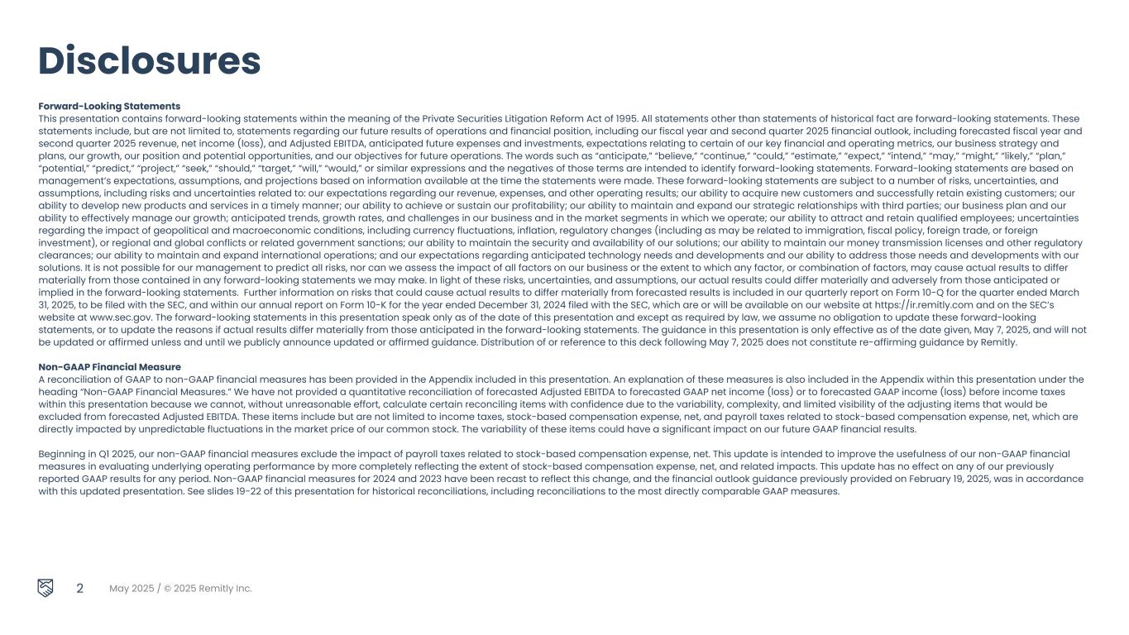
May 2025 / © 2025 Remitly Inc. 2 Forward-Looking Statements This presentation contains forward-looking statements within the meaning of the Private Securities Litigation Reform Act of 1995. All statements other than statements of historical fact are forward-looking statements. These statements include, but are not limited to, statements regarding our future results of operations and financial position, including our fiscal year and second quarter 2025 financial outlook, including forecasted fiscal year and second quarter 2025 revenue, net income (loss), and Adjusted EBITDA, anticipated future expenses and investments, expectations relating to certain of our key financial and operating metrics, our business strategy and plans, our growth, our position and potential opportunities, and our objectives for future operations. The words such as “anticipate,” “believe,” “continue,” “could,” “estimate,” “expect,” “intend,” “may,” “might,” “likely,” “plan,” “potential,” “predict,” “project,” “seek,” “should,” “target,” “will,” “would,” or similar expressions and the negatives of those terms are intended to identify forward-looking statements. Forward-looking statements are based on management’s expectations, assumptions, and projections based on information available at the time the statements were made. These forward-looking statements are subject to a number of risks, uncertainties, and assumptions, including risks and uncertainties related to: our expectations regarding our revenue, expenses, and other operating results; our ability to acquire new customers and successfully retain existing customers; our ability to develop new products and services in a timely manner; our ability to achieve or sustain our profitability; our ability to maintain and expand our strategic relationships with third parties; our business plan and our ability to effectively manage our growth; anticipated trends, growth rates, and challenges in our business and in the market segments in which we operate; our ability to attract and retain qualified employees; uncertainties regarding the impact of geopolitical and macroeconomic conditions, including currency fluctuations, inflation, regulatory changes (including as may be related to immigration, fiscal policy, foreign trade, or foreign investment), or regional and global conflicts or related government sanctions; our ability to maintain the security and availability of our solutions; our ability to maintain our money transmission licenses and other regulatory clearances; our ability to maintain and expand international operations; and our expectations regarding anticipated technology needs and developments and our ability to address those needs and developments with our solutions. It is not possible for our management to predict all risks, nor can we assess the impact of all factors on our business or the extent to which any factor, or combination of factors, may cause actual results to differ materially from those contained in any forward-looking statements we may make. In light of these risks, uncertainties, and assumptions, our actual results could differ materially and adversely from those anticipated or implied in the forward-looking statements. Further information on risks that could cause actual results to differ materially from forecasted results is included in our quarterly report on Form 10-Q for the quarter ended March 31, 2025, to be filed with the SEC, and within our annual report on Form 10-K for the year ended December 31, 2024 filed with the SEC, which are or will be available on our website at https://ir.remitly.com and on the SEC’s website at www.sec.gov. The forward-looking statements in this presentation speak only as of the date of this presentation and except as required by law, we assume no obligation to update these forward-looking statements, or to update the reasons if actual results differ materially from those anticipated in the forward-looking statements. The guidance in this presentation is only effective as of the date given, May 7, 2025, and will not be updated or affirmed unless and until we publicly announce updated or affirmed guidance. Distribution of or reference to this deck following May 7, 2025 does not constitute re-affirming guidance by Remitly. Non-GAAP Financial Measure A reconciliation of GAAP to non-GAAP financial measures has been provided in the Appendix included in this presentation. An explanation of these measures is also included in the Appendix within this presentation under the heading “Non-GAAP Financial Measures.” We have not provided a quantitative reconciliation of forecasted Adjusted EBITDA to forecasted GAAP net income (loss) or to forecasted GAAP income (loss) before income taxes within this presentation because we cannot, without unreasonable effort, calculate certain reconciling items with confidence due to the variability, complexity, and limited visibility of the adjusting items that would be excluded from forecasted Adjusted EBITDA. These items include but are not limited to income taxes, stock-based compensation expense, net, and payroll taxes related to stock-based compensation expense, net, which are directly impacted by unpredictable fluctuations in the market price of our common stock. The variability of these items could have a significant impact on our future GAAP financial results. Beginning in Q1 2025, our non-GAAP financial measures exclude the impact of payroll taxes related to stock-based compensation expense, net. This update is intended to improve the usefulness of our non-GAAP financial measures in evaluating underlying operating performance by more completely reflecting the extent of stock-based compensation expense, net, and related impacts. This update has no effect on any of our previously reported GAAP results for any period. Non-GAAP financial measures for 2024 and 2023 have been recast to reflect this change, and the financial outlook guidance previously provided on February 19, 2025, was in accordance with this updated presentation. See slides 19-22 of this presentation for historical reconciliations, including reconciliations to the most directly comparable GAAP measures. Disclosures


1Q Strategic Overview Matt Oppenheimer Co-Founder & CEO 3 May 2025 / © 2025 Remitly Inc.

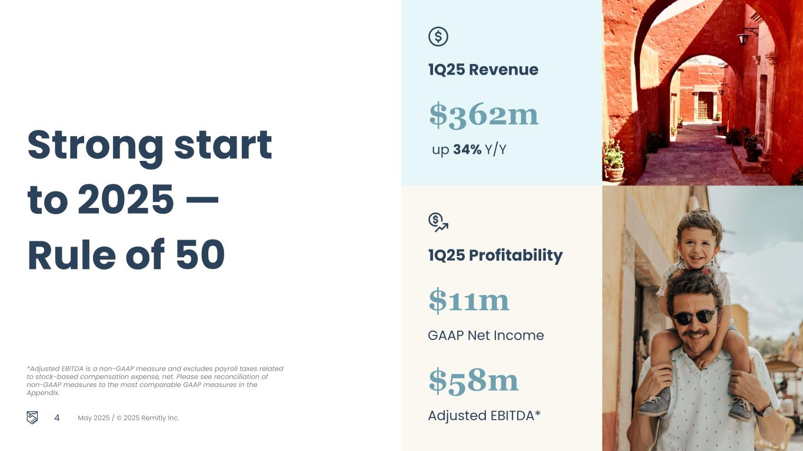
May 2025 / © 2025 Remitly Inc. 1Q25 Revenue Strong start to 2025 — Rule of 50 1Q25 Profitability *Adjusted EBITDA is a non-GAAP measure and excludes payroll taxes related to stock-based compensation expense, net. Please see reconciliation of non-GAAP measures to the most comparable GAAP measures in the Appendix. $362m up 34% Y/Y $11m GAAP Net Income $58m Adjusted EBITDA*4


May 2025 / © 2025 Remitly Inc. 5 1. Remitly internal data for 1Q 2025. 2. Disbursement speed reflects the time between when Remitly has the customer funds and when the funds are successfully disbursed (e.g., completed or available for pickup). Delivering durable growth and profitability Diversification Resilience Trust

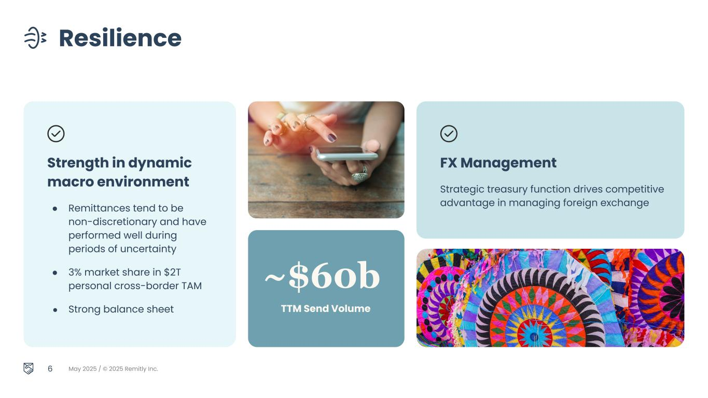
May 2025 / © 2025 Remitly Inc. 6 Resilience ~$60b TTM Send Volume FX Management Strategic treasury function drives competitive advantage in managing foreign exchange Strength in dynamic macro environment ● Remittances tend to be non-discretionary and have performed well during periods of uncertainty ● 3% market share in $2T personal cross-border TAM ● Strong balance sheet


May 2025 / © 2025 Remitly Inc. 45%+ Y/Y growth in send volume from transactions >$1K1 New use cases Microbusiness and WhatsApp experience attract new customers 7 Diversification Network expansion drives better experience with lower costs ● Disbursement - Plin, Orange Money, MACH, Vodafone Cash ● Pay in - Interac in Canada, PayTo in Australia, and Pay by Bank via Plaid in the U.S5,200+ Corridors 1. Remitly internal data for 1Q 2025

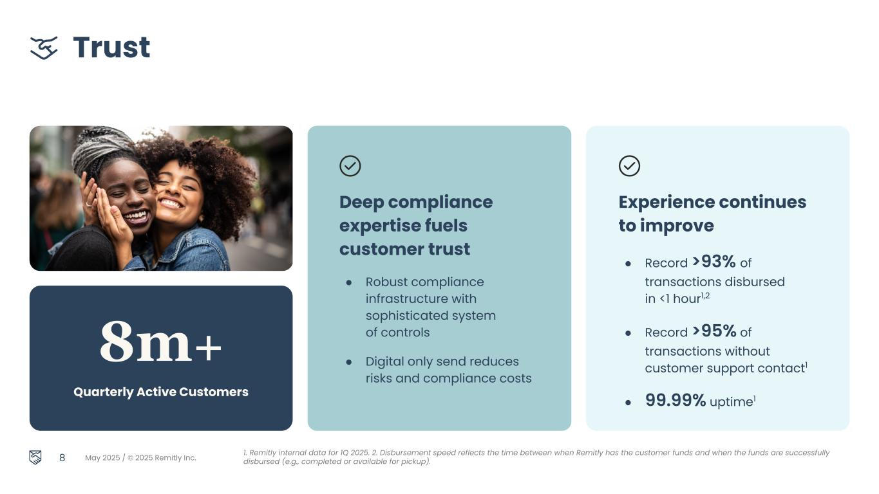
May 2025 / © 2025 Remitly Inc. 8m+ Quarterly Active Customers 8 Trust Experience continues to improve ● Record >93% of transactions disbursed in <1 hour1,2 ● Record >95% of transactions without customer support contact1 ● 99.99% uptime1 1. Remitly internal data for 1Q 2025. 2. Disbursement speed reflects the time between when Remitly has the customer funds and when the funds are successfully disbursed (e.g., completed or available for pickup). Deep compliance expertise fuels customer trust ● Robust compliance infrastructure with sophisticated system of controls ● Digital only send reduces risks and compliance costs


May 2025 / © 2025 Remitly Inc. Our Vision Transform lives with trusted financial services that transcend borders 9


1Q Financial Results Vikas Mehta CFO 10 May 2025 / © 2025 Remitly Inc.

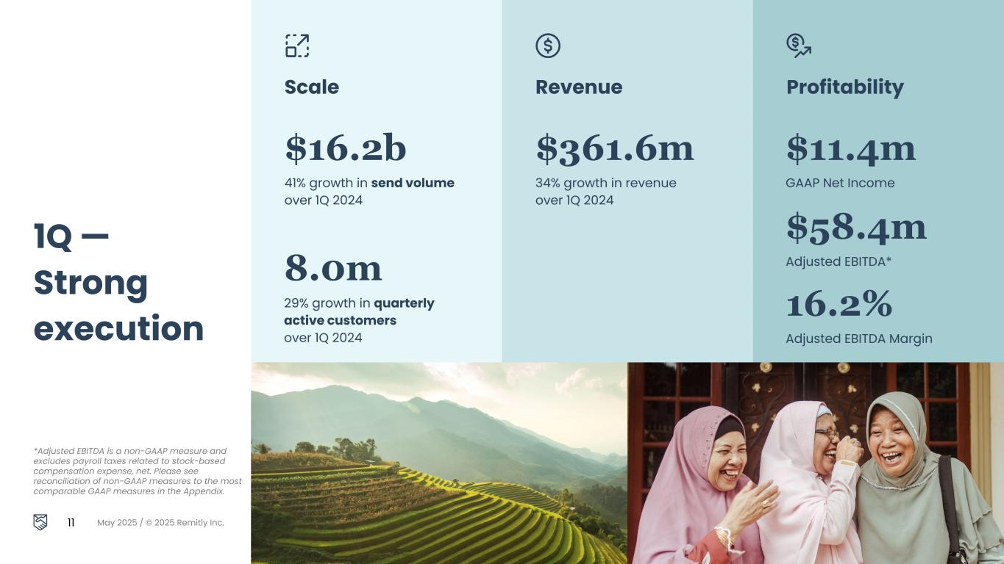
Revenue ProfitabilityScale 1Q — Strong execution *Adjusted EBITDA is a non-GAAP measure and excludes payroll taxes related to stock-based compensation expense, net. Please see reconciliation of non-GAAP measures to the most comparable GAAP measures in the Appendix. 11 May 2025 / © 2025 Remitly Inc. 8.0m 29% growth in quarterly active customers over 1Q 2024 $16.2b 41% growth in send volume over 1Q 2024 $361.6m 34% growth in revenue over 1Q 2024 $58.4m Adjusted EBITDA* $11.4m GAAP Net Income 16.2% Adjusted EBITDA Margin

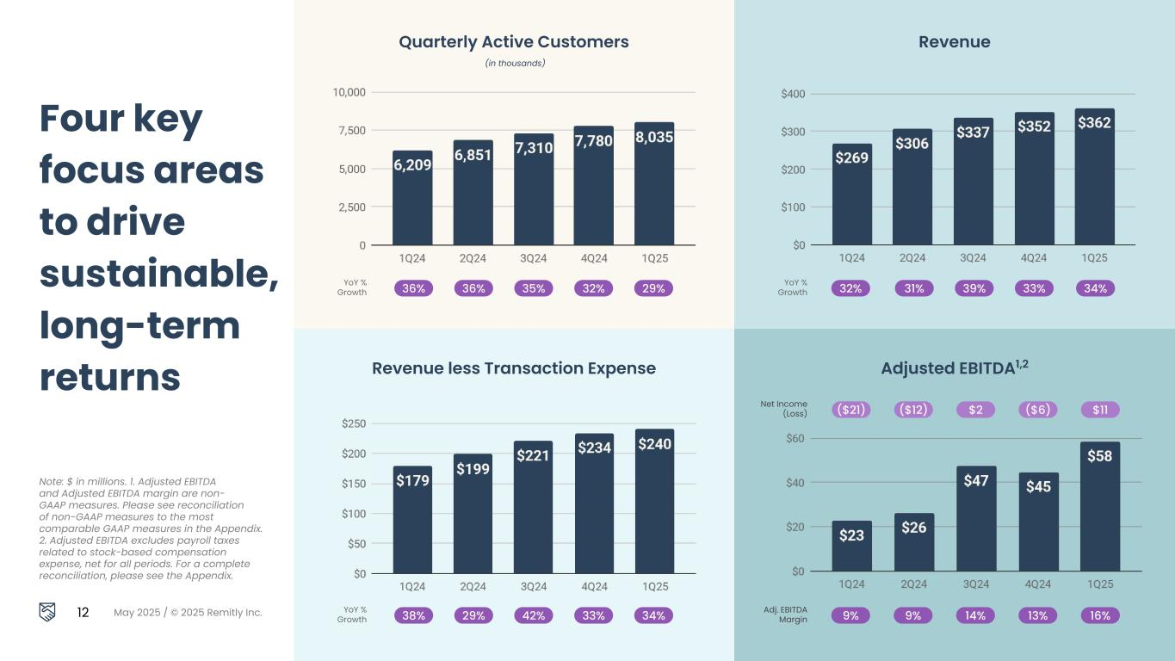
Four key focus areas to drive sustainable, long-term returns Note: $ in millions. 1. Adjusted EBITDA and Adjusted EBITDA margin are non- GAAP measures. Please see reconciliation of non-GAAP measures to the most comparable GAAP measures in the Appendix. 2. Adjusted EBITDA excludes payroll taxes related to stock-based compensation expense, net for all periods. For a complete reconciliation, please see the Appendix. 12 May 2025 / © 2025 Remitly Inc. Quarterly Active Customers (in thousands) Revenue Revenue less Transaction Expense Adjusted EBITDA1,2 YoY % Growth 36% 36% 35% 32% 29% YoY % Growth 38% 29% 42% 33% 34% YoY % Growth 32% 31% 39% 33% 34% Adj. EBITDA Margin 9% 9% 14% 13% 16% Net Income (Loss) ($21) ($12) $2 ($6) $11

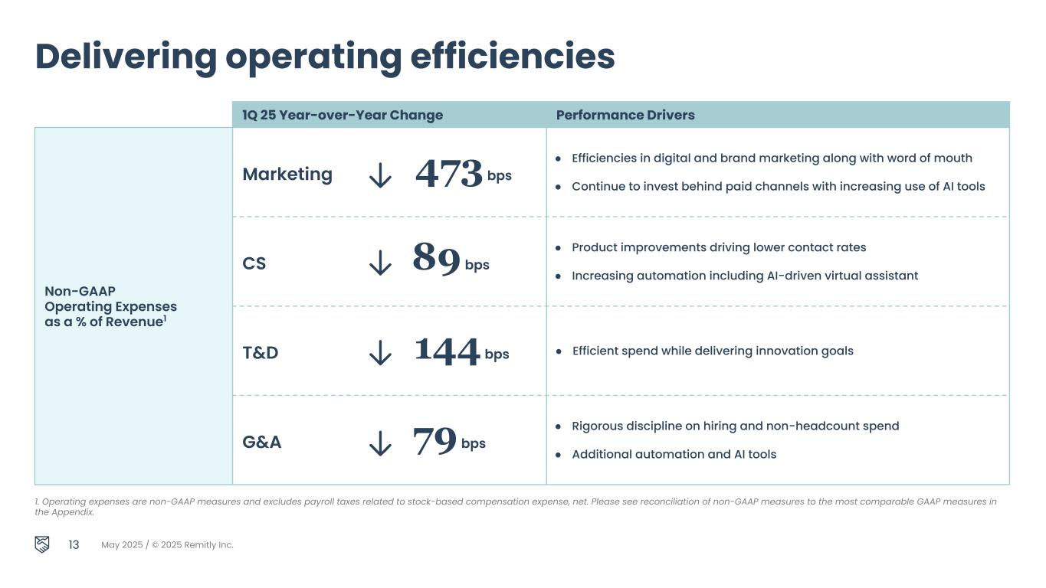
May 2025 / © 2025 Remitly Inc. 13 Delivering operating efficiencies 1Q 25 Year-over-Year Change Performance Drivers Non-GAAP Operating Expenses as a % of Revenue1 Marketing 473 bps ● Efficiencies in digital and brand marketing along with word of mouth ● Continue to invest behind paid channels with increasing use of AI tools CS 89 bps ● Product improvements driving lower contact rates ● Increasing automation including AI-driven virtual assistant T&D 144 bps ● Efficient spend while delivering innovation goals G&A 79 bps ● Rigorous discipline on hiring and non-headcount spend ● Additional automation and AI tools 1. Operating expenses are non-GAAP measures and excludes payroll taxes related to stock-based compensation expense, net. Please see reconciliation of non-GAAP measures to the most comparable GAAP measures in the Appendix.

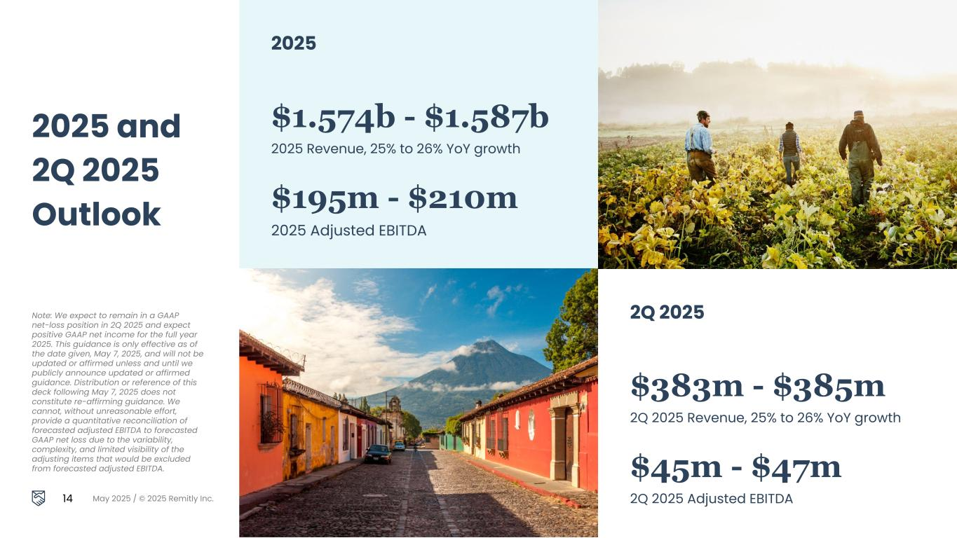
Note: We expect to remain in a GAAP net-loss position in 2Q 2025 and expect positive GAAP net income for the full year 2025. This guidance is only effective as of the date given, May 7, 2025, and will not be updated or affirmed unless and until we publicly announce updated or affirmed guidance. Distribution or reference of this deck following May 7, 2025 does not constitute re-affirming guidance. We cannot, without unreasonable effort, provide a quantitative reconciliation of forecasted adjusted EBITDA to forecasted GAAP net loss due to the variability, complexity, and limited visibility of the adjusting items that would be excluded from forecasted adjusted EBITDA. 14 May 2025 / © 2025 Remitly Inc. 2025 and 2Q 2025 Outlook 2025 $1.574b - $1.587b 2025 Revenue, 25% to 26% YoY growth $195m - $210m 2025 Adjusted EBITDA 2Q 2025 $383m - $385m 2Q 2025 Revenue, 25% to 26% YoY growth $45m - $47m 2Q 2025 Adjusted EBITDA


Q & A 15 May 2025 / © 2025 Remitly Inc.


16 May 2025 / © 2025 Remitly Inc. I’ve found Remitly to be perfect and quick. Ajai Sends money from UK to India & UK to USA “


Appendix 17 May 2025 / © 2025 Remitly Inc.

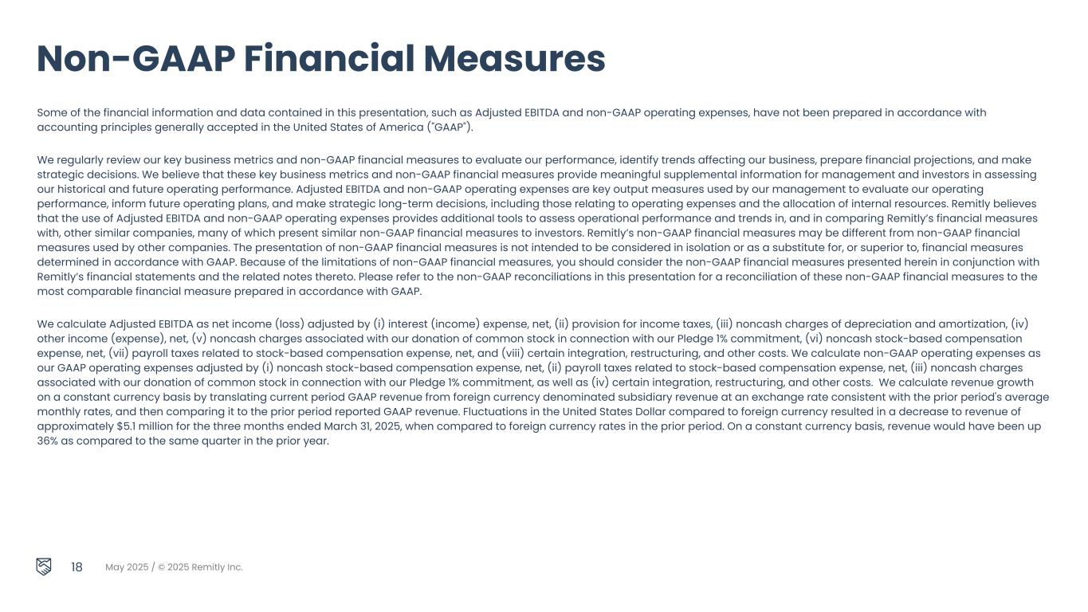
May 2025 / © 2025 Remitly Inc. 18 Some of the financial information and data contained in this presentation, such as Adjusted EBITDA and non-GAAP operating expenses, have not been prepared in accordance with accounting principles generally accepted in the United States of America ("GAAP"). We regularly review our key business metrics and non-GAAP financial measures to evaluate our performance, identify trends affecting our business, prepare financial projections, and make strategic decisions. We believe that these key business metrics and non-GAAP financial measures provide meaningful supplemental information for management and investors in assessing our historical and future operating performance. Adjusted EBITDA and non-GAAP operating expenses are key output measures used by our management to evaluate our operating performance, inform future operating plans, and make strategic long-term decisions, including those relating to operating expenses and the allocation of internal resources. Remitly believes that the use of Adjusted EBITDA and non-GAAP operating expenses provides additional tools to assess operational performance and trends in, and in comparing Remitly’s financial measures with, other similar companies, many of which present similar non-GAAP financial measures to investors. Remitly’s non-GAAP financial measures may be different from non-GAAP financial measures used by other companies. The presentation of non-GAAP financial measures is not intended to be considered in isolation or as a substitute for, or superior to, financial measures determined in accordance with GAAP. Because of the limitations of non-GAAP financial measures, you should consider the non-GAAP financial measures presented herein in conjunction with Remitly’s financial statements and the related notes thereto. Please refer to the non-GAAP reconciliations in this presentation for a reconciliation of these non-GAAP financial measures to the most comparable financial measure prepared in accordance with GAAP. We calculate Adjusted EBITDA as net income (loss) adjusted by (i) interest (income) expense, net, (ii) provision for income taxes, (iii) noncash charges of depreciation and amortization, (iv) other income (expense), net, (v) noncash charges associated with our donation of common stock in connection with our Pledge 1% commitment, (vi) noncash stock-based compensation expense, net, (vii) payroll taxes related to stock-based compensation expense, net, and (viii) certain integration, restructuring, and other costs. We calculate non-GAAP operating expenses as our GAAP operating expenses adjusted by (i) noncash stock-based compensation expense, net, (ii) payroll taxes related to stock-based compensation expense, net, (iii) noncash charges associated with our donation of common stock in connection with our Pledge 1% commitment, as well as (iv) certain integration, restructuring, and other costs. We calculate revenue growth on a constant currency basis by translating current period GAAP revenue from foreign currency denominated subsidiary revenue at an exchange rate consistent with the prior period's average monthly rates, and then comparing it to the prior period reported GAAP revenue. Fluctuations in the United States Dollar compared to foreign currency resulted in a decrease to revenue of approximately $5.1 million for the three months ended March 31, 2025, when compared to foreign currency rates in the prior period. On a constant currency basis, revenue would have been up 36% as compared to the same quarter in the prior year. Non-GAAP Financial Measures

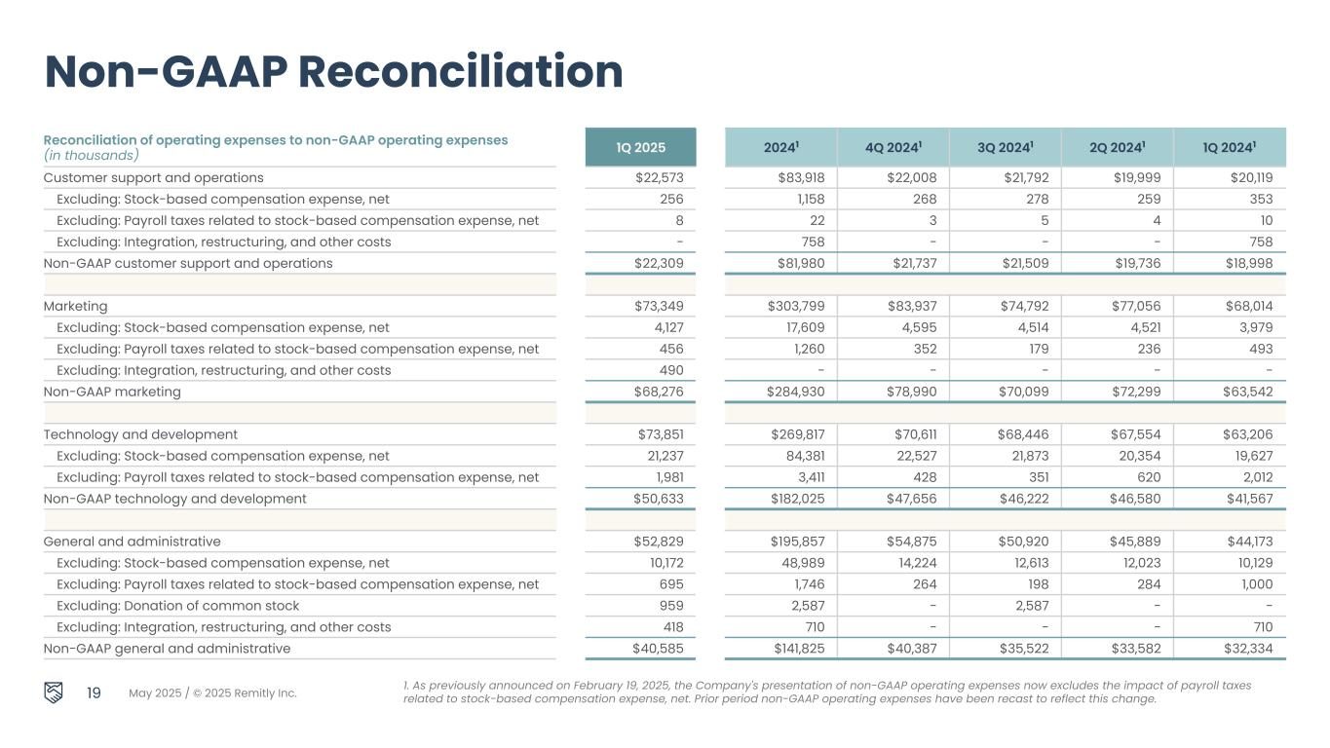
May 2025 / © 2025 Remitly Inc. Reconciliation of operating expenses to non-GAAP operating expenses (in thousands) 1Q 2025 20241 4Q 20241 3Q 20241 2Q 20241 1Q 20241 Customer support and operations $22,573 $83,918 $22,008 $21,792 $19,999 $20,119 Excluding: Stock-based compensation expense, net 256 1,158 268 278 259 353 Excluding: Payroll taxes related to stock-based compensation expense, net 8 22 3 5 4 10 Excluding: Integration, restructuring, and other costs - 758 - - - 758 Non-GAAP customer support and operations $22,309 $81,980 $21,737 $21,509 $19,736 $18,998 Marketing $73,349 $303,799 $83,937 $74,792 $77,056 $68,014 Excluding: Stock-based compensation expense, net 4,127 17,609 4,595 4,514 4,521 3,979 Excluding: Payroll taxes related to stock-based compensation expense, net 456 1,260 352 179 236 493 Excluding: Integration, restructuring, and other costs 490 - - - - - Non-GAAP marketing $68,276 $284,930 $78,990 $70,099 $72,299 $63,542 Technology and development $73,851 $269,817 $70,611 $68,446 $67,554 $63,206 Excluding: Stock-based compensation expense, net 21,237 84,381 22,527 21,873 20,354 19,627 Excluding: Payroll taxes related to stock-based compensation expense, net 1,981 3,411 428 351 620 2,012 Non-GAAP technology and development $50,633 $182,025 $47,656 $46,222 $46,580 $41,567 General and administrative $52,829 $195,857 $54,875 $50,920 $45,889 $44,173 Excluding: Stock-based compensation expense, net 10,172 48,989 14,224 12,613 12,023 10,129 Excluding: Payroll taxes related to stock-based compensation expense, net 695 1,746 264 198 284 1,000 Excluding: Donation of common stock 959 2,587 - 2,587 - - Excluding: Integration, restructuring, and other costs 418 710 - - - 710 Non-GAAP general and administrative $40,585 $141,825 $40,387 $35,522 $33,582 $32,334 19 Non-GAAP Reconciliation 1. As previously announced on February 19, 2025, the Company's presentation of non-GAAP operating expenses now excludes the impact of payroll taxes related to stock-based compensation expense, net. Prior period non-GAAP operating expenses have been recast to reflect this change.

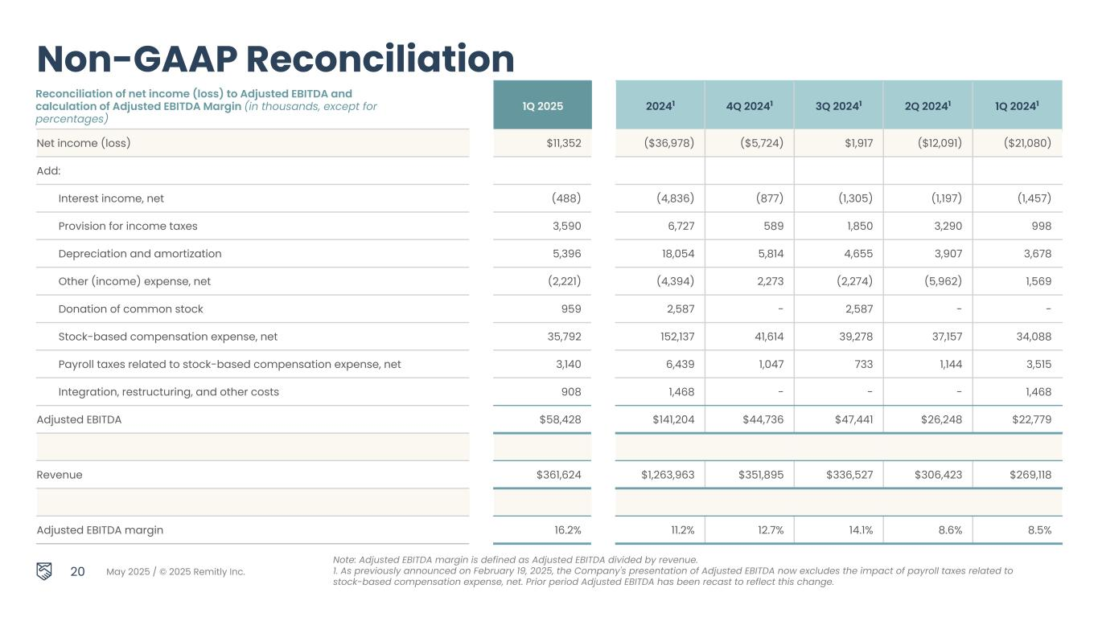
May 2025 / © 2025 Remitly Inc. Reconciliation of net income (loss) to Adjusted EBITDA and calculation of Adjusted EBITDA Margin (in thousands, except for percentages) 1Q 2025 20241 4Q 20241 3Q 20241 2Q 20241 1Q 20241 20 Non-GAAP Reconciliation Net income (loss) $11,352 ($36,978) ($5,724) $1,917 ($12,091) ($21,080) Add: Interest income, net (488) (4,836) (877) (1,305) (1,197) (1,457) Provision for income taxes 3,590 6,727 589 1,850 3,290 998 Depreciation and amortization 5,396 18,054 5,814 4,655 3,907 3,678 Other (income) expense, net (2,221) (4,394) 2,273 (2,274) (5,962) 1,569 Donation of common stock 959 2,587 - 2,587 - - Stock-based compensation expense, net 35,792 152,137 41,614 39,278 37,157 34,088 Payroll taxes related to stock-based compensation expense, net 3,140 6,439 1,047 733 1,144 3,515 Integration, restructuring, and other costs 908 1,468 - - - 1,468 Adjusted EBITDA $58,428 $141,204 $44,736 $47,441 $26,248 $22,779 Revenue $361,624 $1,263,963 $351,895 $336,527 $306,423 $269,118 Adjusted EBITDA margin 16.2% 11.2% 12.7% 14.1% 8.6% 8.5% Note: Adjusted EBITDA margin is defined as Adjusted EBITDA divided by revenue. 1. As previously announced on February 19, 2025, the Company's presentation of Adjusted EBITDA now excludes the impact of payroll taxes related to stock-based compensation expense, net. Prior period Adjusted EBITDA has been recast to reflect this change.

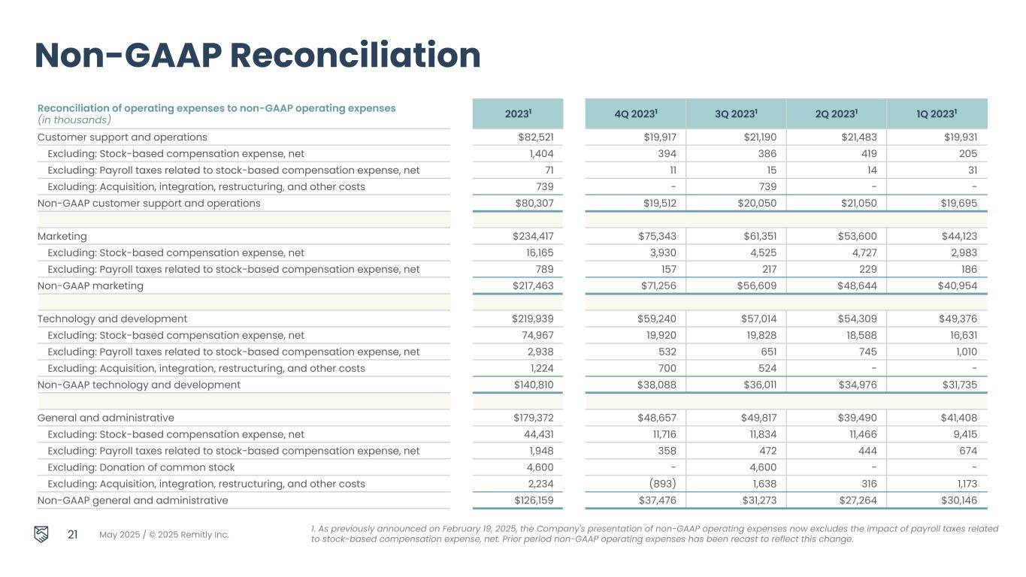
May 2025 / © 2025 Remitly Inc. Reconciliation of operating expenses to non-GAAP operating expenses (in thousands) 20231 4Q 20231 3Q 20231 2Q 20231 1Q 20231 Customer support and operations $82,521 $19,917 $21,190 $21,483 $19,931 Excluding: Stock-based compensation expense, net 1,404 394 386 419 205 Excluding: Payroll taxes related to stock-based compensation expense, net 71 11 15 14 31 Excluding: Acquisition, integration, restructuring, and other costs 739 - 739 - - Non-GAAP customer support and operations $80,307 $19,512 $20,050 $21,050 $19,695 Marketing $234,417 $75,343 $61,351 $53,600 $44,123 Excluding: Stock-based compensation expense, net 16,165 3,930 4,525 4,727 2,983 Excluding: Payroll taxes related to stock-based compensation expense, net 789 157 217 229 186 Non-GAAP marketing $217,463 $71,256 $56,609 $48,644 $40,954 Technology and development $219,939 $59,240 $57,014 $54,309 $49,376 Excluding: Stock-based compensation expense, net 74,967 19,920 19,828 18,588 16,631 Excluding: Payroll taxes related to stock-based compensation expense, net 2,938 532 651 745 1,010 Excluding: Acquisition, integration, restructuring, and other costs 1,224 700 524 - - Non-GAAP technology and development $140,810 $38,088 $36,011 $34,976 $31,735 General and administrative $179,372 $48,657 $49,817 $39,490 $41,408 Excluding: Stock-based compensation expense, net 44,431 11,716 11,834 11,466 9,415 Excluding: Payroll taxes related to stock-based compensation expense, net 1,948 358 472 444 674 Excluding: Donation of common stock 4,600 - 4,600 - - Excluding: Acquisition, integration, restructuring, and other costs 2,234 (893) 1,638 316 1,173 Non-GAAP general and administrative $126,159 $37,476 $31,273 $27,264 $30,146 21 Non-GAAP Reconciliation 1. As previously announced on February 19, 2025, the Company's presentation of non-GAAP operating expenses now excludes the impact of payroll taxes related to stock-based compensation expense, net. Prior period non-GAAP operating expenses has been recast to reflect this change.

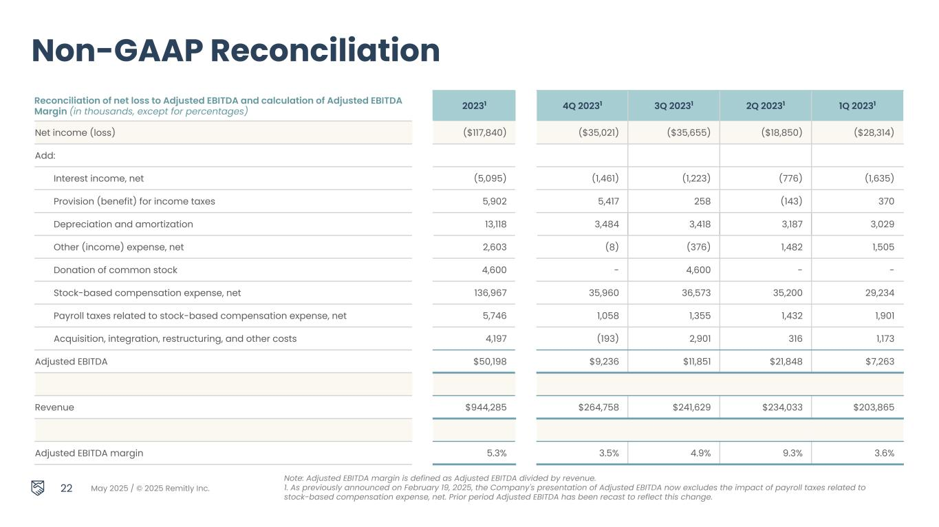
May 2025 / © 2025 Remitly Inc. 22 Non-GAAP Reconciliation Note: Adjusted EBITDA margin is defined as Adjusted EBITDA divided by revenue. 1. As previously announced on February 19, 2025, the Company's presentation of Adjusted EBITDA now excludes the impact of payroll taxes related to stock-based compensation expense, net. Prior period Adjusted EBITDA has been recast to reflect this change. Reconciliation of net loss to Adjusted EBITDA and calculation of Adjusted EBITDA Margin (in thousands, except for percentages) 20231 4Q 20231 3Q 20231 2Q 20231 1Q 20231 Net income (loss) ($117,840) ($35,021) ($35,655) ($18,850) ($28,314) Add: Interest income, net (5,095) (1,461) (1,223) (776) (1,635) Provision (benefit) for income taxes 5,902 5,417 258 (143) 370 Depreciation and amortization 13,118 3,484 3,418 3,187 3,029 Other (income) expense, net 2,603 (8) (376) 1,482 1,505 Donation of common stock 4,600 - 4,600 - - Stock-based compensation expense, net 136,967 35,960 36,573 35,200 29,234 Payroll taxes related to stock-based compensation expense, net 5,746 1,058 1,355 1,432 1,901 Acquisition, integration, restructuring, and other costs 4,197 (193) 2,901 316 1,173 Adjusted EBITDA $50,198 $9,236 $11,851 $21,848 $7,263 Revenue $944,285 $264,758 $241,629 $234,033 $203,865 Adjusted EBITDA margin 5.3% 3.5% 4.9% 9.3% 3.6%


Thank you.

