UNITED STATES
SECURITIES AND EXCHANGE COMMISSION
WASHINGTON, D.C. 20549

FORM 8-K

CURRENT REPORT
Pursuant to Section 13 or 15(d) of the Securities Exchange Act of 1934
Date of Report (Date of earliest event reported): August 5, 2026

Remitly Global, Inc.
(Exact name of registrant as specified in its charter)

Delaware |  |  | 001-40822 |  |  | 83-2301143
(State or other jurisdiction  of incorporation) |  |  | (Commission File Number) |  |  | (I.R.S. Employer  Identification No.)
401 Union Street, Suite 1000
Seattle, WA 98101
(Address of Principal Executive Offices and Zip Code)
(888) 736-4859
(Registrant’s Telephone Number, Including Area Code)
Not Applicable
(Former Name or Former Address, if Changed Since Last Report)

Check the appropriate box below if the Form 8-K filing is intended to simultaneously satisfy the filing obligation of the registrant under any of the following provisions (see General Instructions A.2. below):
☐ Written communications pursuant to Rule 425 under the Securities Act (17 CFR 230.425)
☐ Soliciting material pursuant to Rule 14a-12 under the Exchange Act (17 CFR 240.14a-12)
☐ Pre-commencement communications pursuant to Rule 14d-2(b) under the Exchange Act (17 CFR 240.14d-2(b))
☐ Pre-commencement communications pursuant to Rule 13e-4(c) under the Exchange Act (17 CFR 240.13e-4(c))
Securities registered pursuant to Section 12(b) of the Act:
Title of each class |  |  |  |  |  | Trading Symbol(s) |  |  |  |  |  | Name of each exchange on which registered
Common Stock, par value $0.0001 per share |  |  |  |  |  | RELY |  |  |  |  |  | The NASDAQ Global Select Market
Indicate by check mark whether the registrant is an emerging growth company as defined in Rule 405 of the Securities Act of 1933 (§230.405 of this chapter) or Rule 12b-2 of the Securities Exchange Act of 1934 (§240.12b-2 of this chapter).
Emerging growth company ☐
If an emerging growth company, indicate by check mark if the registrant has elected not to use the extended transition period for complying with any new or revised financial accounting standards provided pursuant to Section 13(a) of the Exchange Act. ☐

1

Item 2.02 Results of Operations and Financial Condition.
On August 5, 2026, Remitly Global, Inc. (the “Company”) issued a press release announcing its financial results for the fiscal quarter ended June 30, 2026. A copy of the press release is furnished as Exhibit 99.1 hereto and is incorporated by reference herein.

Item 7.01 Regulation FD Disclosure.
On August 5, 2026, the Company provided an investor presentation that will be made available on the investor relations section of the Company’s website at https://ir.remitly.com/. The investor presentation is furnished as Exhibit 99.2 hereto and is incorporated by reference herein.
The information in Items 2.02 and 7.01 of this Current Report, including the accompanying Exhibit 99.1 and Exhibit 99.2, is being furnished and shall not be deemed “filed” for the purposes of Section 18 of the Securities Exchange Act of 1934, as amended (the “Exchange Act”), or otherwise subject to the liabilities of Section 18. The information in Items 2.02 and 7.01 of this Current Report, including the accompanying Exhibit 99.1 and Exhibit 99.2, shall not be incorporated by reference into any registration statement or other document filed pursuant to the Securities Act of 1933, as amended, or the Exchange Act, regardless of any general incorporation language contained in such filing.

Item 9.01 Financial Statements and Exhibits.
(d) Exhibits
Exhibit No. |  |  | Description
99.1 |  |  | Press Release dated August 5, 2026
99.2 |  |  | Investor Presentation dated August 5, 2026
104 |  |  | Cover page interactive data file (embedded with the inline XBRL document)

2

SIGNATURES
Pursuant to the requirements of the Securities Exchange Act of 1934, the registrant has duly caused this report to be signed on its behalf by the undersigned thereunto duly authorized.
 |  |  | Remitly Global, Inc.
Date: August 5, 2026 |  |  | By: |  |  | /s/ Vikas Mehta
 |  |  |  |  |  | Vikas Mehta
 |  |  |  |  |  | Chief Financial Officer
 |  |  |  |  |  | (Principal Financial Officer)
Date: August 5, 2026 |  |  | By: |  |  | /s/ Tai-Hong Fung
 |  |  |  |  |  | Tai-Hong Fung
 |  |  |  |  |  | Chief Accounting Officer
 |  |  |  |  |  | (Principal Accounting Officer)

3

Remitly Reports Record Second Quarter Results and Raises Full Year 2026 Outlook
Quarterly Active Customers surpass 10 million
Second quarter send volume up 27% and revenue up 20% year over year
Second quarter net income of $205.9 million, inclusive of a $140.6 million discrete tax benefit
Adjusted EBITDA of $114.7 million up 79% year over year

SEATTLE, WA / August 5, 2026 / GlobeNewswire / - Remitly Global, Inc. (NASDAQ: RELY), a trusted provider of financial services that transcend borders, reported results for the second quarter ended June 30, 2026.
“We delivered another excellent quarter, achieving record revenue, Adjusted EBITDA, and net income, while surpassing 10 million quarterly active customers for the first time in our company's history, a direct reflection of the trust and confidence customers place in Remitly,” said Sebastian Gunningham, Chief Executive Officer. “Our results reflect the compounding advantages of a trusted global network, a strategy that resonates with customers, and rigorous cost discipline. AI-driven operating efficiencies are creating additional capacity to invest in growth while improving margins, giving us more confidence in the opportunities ahead.”

Second Quarter 2026 Highlights and Key Operating Data
(All comparisons relative to the second quarter of 2025)
•Active customers increased to 10.2 million, compared to 8.5 million, up 20%.
•Send volume increased to $23.5 billion, compared to $18.5 billion, up 27%.
•Revenue totaled $495.2 million, compared to $411.9 million, up 20%.
•Net income was $205.9 million, inclusive of a $140.6 million discrete tax benefit from the U.S. valuation allowance release.
•Adjusted EBITDA was $114.7 million, compared to $64.0 million, up 79%.

2026 Financial Outlook
For fiscal year 2026, Remitly currently expects:
•Total revenue in the range of $1.978 billion to $1.988 billion, representing a growth rate of 21% to 22% year over year.
•Year over year growth in net income, and Adjusted EBITDA in the range of $410 million to $415 million.
For the third quarter of 2026, Remitly currently expects:
•Total revenue in the range of $505 million to $507 million, representing a growth rate of 20% to 21% year over year.
•Year over year growth in net income, and Adjusted EBITDA in the range of $92 million to $94 million.
Reconciliation of GAAP to Non-GAAP Financial Measures
A reconciliation of accounting principles generally accepted in the United States of America (“GAAP”) to non-GAAP financial measures has been provided in the financial statement tables included in this earnings release. An explanation of these measures is also included below under the heading “Non-GAAP Financial Measures.” We have not provided a quantitative reconciliation of forecasted Adjusted EBITDA to forecasted GAAP net income (loss) or to forecasted GAAP income (loss) before income taxes within this earnings release because we cannot, without unreasonable effort, calculate certain reconciling items with confidence due to the variability, complexity, and limited visibility of the adjusting items that would be excluded from forecasted Adjusted EBITDA. These items include, but are not limited to, income taxes, stock-based compensation expense, and payroll taxes related to stock-based compensation expense, which are directly impacted by unpredictable fluctuations in the market price of our common stock. The variability of these items could have a significant impact on our future GAAP financial results.
Note: All percentage changes described within this press release are calculated using amounts in the Company’s Annual Reports on Form 10-K and Quarterly Reports on Form 10-Q filed with the Securities and Exchange Commission (the “SEC”), for which revenue and active customers are presented in thousands and send volume is presented in millions. Rounding differences may occur when individually calculating percentages or totals from rounded amounts included within the press release body as compared to the amounts included within the Company’s SEC filings.

1
Webcast Information
Remitly will host a webcast at 5:00 p.m. Eastern Time on Wednesday, August 5, 2026, to discuss its second quarter 2026 financial results. The live webcast and investor presentation will be accessible on Remitly’s website at https://ir.remitly.com. A webcast replay will be available on our website at https://ir.remitly.com following the live event.
We have used, and intend to continue to use, the Investor Relations section of our website at https://ir.remitly.com as a means of disclosing material nonpublic information and for complying with our disclosure obligations under Regulation FD (Fair Disclosure).

Non-GAAP Financial Measures
Some of the financial information and data contained in this earnings release, such as Adjusted EBITDA, non-GAAP operating expenses, transaction margin dollars, transaction margin, and free cash flow, have not been prepared in accordance with GAAP.
We regularly review our key business metrics and non-GAAP financial measures to evaluate our performance, identify trends affecting our business, prepare financial projections, and make strategic decisions. We believe that these key business metrics and non-GAAP financial measures provide meaningful supplemental information for management and investors in assessing our historical and future operating performance. Specifically, the company believes the non-GAAP measures provide useful information to both management and investors by excluding certain items that may not be indicative of its recurring core operating results and business outlook.
Our non-GAAP financial measures may be different from non-GAAP financial measures used by other companies. The presentation of non-GAAP financial measures is not intended to be considered in isolation or as a substitute for, or superior to, financial measures determined in accordance with GAAP. Because of the limitations of non-GAAP financial measures, you should consider the non-GAAP financial measures presented herein in conjunction with our financial statements and the related notes thereto. Please refer to the non-GAAP reconciliations in this press release for a reconciliation of these non-GAAP financial measures to the most comparable financial measure prepared in accordance with GAAP.
We calculate Adjusted EBITDA as net income (loss) adjusted by (i) interest (income) expense, net; (ii) (benefit from) provision for income taxes; (iii) noncash charges of depreciation and amortization; (iv) other (income) expense, net; (v) noncash charges associated with our donation of common stock in connection with our Pledge 1% commitment; (vi) noncash stock-based compensation expense, net; (vii) payroll taxes related to stock-based compensation expense, net; and (viii) certain restructuring and other costs. We calculate non-GAAP operating expenses as our GAAP operating expenses adjusted by (i) noncash stock-based compensation expense, net; (ii) payroll taxes related to stock-based compensation expense, net; (iii) noncash charges associated with our donation of common stock in connection with our Pledge 1% commitment; as well as (iv) certain restructuring and other costs. Adjusted EBITDA and non-GAAP operating expenses are key output measures used by our management to evaluate our operating performance, inform future operating plans, and make strategic long-term decisions, including those relating to operating expenses and the allocation of internal resources. We believe that the use of Adjusted EBITDA and non-GAAP operating expenses provides additional tools to assess operational performance and trends in, and in comparing our financial measures with, other similar companies, many of which present similar non-GAAP financial measures to investors.
We calculate transaction margin dollars as income from operations, excluding expenses related to (i) customer support and operations; (ii) marketing; (iii) technology and development; (iv) general and administrative; and (v) depreciation and amortization. Transaction margin dollars can also be calculated as revenue less transaction expenses. We calculate transaction margin as transaction margin dollars divided by revenue. Transaction margin dollars and transaction margin are non-GAAP financial measures that management uses to evaluate the economic returns generated by the company's platform. We believe that transaction margin dollars provides useful information in understanding and evaluating our financial results.
We calculate free cash flow as net cash provided by operating activities, adjusted for capitalized expenditures that include purchases of property and equipment and capitalized internal-use software. Free cash flow is a key measure used by our management to understand the strength of our liquidity and available cash, and we believe that the presentation of this measure is useful because we are focused on growing our free cash flow generation over time. Free cash flow is not intended to represent the total increase or decrease in our cash balance for the period.

2
Forward-Looking Statements
This press release contains forward-looking statements within the meaning of the Private Securities Litigation Reform Act of 1995. All statements other than statements of historical fact are forward-looking statements. These statements include, but are not limited to, statements regarding future events or our future results of operations and financial position, including our fiscal year and third quarter 2026 financial outlook, including forecasted fiscal year and third quarter 2026 revenue, net income (loss), and Adjusted EBITDA, anticipated future expenses and investments, expectations relating to certain of our key financial and operating metrics, our business strategy and plans, our growth, our position and potential opportunities, and our objectives for future operations. The words such as “anticipate,” “believe,” “continue,” “could,” “estimate,” “expect,” “intend,” “may,” “might,” “likely,” “plan,” “potential,” “predict,” “project,” “seek,” “should,” “target,” “will,” “would,” or similar expressions and the negatives of those terms are intended to identify forward-looking statements. Forward-looking statements are based on management’s expectations, assumptions, and projections based on information available at the time the statements were made. These forward-looking statements are subject to a number of risks, uncertainties, and assumptions, including risks and uncertainties related to our expectations regarding our revenue, expenses, and other operating results; our ability to acquire new customers and successfully retain existing customers; our ability to continue to develop new products and services in a timely manner; our ability to sustain our profitability; our ability to maintain and expand our strategic relationships with third parties; our business plan and our ability to effectively manage our growth; anticipated trends, growth rates, and challenges in our business and in the market segments in which we operate; our ability to effectively integrate and leverage artificial intelligence and machine learning technologies; our ability to attract, integrate, and retain qualified employees, including key members of our management team; uncertainties regarding the impact of geopolitical and macroeconomic conditions, including currency fluctuations, inflation, regulatory changes (including as may be related to immigration, fiscal and tax policy, foreign trade, or foreign investment), regional and global conflicts or related government sanctions, or legislative or regulatory developments; our ability to maintain the security and availability of our solutions; our ability to maintain our money transmission licenses and other regulatory clearances or obtain new licenses and regulatory clearances; our ability to maintain and expand international operations; our expectations regarding anticipated technology needs and developments and our ability to address those needs and developments with our solutions; and our stock repurchase program, the timing and number of shares of our common stock to be repurchased, and the potential benefits thereof. It is not possible for our management to predict all risks, nor can we assess the impact of all factors on our business or the extent to which any factor, or combination of factors, may cause actual results to differ materially from those contained in any forward-looking statements we may make. In light of these risks, uncertainties, and assumptions, our actual results could differ materially and adversely from those anticipated or implied in the forward-looking statements. Further information on risks that could cause actual results to differ materially from forecasted results is included in our quarterly report on Form 10-Q for the quarter ended June 30, 2026, to be filed with the SEC, and within our annual report on Form 10-K for the year ended December 31, 2025, filed with the SEC, which are or will be available on our website at https://ir.remitly.com and on the SEC’s website at www.sec.gov. Except as required by law, we assume no obligation to update these forward-looking statements, or to update the reasons if actual results differ materially from those anticipated in the forward-looking statements.

About Remitly
Remitly is a trusted provider of financial services that transcend borders. With a footprint spanning more than 175 countries, Remitly has built one of the world’s leading global money movement platforms, trusted by millions of customers. Remitly continues to evolve beyond a remittance company into a diversified, cross-border financial services provider, serving both consumers and businesses across a growing set of use cases.

Contacts

Media Inquiries:
press@remitly.com

Investor Relations:
ir@remitly.com

3
REMITLY GLOBAL, INC.
Condensed Consolidated Statements of Operations
(unaudited)

 |  |  | Three Months Ended June 30, |  |  |  |  |  |  |  |  |  |  |  | Six Months Ended June 30,
(in thousands, except per share data) |  |  | 2026 |  |  |  |  |  | 2025 |  |  |  |  |  | 2026 |  |  |  |  |  | 2025
Revenue |  |  | $ | 495,156 |  |  |  |  | $ | 411,852 |  |  |  |  | $ | 947,958 |  |  |  |  | $ | 773,476
Costs and expenses
Transaction expenses(1) |  |  | 161,174 |  |  |  |  |  | 143,756 |  |  |  |  |  | 306,114 |  |  |  |  |  | 265,149
Customer support and operations(1) |  |  | 26,639 |  |  |  |  |  | 25,074 |  |  |  |  |  | 53,450 |  |  |  |  |  | 47,647
Marketing(1) |  |  | 104,388 |  |  |  |  |  | 84,976 |  |  |  |  |  | 190,750 |  |  |  |  |  | 158,325
Technology and development(1) |  |  | 74,049 |  |  |  |  |  | 77,496 |  |  |  |  |  | 153,652 |  |  |  |  |  | 151,347
General and administrative(1) |  |  | 55,918 |  |  |  |  |  | 59,581 |  |  |  |  |  | 111,065 |  |  |  |  |  | 112,410
Depreciation and amortization |  |  | 6,307 |  |  |  |  |  | 6,326 |  |  |  |  |  | 12,506 |  |  |  |  |  | 11,722
Total costs and expenses |  |  | 428,475 |  |  |  |  |  | 397,209 |  |  |  |  |  | 827,537 |  |  |  |  |  | 746,600
Income from operations |  |  | 66,681 |  |  |  |  |  | 14,643 |  |  |  |  |  | 120,421 |  |  |  |  |  | 26,876
Interest income |  |  | 1,485 |  |  |  |  |  | 2,061 |  |  |  |  |  | 3,138 |  |  |  |  |  | 3,848
Interest expense |  |  | (3,152) |  |  |  |  |  | (1,650) |  |  |  |  |  | (5,589) |  |  |  |  |  | (2,949)
Other expense, net |  |  | (370) |  |  |  |  |  | (6,940) |  |  |  |  |  | (1,251) |  |  |  |  |  | (4,719)
Income before (benefit from) provision for income taxes |  |  | 64,644 |  |  |  |  |  | 8,114 |  |  |  |  |  | 116,719 |  |  |  |  |  | 23,056
(Benefit from) provision for income taxes |  |  | (141,264) |  |  |  |  |  | 1,578 |  |  |  |  |  | (138,242) |  |  |  |  |  | 5,168
Net income |  |  | $ | 205,908 |  |  |  |  | $ | 6,536 |  |  |  |  | $ | 254,961 |  |  |  |  | $ | 17,888
Net income per share attributable to common stockholders:
Basic |  |  | $ | 0.98 |  |  |  |  | $ | 0.03 |  |  |  |  | $ | 1.21 |  |  |  |  | $ | 0.09
Diluted |  |  | $ | 0.93 |  |  |  |  | $ | 0.03 |  |  |  |  | $ | 1.16 |  |  |  |  | $ | 0.08
Weighted-average shares used in computing net income per share attributable to common stockholders:
Basic |  |  | 210,839 |  |  |  |  |  | 204,693 |  |  |  |  |  | 210,936 |  |  |  |  |  | 203,227
Diluted |  |  | 221,049 |  |  |  |  |  | 218,978 |  |  |  |  |  | 219,023 |  |  |  |  |  | 218,704
__________
(1) Exclusive of depreciation and amortization, shown separately.

4
REMITLY GLOBAL, INC.
Condensed Consolidated Balance Sheets
(unaudited)

 |  |  | June 30, |  |  |  |  |  | December 31,
(in thousands) |  |  | 2026 |  |  |  |  |  | 2025
Assets
Current assets
Cash and cash equivalents |  |  | $ | 676,394 |  |  |  |  | $ | 542,426
Disbursement prefunding |  |  | 234,640 |  |  |  |  |  | 441,335
Customer funds receivable, net |  |  | 322,019 |  |  |  |  |  | 286,455
Prepaid expenses and other current assets |  |  | 52,894 |  |  |  |  |  | 45,735
Total current assets |  |  | 1,285,947 |  |  |  |  |  | 1,315,951
Property and equipment, net |  |  | 60,097 |  |  |  |  |  | 61,521
Operating lease right-of-use assets |  |  | 9,898 |  |  |  |  |  | 12,452
Goodwill |  |  | 54,940 |  |  |  |  |  | 54,940
Intangible assets, net |  |  | 1,063 |  |  |  |  |  | 2,125
Other noncurrent assets, net |  |  | 155,510 |  |  |  |  |  | 11,724
Total assets |  |  | $ | 1,567,455 |  |  |  |  | $ | 1,458,713
Liabilities and stockholders’ equity
Current liabilities
Accounts payable |  |  | $ | 39,893 |  |  |  |  | $ | 28,450
Customer liabilities |  |  | 195,521 |  |  |  |  |  | 219,667
Short-term debt |  |  | 3,022 |  |  |  |  |  | 2,821
Accrued expenses and other current liabilities |  |  | 158,072 |  |  |  |  |  | 141,948
Operating lease liabilities |  |  | 7,806 |  |  |  |  |  | 6,166
Total current liabilities |  |  | 404,314 |  |  |  |  |  | 399,052
Operating lease liabilities, noncurrent |  |  | 27,436 |  |  |  |  |  | 28,135
Long-term debt |  |  | — |  |  |  |  |  | 155,000
Other noncurrent liabilities |  |  | 8,857 |  |  |  |  |  | 7,737
Total liabilities |  |  | 440,607 |  |  |  |  |  | 589,924
Commitments and contingencies
Stockholders’ equity
Common stock |  |  | 21 |  |  |  |  |  | 21
Additional paid-in capital |  |  | 1,329,975 |  |  |  |  |  | 1,325,520
Accumulated other comprehensive income |  |  | 2,239 |  |  |  |  |  | 3,596
Accumulated deficit |  |  | (205,387) |  |  |  |  |  | (460,348)
Total stockholders’ equity |  |  | 1,126,848 |  |  |  |  |  | 868,789
Total liabilities and stockholders’ equity |  |  | $ | 1,567,455 |  |  |  |  | $ | 1,458,713

5
REMITLY GLOBAL, INC.
Condensed Consolidated Statements of Cash Flows
(unaudited)
 |  |  | Six Months Ended June 30,
(in thousands) |  |  | 2026 |  |  |  |  |  | 2025(1)
Cash flows from operating activities
Net income |  |  | $ | 254,961 |  |  |  |  | $ | 17,888
Adjustments to reconcile net income to net cash provided by operating activities:
Depreciation, amortization, and other |  |  | 25,928 |  |  |  |  |  | 27,641
Deferred income taxes |  |  | (143,856) |  |  |  |  |  | —
Stock-based compensation expense, net |  |  | 62,027 |  |  |  |  |  | 73,858
Donation of common stock |  |  | 1,722 |  |  |  |  |  | 1,866
Changes in operating assets and liabilities:
Prepaid expenses and other assets |  |  | (7,277) |  |  |  |  |  | (19,614)
Operating lease right-of-use assets |  |  | 1,700 |  |  |  |  |  | 3,700
Accounts payable |  |  | 15,965 |  |  |  |  |  | 4,443
Accrued expenses and other liabilities |  |  | 4,930 |  |  |  |  |  | 13,397
Operating lease liabilities |  |  | 412 |  |  |  |  |  | 12,293
Net cash provided by operating activities |  |  | 216,512 |  |  |  |  |  | 135,472
Cash flows from investing activities
Purchases of property and equipment |  |  | (7,171) |  |  |  |  |  | (18,484)
Capitalized internal-use software costs |  |  | (6,531) |  |  |  |  |  | (6,012)
Net (originations) collections from consumer receivables |  |  | (6,613) |  |  |  |  |  | (8,069)
Net cash used in investing activities |  |  | (20,315) |  |  |  |  |  | (32,565)
Cash flows from financing activities
Proceeds from exercise of stock options |  |  | 1,451 |  |  |  |  |  | 4,578
Proceeds from issuance of common stock in connection with ESPP |  |  | 6,340 |  |  |  |  |  | 5,768
Cash paid for repurchase of common stock |  |  | (65,164) |  |  |  |  |  | —
Proceeds from revolving credit facility borrowings |  |  | 5,817,000 |  |  |  |  |  | 2,493,000
Repayments of revolving credit facility borrowings |  |  | (5,972,000) |  |  |  |  |  | (2,493,000)
Net change in customer funds assets and liabilities |  |  | 155,461 |  |  |  |  |  | 38,622
Taxes paid related to net share settlement of equity awards |  |  | (3,727) |  |  |  |  |  | (11,617)
Payment of debt issuance costs |  |  | — |  |  |  |  |  | (2,628)
Net cash (used in) provided by financing activities |  |  | (60,639) |  |  |  |  |  | 34,723
Effect of foreign exchange rate changes on cash, cash equivalents, and restricted cash |  |  | (1,723) |  |  |  |  |  | 10,182
Net increase in cash, cash equivalents, and restricted cash |  |  | 133,835 |  |  |  |  |  | 147,812
Cash, cash equivalents, and restricted cash at beginning of period |  |  | 544,299 |  |  |  |  |  | 369,817
Cash, cash equivalents, and restricted cash at end of period |  |  | $ | 678,134 |  |  |  |  | $ | 517,629
Reconciliation of cash, cash equivalents, and restricted cash
Cash and cash equivalents |  |  | $ | 676,394 |  |  |  |  | $ | 515,896
Restricted cash included in prepaid expenses and other current assets |  |  | 485 |  |  |  |  |  | 664
Restricted cash included in other noncurrent assets, net |  |  | 1,255 |  |  |  |  |  | 1,069
Total cash, cash equivalents, and restricted cash |  |  | $ | 678,134 |  |  |  |  | $ | 517,629
__________
(1) Beginning in the fourth quarter of 2025, the Company changed the presentation of certain cash activity related to customer funds assets and liabilities, which is comprised of disbursement prefunding, customer funds receivable, customer liabilities, and trade settlement liability included within the line item ‘Accrued expenses and other current liabilities’ on the Consolidated Balance Sheets. Certain components of this activity were reclassified from cash flows from operating activities to cash flows from financing activities, reflected within the line item ‘Net change in customer funds assets and liabilities.’

6

REMITLY GLOBAL, INC.
Reconciliation of GAAP to Non-GAAP Financial Measures
(unaudited)

Reconciliation of net income to Adjusted EBITDA:
 |  |  | Three Months Ended June 30, |  |  |  |  |  |  |  |  |  |  |  | Six Months Ended June 30,
(in thousands) |  |  | 2026 |  |  |  |  |  | 2025 |  |  |  |  |  | 2026 |  |  |  |  |  | 2025
Net income |  |  | $ | 205,908 |  |  |  |  | $ | 6,536 |  |  |  |  | $ | 254,961 |  |  |  |  | $ | 17,888
Add:
Interest (income) expense, net |  |  | 1,667 |  |  |  |  |  | (411) |  |  |  |  |  | 2,451 |  |  |  |  |  | (899)
(Benefit from) provision for income taxes |  |  | (141,264) |  |  |  |  |  | 1,578 |  |  |  |  |  | (138,242) |  |  |  |  |  | 5,168
Depreciation and amortization |  |  | 6,307 |  |  |  |  |  | 6,326 |  |  |  |  |  | 12,506 |  |  |  |  |  | 11,722
Other expense, net |  |  | 370 |  |  |  |  |  | 6,940 |  |  |  |  |  | 1,251 |  |  |  |  |  | 4,719
Donation of common stock |  |  | 957 |  |  |  |  |  | 907 |  |  |  |  |  | 1,722 |  |  |  |  |  | 1,866
Stock-based compensation expense, net |  |  | 34,491 |  |  |  |  |  | 38,066 |  |  |  |  |  | 62,027 |  |  |  |  |  | 73,858
Payroll taxes related to stock-based compensation expense, net |  |  | 2,061 |  |  |  |  |  | 1,519 |  |  |  |  |  | 3,833 |  |  |  |  |  | 4,659
Restructuring and other costs(1) |  |  | 4,245 |  |  |  |  |  | 2,536 |  |  |  |  |  | 15,783 |  |  |  |  |  | 3,444
Adjusted EBITDA |  |  | $ | 114,742 |  |  |  |  | $ | 63,997 |  |  |  |  | $ | 216,292 |  |  |  |  | $ | 122,425
__________
(1) Restructuring and other costs for the three and six months ended June 30, 2026 and June 30, 2025 consisted primarily of termination benefits. These costs are not indicative of ongoing operating performance.
Reconciliation of income from operations to transaction margin dollars and transaction margin:
 |  |  | Three Months Ended June 30, |  |  |  |  |  |  |  |  |  |  |  | Six Months Ended June 30,
(in thousands) |  |  | 2026 |  |  |  |  |  | 2025 |  |  |  |  |  | 2026 |  |  |  |  |  | 2025
Income from operations |  |  | $ | 66,681 |  |  |  |  | $ | 14,643 |  |  |  |  | $ | 120,421 |  |  |  |  | $ | 26,876
Add:
Customer support and operations |  |  | 26,639 |  |  |  |  |  | 25,074 |  |  |  |  |  | 53,450 |  |  |  |  |  | 47,647
Marketing |  |  | 104,388 |  |  |  |  |  | 84,976 |  |  |  |  |  | 190,750 |  |  |  |  |  | 158,325
Technology and development |  |  | 74,049 |  |  |  |  |  | 77,496 |  |  |  |  |  | 153,652 |  |  |  |  |  | 151,347
General and administrative |  |  | 55,918 |  |  |  |  |  | 59,581 |  |  |  |  |  | 111,065 |  |  |  |  |  | 112,410
Depreciation and amortization |  |  | 6,307 |  |  |  |  |  | 6,326 |  |  |  |  |  | 12,506 |  |  |  |  |  | 11,722
Transaction margin dollars |  |  | $ | 333,982 |  |  |  |  | $ | 268,096 |  |  |  |  | $ | 641,844 |  |  |  |  | $ | 508,327
Revenue |  |  | $ | 495,156 |  |  |  |  | $ | 411,852 |  |  |  |  | $ | 947,958 |  |  |  |  | $ | 773,476
Transaction margin |  |  | 67 |  | % |  |  |  | 65 |  | % |  |  |  | 68 |  | % |  |  |  | 66 |  | %
Reconciliation of cash flow from operations to free cash flow:
 |  |  | Three Months Ended June 30, |  |  |  |  |  |  |  |  |  |  |  | Six Months Ended June 30,
(in thousands) |  |  | 2026 |  |  |  |  |  | 2025 |  |  |  |  |  | 2026 |  |  |  |  |  | 2025
Net cash provided by operating activities |  |  | $ | 134,620 |  |  |  |  | $ | 54,689 |  |  |  |  | $ | 216,512 |  |  |  |  | $ | 135,472
Less:
Purchases of property and equipment |  |  | (1,184) |  |  |  |  |  | (7,869) |  |  |  |  |  | (7,171) |  |  |  |  |  | (18,484)
Capitalized internal-use software costs |  |  | (3,332) |  |  |  |  |  | (3,063) |  |  |  |  |  | (6,531) |  |  |  |  |  | (6,012)
Free cash flow |  |  | $ | 130,104 |  |  |  |  | $ | 43,757 |  |  |  |  | $ | 202,810 |  |  |  |  | $ | 110,976

7
Reconciliation of operating expenses to non-GAAP operating expenses:
 |  |  | Three Months Ended June 30, |  |  |  |  |  |  |  |  |  |  |  | Six Months Ended June 30,
(in thousands) |  |  | 2026 |  |  |  |  |  | 2025 |  |  |  |  |  | 2026 |  |  |  |  |  | 2025
Customer support and operations |  |  | $ | 26,639 |  |  |  |  | $ | 25,074 |  |  |  |  | $ | 53,450 |  |  |  |  | $ | 47,647
Excluding: Stock-based compensation expense, net |  |  | 417 |  |  |  |  |  | 453 |  |  |  |  |  | 726 |  |  |  |  |  | 709
Excluding: Payroll taxes related to stock-based compensation expense, net |  |  | 7 |  |  |  |  |  | 8 |  |  |  |  |  | 12 |  |  |  |  |  | 16
Excluding: Restructuring and other costs |  |  | — |  |  |  |  |  | — |  |  |  |  |  | 1,644 |  |  |  |  |  | —
Non-GAAP customer support and operations |  |  | $ | 26,215 |  |  |  |  | $ | 24,613 |  |  |  |  | $ | 51,068 |  |  |  |  | $ | 46,922
 |  |  | Three Months Ended June 30, |  |  |  |  |  |  |  |  |  |  |  | Six Months Ended June 30,
(in thousands) |  |  | 2026 |  |  |  |  |  | 2025 |  |  |  |  |  | 2026 |  |  |  |  |  | 2025
Marketing |  |  | $ | 104,388 |  |  |  |  | $ | 84,976 |  |  |  |  | $ | 190,750 |  |  |  |  | $ | 158,325
Excluding: Stock-based compensation expense, net |  |  | 5,530 |  |  |  |  |  | 4,747 |  |  |  |  |  | 7,703 |  |  |  |  |  | 8,874
Excluding: Payroll taxes related to stock-based compensation expense, net |  |  | 409 |  |  |  |  |  | 258 |  |  |  |  |  | 450 |  |  |  |  |  | 714
Excluding: Restructuring and other costs |  |  | 1,979 |  |  |  |  |  | 175 |  |  |  |  |  | 3,688 |  |  |  |  |  | 665
Non-GAAP marketing |  |  | $ | 96,470 |  |  |  |  | $ | 79,796 |  |  |  |  | $ | 178,909 |  |  |  |  | $ | 148,072
 |  |  | Three Months Ended June 30, |  |  |  |  |  |  |  |  |  |  |  | Six Months Ended June 30,
(in thousands) |  |  | 2026 |  |  |  |  |  | 2025 |  |  |  |  |  | 2026 |  |  |  |  |  | 2025
Technology and development |  |  | $ | 74,049 |  |  |  |  | $ | 77,496 |  |  |  |  | $ | 153,652 |  |  |  |  | $ | 151,347
Excluding: Stock-based compensation expense, net |  |  | 15,939 |  |  |  |  |  | 21,873 |  |  |  |  |  | 33,097 |  |  |  |  |  | 43,110
Excluding: Payroll taxes related to stock-based compensation expense, net |  |  | 1,127 |  |  |  |  |  | 885 |  |  |  |  |  | 2,395 |  |  |  |  |  | 2,866
Excluding: Restructuring and other costs |  |  | 1,475 |  |  |  |  |  | 1,382 |  |  |  |  |  | 4,938 |  |  |  |  |  | 1,382
Non-GAAP technology and development |  |  | $ | 55,508 |  |  |  |  | $ | 53,356 |  |  |  |  | $ | 113,222 |  |  |  |  | $ | 103,989
 |  |  | Three Months Ended June 30, |  |  |  |  |  |  |  |  |  |  |  | Six Months Ended June 30,
(in thousands) |  |  | 2026 |  |  |  |  |  | 2025 |  |  |  |  |  | 2026 |  |  |  |  |  | 2025
General and administrative |  |  | $ | 55,918 |  |  |  |  | $ | 59,581 |  |  |  |  | $ | 111,065 |  |  |  |  | $ | 112,410
Excluding: Stock-based compensation expense, net |  |  | 12,605 |  |  |  |  |  | 10,993 |  |  |  |  |  | 20,501 |  |  |  |  |  | 21,165
Excluding: Payroll taxes related to stock-based compensation expense, net |  |  | 518 |  |  |  |  |  | 368 |  |  |  |  |  | 976 |  |  |  |  |  | 1,063
Excluding: Donation of common stock |  |  | 957 |  |  |  |  |  | 907 |  |  |  |  |  | 1,722 |  |  |  |  |  | 1,866
Excluding: Restructuring and other costs |  |  | 791 |  |  |  |  |  | 979 |  |  |  |  |  | 5,513 |  |  |  |  |  | 1,397
Non-GAAP general and administrative |  |  | $ | 41,047 |  |  |  |  | $ | 46,334 |  |  |  |  | $ | 82,353 |  |  |  |  | $ | 86,919


8
Investor Presentation Second Quarter 2026 Earnings August 5, 2026

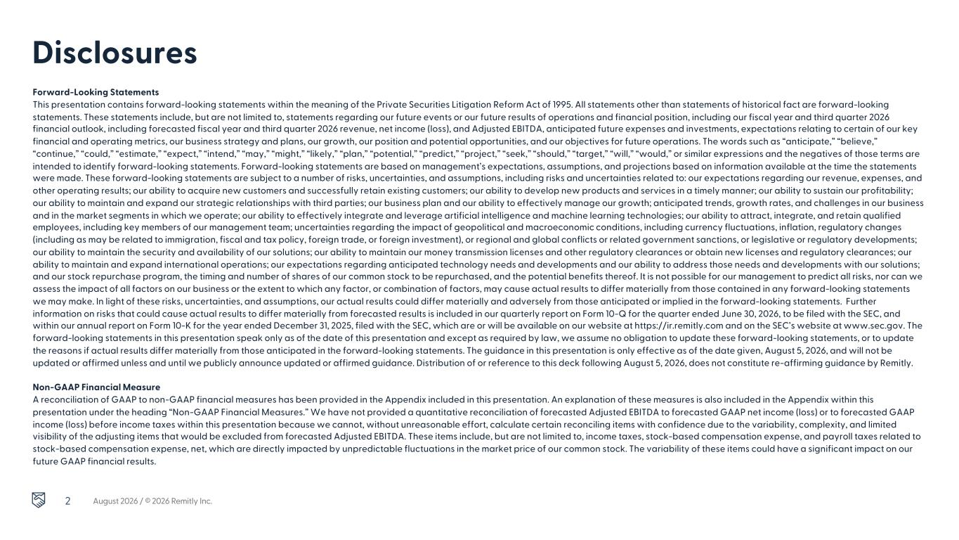
2 Forward-Looking Statements This presentation contains forward-looking statements within the meaning of the Private Securities Litigation Reform Act of 1995. All statements other than statements of historical fact are forward-looking statements. These statements include, but are not limited to, statements regarding our future events or our future results of operations and financial position, including our fiscal year and third quarter 2026 financial outlook, including forecasted fiscal year and third quarter 2026 revenue, net income (loss), and Adjusted EBITDA, anticipated future expenses and investments, expectations relating to certain of our key financial and operating metrics, our business strategy and plans, our growth, our position and potential opportunities, and our objectives for future operations. The words such as “anticipate,” “believe,” “continue,” “could,” “estimate,” “expect,” “intend,” “may,” “might,” “likely,” “plan,” “potential,” “predict,” “project,” “seek,” “should,” “target,” “will,” “would,” or similar expressions and the negatives of those terms are intended to identify forward-looking statements. Forward-looking statements are based on management’s expectations, assumptions, and projections based on information available at the time the statements were made. These forward-looking statements are subject to a number of risks, uncertainties, and assumptions, including risks and uncertainties related to: our expectations regarding our revenue, expenses, and other operating results; our ability to acquire new customers and successfully retain existing customers; our ability to develop new products and services in a timely manner; our ability to sustain our profitability; our ability to maintain and expand our strategic relationships with third parties; our business plan and our ability to effectively manage our growth; anticipated trends, growth rates, and challenges in our business and in the market segments in which we operate; our ability to effectively integrate and leverage artificial intelligence and machine learning technologies; our ability to attract, integrate, and retain qualified employees, including key members of our management team; uncertainties regarding the impact of geopolitical and macroeconomic conditions, including currency fluctuations, inflation, regulatory changes (including as may be related to immigration, fiscal and tax policy, foreign trade, or foreign investment), or regional and global conflicts or related government sanctions, or legislative or regulatory developments; our ability to maintain the security and availability of our solutions; our ability to maintain our money transmission licenses and other regulatory clearances or obtain new licenses and regulatory clearances; our ability to maintain and expand international operations; our expectations regarding anticipated technology needs and developments and our ability to address those needs and developments with our solutions; and our stock repurchase program, the timing and number of shares of our common stock to be repurchased, and the potential benefits thereof. It is not possible for our management to predict all risks, nor can we assess the impact of all factors on our business or the extent to which any factor, or combination of factors, may cause actual results to differ materially from those contained in any forward-looking statements we may make. In light of these risks, uncertainties, and assumptions, our actual results could differ materially and adversely from those anticipated or implied in the forward-looking statements. Further information on risks that could cause actual results to differ materially from forecasted results is included in our quarterly report on Form 10-Q for the quarter ended June 30, 2026, to be filed with the SEC, and within our annual report on Form 10-K for the year ended December 31, 2025, filed with the SEC, which are or will be available on our website at https://ir.remitly.com and on the SEC’s website at www.sec.gov. The forward-looking statements in this presentation speak only as of the date of this presentation and except as required by law, we assume no obligation to update these forward-looking statements, or to update the reasons if actual results differ materially from those anticipated in the forward-looking statements. The guidance in this presentation is only effective as of the date given, August 5, 2026, and will not be updated or affirmed unless and until we publicly announce updated or affirmed guidance. Distribution of or reference to this deck following August 5, 2026, does not constitute re-affirming guidance by Remitly. Non-GAAP Financial Measure A reconciliation of GAAP to non-GAAP financial measures has been provided in the Appendix included in this presentation. An explanation of these measures is also included in the Appendix within this presentation under the heading “Non-GAAP Financial Measures.” We have not provided a quantitative reconciliation of forecasted Adjusted EBITDA to forecasted GAAP net income (loss) or to forecasted GAAP income (loss) before income taxes within this presentation because we cannot, without unreasonable effort, calculate certain reconciling items with confidence due to the variability, complexity, and limited visibility of the adjusting items that would be excluded from forecasted Adjusted EBITDA. These items include, but are not limited to, income taxes, stock-based compensation expense, and payroll taxes related to stock-based compensation expense, net, which are directly impacted by unpredictable fluctuations in the market price of our common stock. The variability of these items could have a significant impact on our future GAAP financial results. Disclosures August 2026 / © 2026 Remitly Inc.


2Q Strategic Overview Sebastian Gunningham CEO August 2026 / © 2026 Remitly Inc.3

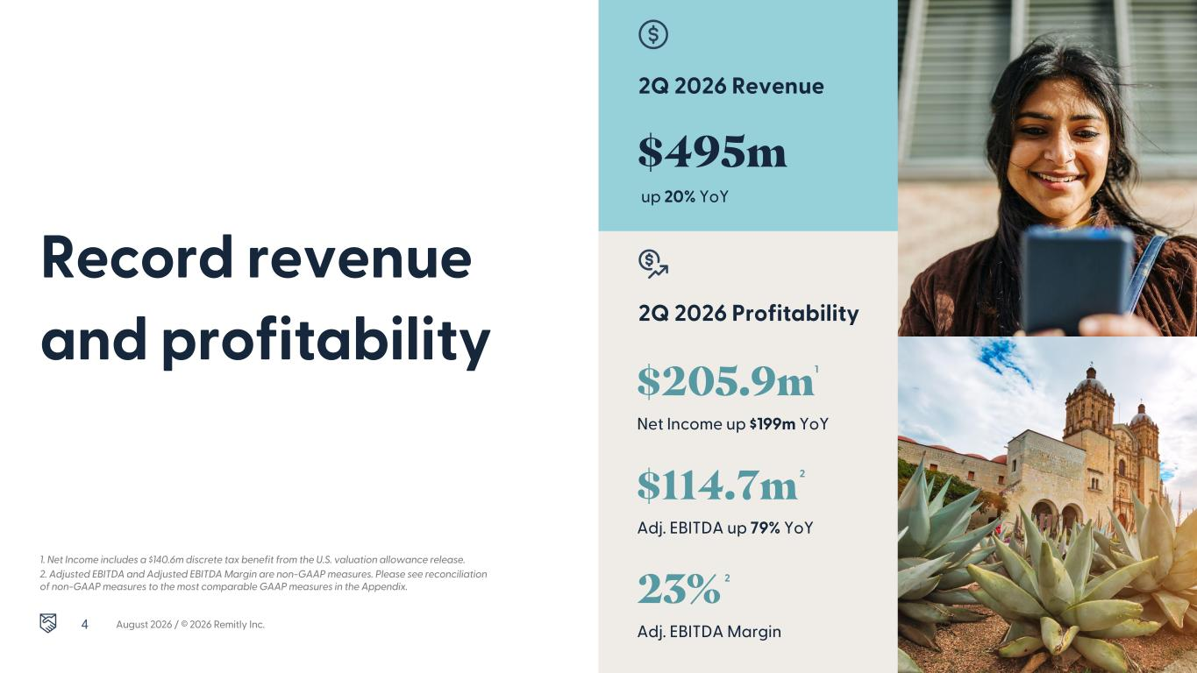
2Q 2026 Revenue Record revenue and profitability 2Q 2026 Profitability 1. Net Income includes a $140.6m discrete tax benefit from the U.S. valuation allowance release. 2. Adjusted EBITDA and Adjusted EBITDA Margin are non-GAAP measures. Please see reconciliation of non-GAAP measures to the most comparable GAAP measures in the Appendix. August 2026 / © 2026 Remitly Inc. $495m up 20% YoY $205.9m Net Income up $199m YoY $114.7m Adj. EBITDA up 79% YoY 23% Adj. EBITDA Margin 1 2 2 4

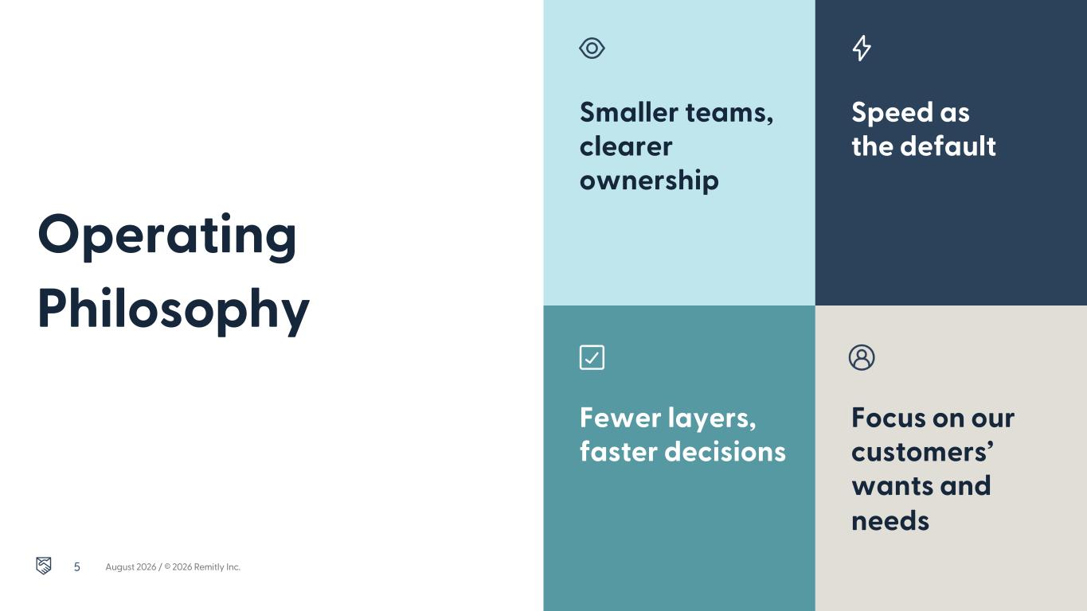
Smaller teams, clearer ownership Operating Philosophy Speed as the default Fewer layers, faster decisions Focus on our customers’ wants and needs August 2026 / © 2026 Remitly Inc.5

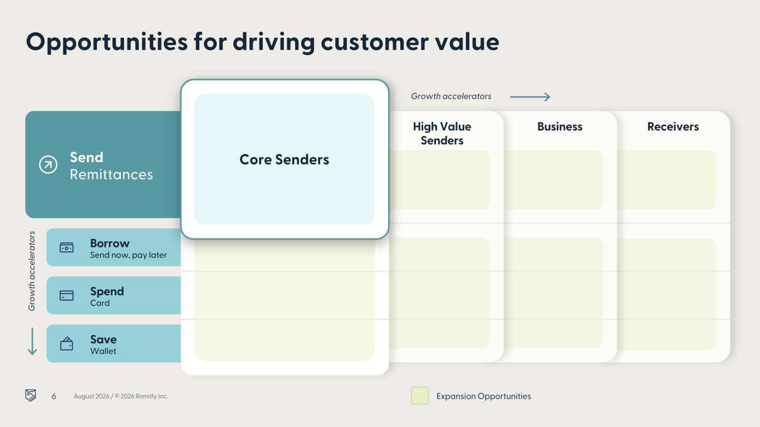
Spend Card Save Wallet Borrow Send now, pay later ReceiversBusiness Opportunities for driving customer value Send Remittances High Value Senders Core SendCore Senders August 2026 / © 2026 Remitly Inc. Expansion Opportunities Growth accelerators G ro w th a cc el er a to rs 6

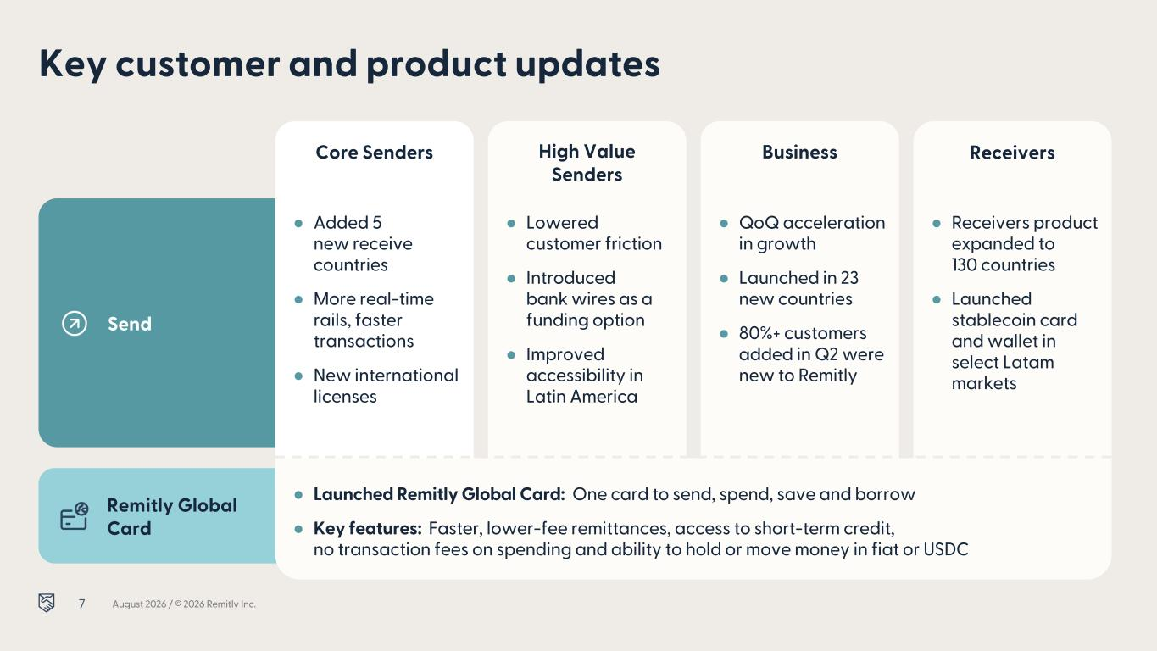
Remitly Global Card Key customer and product updates Send Core Senders ReceiversBusiness High Value Senders ● QoQ acceleration in growth ● Launched in 23 new countries ● 80%+ customers added in Q2 were new to Remitly ● Receivers product expanded to 130 countries ● Launched stablecoin card and wallet in select Latam markets ● Added 5 new receive countries ● More real-time rails, faster transactions ● New international licenses ● Lowered customer friction ● Introduced bank wires as a funding option ● Improved accessibility in Latin America ● Launched Remitly Global Card: One card to send, spend, save and borrow ● Key features: Faster, lower-fee remittances, access to short-term credit, no transaction fees on spending and ability to hold or move money in fiat or USDC August 2026 / © 2026 Remitly Inc.7

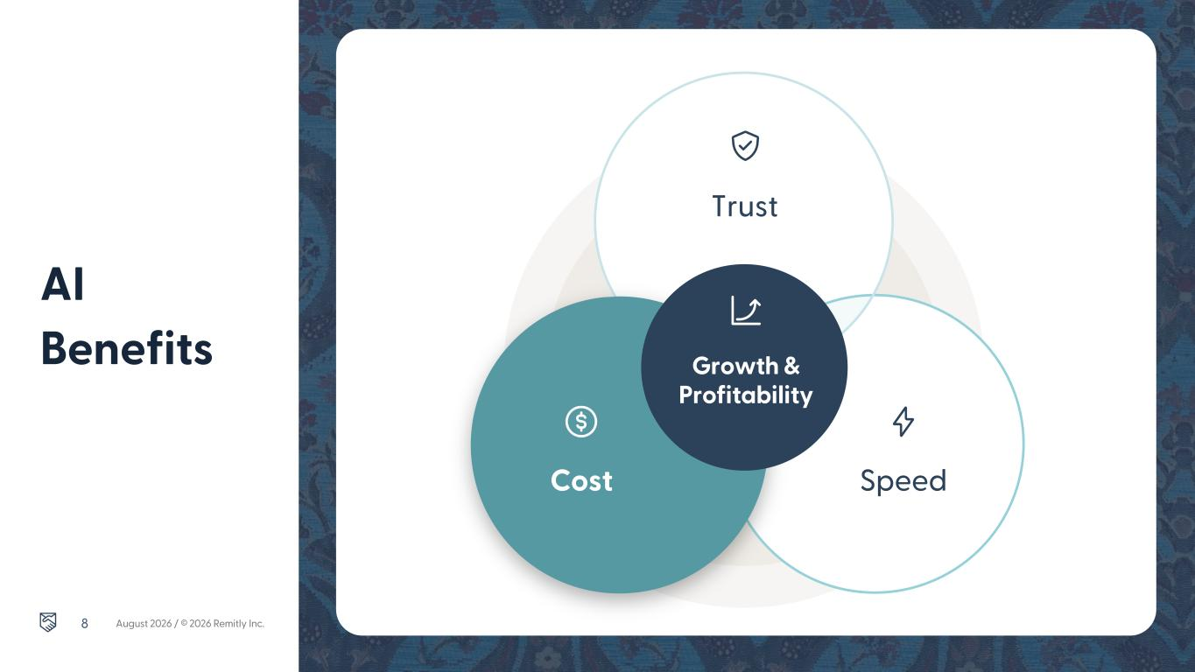
AI Benefits August 2026 / © 2026 Remitly Inc. Cost Speed Trust Growth & Profitability 8


2Q Financial Results Vikas Mehta CFO August 2026 / © 2026 Remitly Inc.9

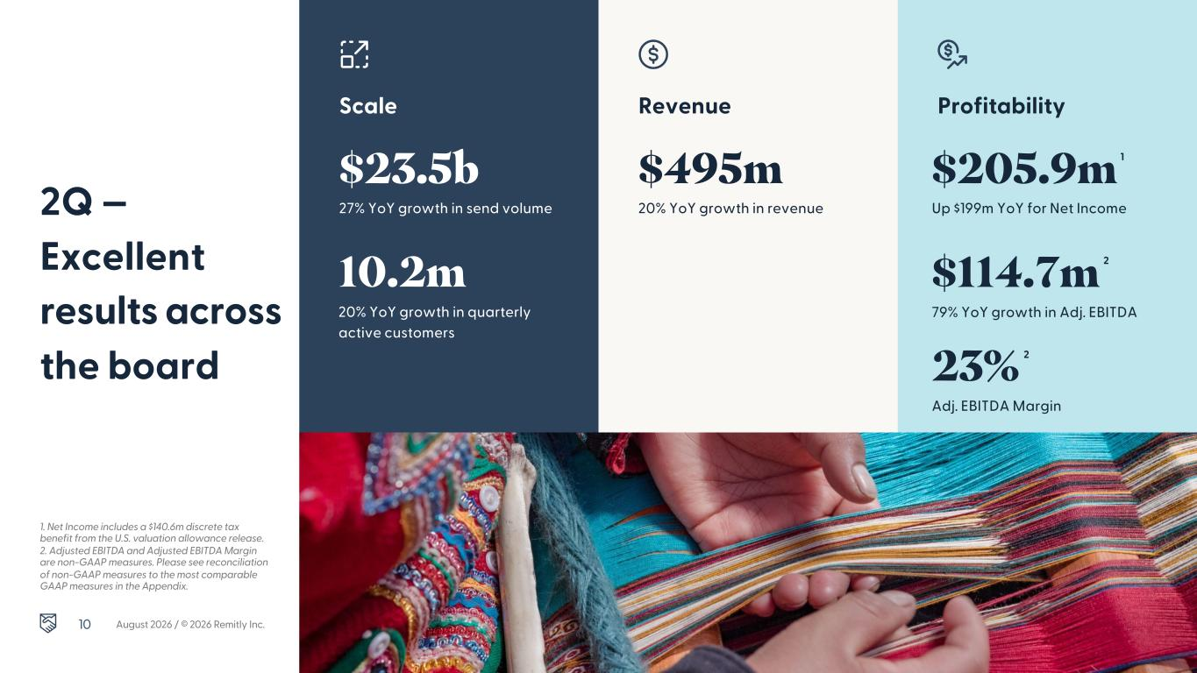
Revenue ProfitabilityScale 2Q — Excellent results across the board 1. Net Income includes a $140.6m discrete tax benefit from the U.S. valuation allowance release. 2. Adjusted EBITDA and Adjusted EBITDA Margin are non-GAAP measures. Please see reconciliation of non-GAAP measures to the most comparable GAAP measures in the Appendix. 10.2m 20% YoY growth in quarterly active customers $23.5b 27% YoY growth in send volume $495m 20% YoY growth in revenue $114.7m 79% YoY growth in Adj. EBITDA $205.9m Up $199m YoY for Net Income 23% Adj. EBITDA Margin August 2026 / © 2026 Remitly Inc. 1 2 2 10

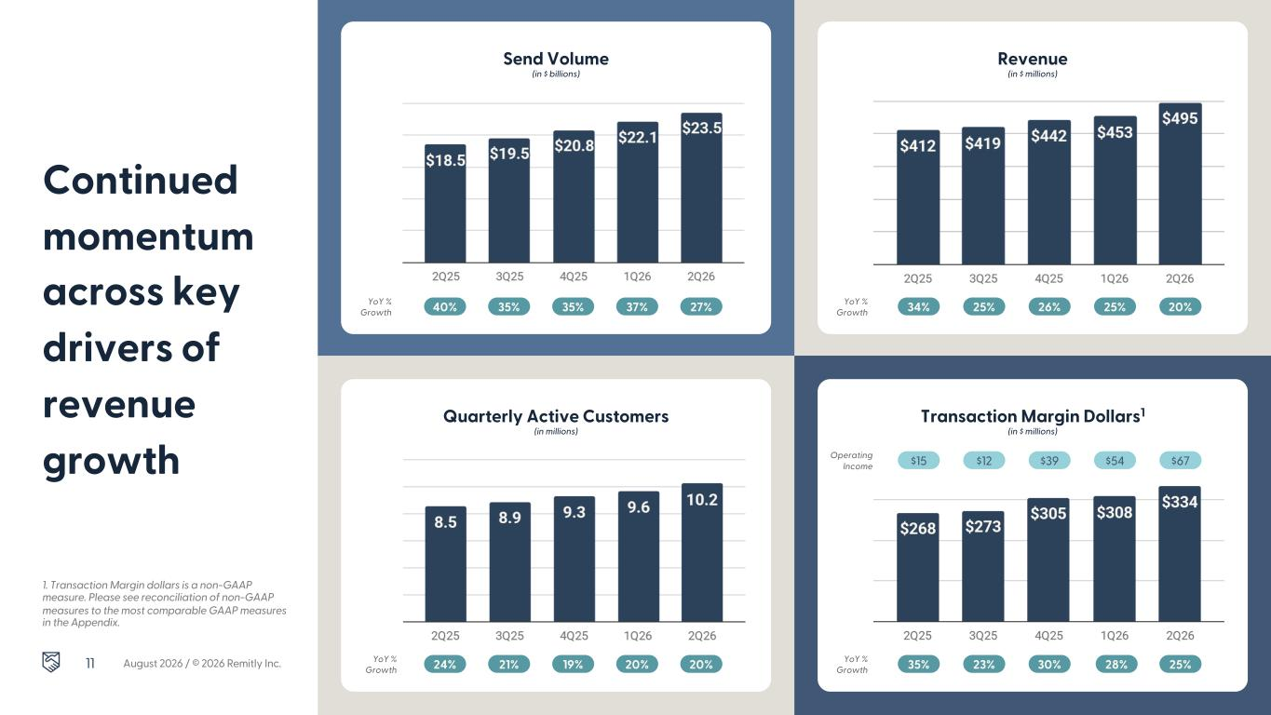
Send Volume (in billions) Quarterly Active Customers (in millions) Transaction Margin Dollars1 (in $ millions) Revenue (in $ millions) Send Volume (in $ billions) Continued momentum across key drivers of revenue growth YoY % Growth 34% 25% 26% 25% 20%YoY % Growth 40% 35% 35% 37% 27% YoY % Growth 24% 21% 19% 20% 20% YoY % Growth 35% 23% 30% 28% 25% Operating Income $15 $12 $39 $54 $67 1. Transaction Margin dollars is a non-GAAP measure. Please see reconciliation of non-GAAP measures to the most comparable GAAP measures in the Appendix. August 2026 / © 2026 Remitly Inc.11

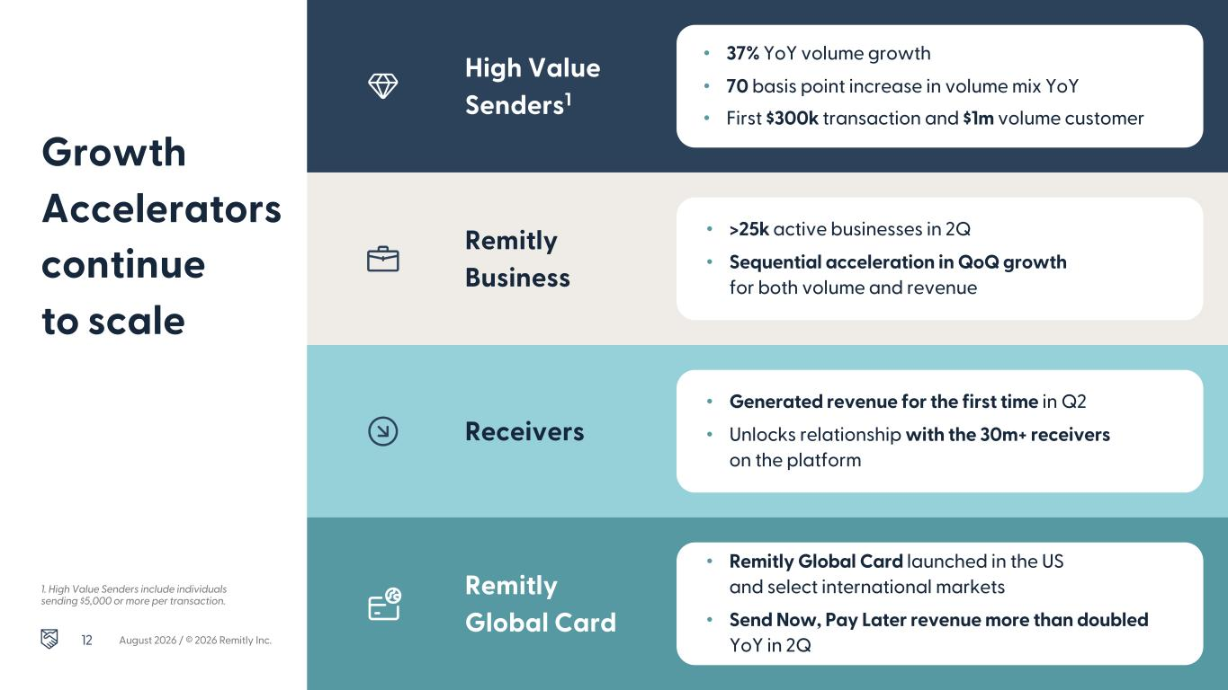
Growth Accelerators continue to scale High Value Senders1 Remitly Business Receivers • 37% YoY volume growth • 70 basis point increase in volume mix YoY • First $300k transaction and $1m volume customer 1. High Value Senders include individuals sending $5,000 or more per transaction. Remitly Global Card • >25k active businesses in 2Q • Sequential acceleration in QoQ growth for both volume and revenue • Generated revenue for the first time in Q2 • Unlocks relationship with the 30m+ receivers on the platform • Remitly Global Card launched in the US and select international markets • Send Now, Pay Later revenue more than doubled YoY in 2QAugust 2026 / © 2026 Remitly Inc.12

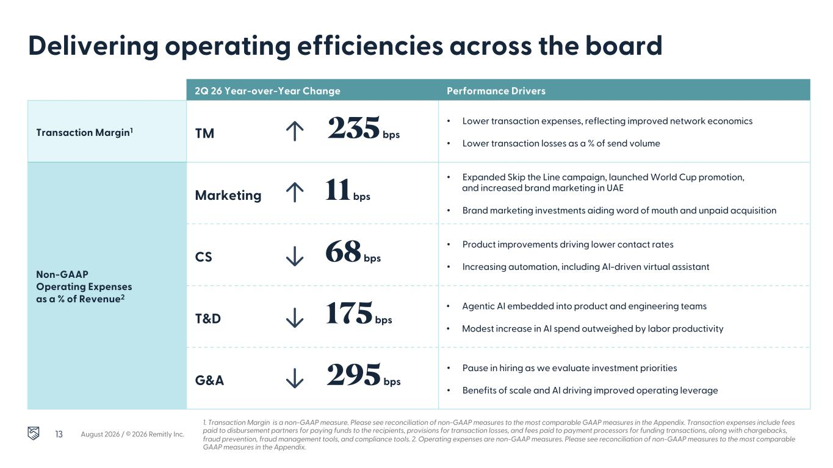
Delivering operating efficiencies across the board 1. Transaction Margin is a non-GAAP measure. Please see reconciliation of non-GAAP measures to the most comparable GAAP measures in the Appendix. Transaction expenses include fees paid to disbursement partners for paying funds to the recipients, provisions for transaction losses, and fees paid to payment processors for funding transactions, along with chargebacks, fraud prevention, fraud management tools, and compliance tools. 2. Operating expenses are non-GAAP measures. Please see reconciliation of non-GAAP measures to the most comparable GAAP measures in the Appendix. 2Q 26 Year-over-Year Change Performance Drivers Transaction Margin1 TM 235 bps • Lower transaction expenses, reflecting improved network economics • Lower transaction losses as a % of send volume Non-GAAP Operating Expenses as a % of Revenue2 Marketing 11 bps • Expanded Skip the Line campaign, launched World Cup promotion, and increased brand marketing in UAE • Brand marketing investments aiding word of mouth and unpaid acquisition CS 68 bps • Product improvements driving lower contact rates • Increasing automation, including AI-driven virtual assistant T&D 175 bps • Agentic AI embedded into product and engineering teams • Modest increase in AI spend outweighed by labor productivity G&A 295 bps • Pause in hiring as we evaluate investment priorities • Benefits of scale and AI driving improved operating leverage August 2026 / © 2026 Remitly Inc.13

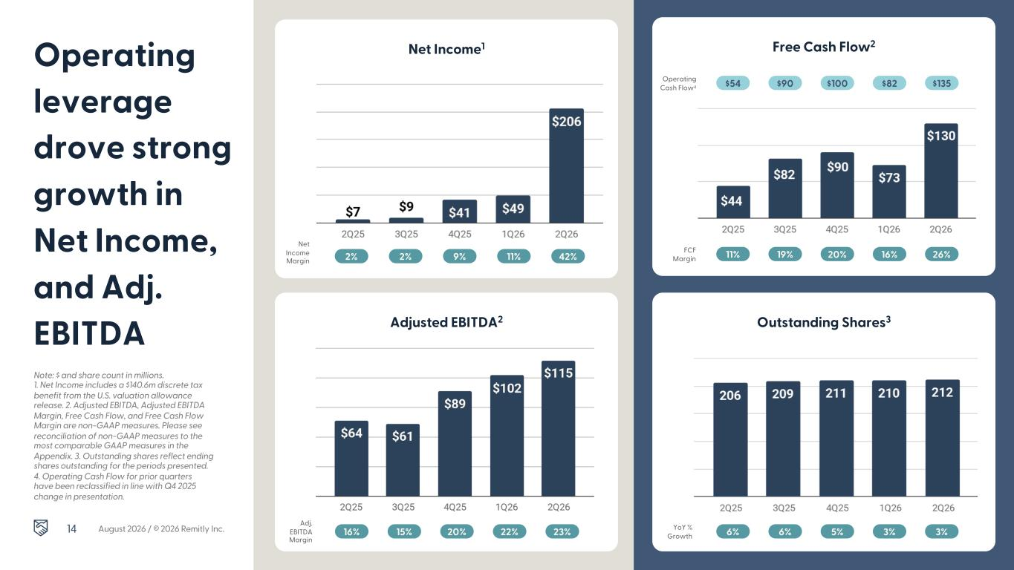
Note: $ and share count in millions. 1. Net Income includes a $140.6m discrete tax benefit from the U.S. valuation allowance release. 2. Adjusted EBITDA, Adjusted EBITDA Margin, Free Cash Flow, and Free Cash Flow Margin are non-GAAP measures. Please see reconciliation of non-GAAP measures to the most comparable GAAP measures in the Appendix. 3. Outstanding shares reflect ending shares outstanding for the periods presented. 4. Operating Cash Flow for prior quarters have been reclassified in line with Q4 2025 change in presentation. Operating leverage drove strong growth in Net Income, and Adj. EBITDA Net Income1 Outstanding Shares3 Free Cash Flow2 Adjusted EBITDA2 FCF Margin 11% 19% 20% 16% 26% Adj. EBITDA Margin 16% 15% 20% 22% 23% 2% 2% 9% 11% 42% YoY % Growth 6% 6% 5% 3% 3% $54 $90 $100 $82 $135Operating Cash Flow4 August 2026 / © 2026 Remitly Inc. Net Income Margin 14


Note: Year over year growth in net income in 2Q and full year 2026. This guidance is only effective as of the date given, May 6, 2026, and will not be updated or affirmed unless and until we publicly announce updated or affirmed guidance. Distribution or reference of this deck following May 6, 2026, does not constitute re-affirming guidance. We cannot, without unreasonable effort, provide a quantitative reconciliation of forecasted Adjusted EBITDA to forecasted GAAP net income due to the variability, complexity, and limited visibility of the adjusting items that would be excluded from forecasted Adjusted EBITDA. 2026 and 3Q 2026 Outlook 2026 $1.978b - $1.988b 2026 Revenue, 21% to 22% YoY growth $410m - $415m 2026 Adj. EBITDA, 21% Adj. EBITDA margin 3Q 2026 $505m - $507m 3Q 2026 Revenue, 20-21% YoY growth $92m - $94m 3Q 2026 Adj. EBITDA, 18-19% Adj. EBITDA margin15 August 2026 / © 2026 Remitly Inc.


Q & A August 2026 / © 2026 Remitly Inc.16


Thank you.


Appendix August 2026 / © 2026 Remitly Inc.18

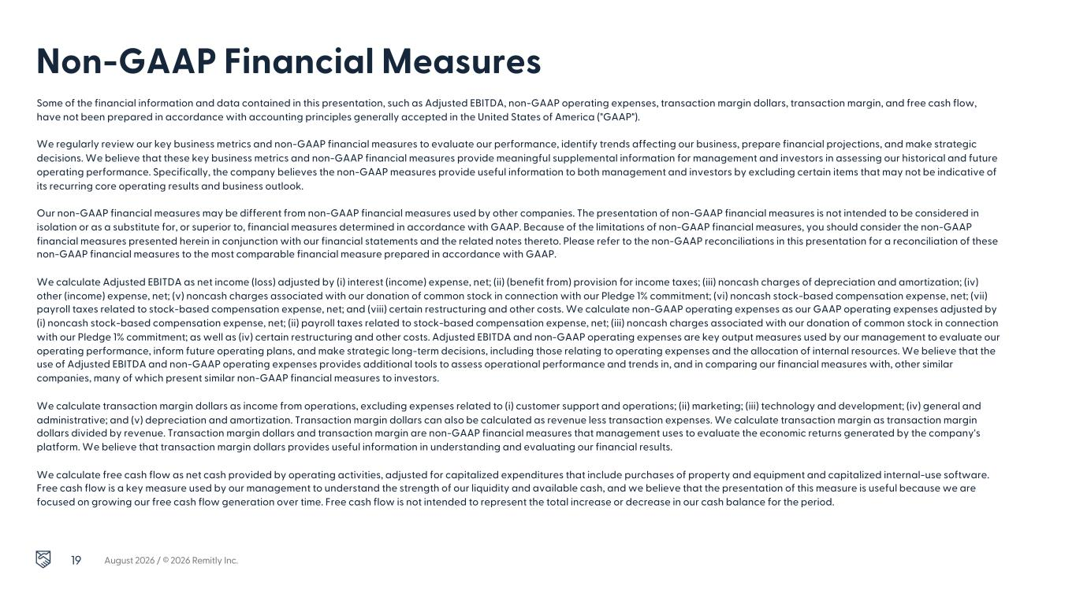
Non-GAAP Financial Measures Some of the financial information and data contained in this presentation, such as Adjusted EBITDA, non-GAAP operating expenses, transaction margin dollars, transaction margin, and free cash flow, have not been prepared in accordance with accounting principles generally accepted in the United States of America ("GAAP"). We regularly review our key business metrics and non-GAAP financial measures to evaluate our performance, identify trends affecting our business, prepare financial projections, and make strategic decisions. We believe that these key business metrics and non-GAAP financial measures provide meaningful supplemental information for management and investors in assessing our historical and future operating performance. Specifically, the company believes the non-GAAP measures provide useful information to both management and investors by excluding certain items that may not be indicative of its recurring core operating results and business outlook. Our non-GAAP financial measures may be different from non-GAAP financial measures used by other companies. The presentation of non-GAAP financial measures is not intended to be considered in isolation or as a substitute for, or superior to, financial measures determined in accordance with GAAP. Because of the limitations of non-GAAP financial measures, you should consider the non-GAAP financial measures presented herein in conjunction with our financial statements and the related notes thereto. Please refer to the non-GAAP reconciliations in this presentation for a reconciliation of these non-GAAP financial measures to the most comparable financial measure prepared in accordance with GAAP. We calculate Adjusted EBITDA as net income (loss) adjusted by (i) interest (income) expense, net; (ii) (benefit from) provision for income taxes; (iii) noncash charges of depreciation and amortization; (iv) other (income) expense, net; (v) noncash charges associated with our donation of common stock in connection with our Pledge 1% commitment; (vi) noncash stock-based compensation expense, net; (vii) payroll taxes related to stock-based compensation expense, net; and (viii) certain restructuring and other costs. We calculate non-GAAP operating expenses as our GAAP operating expenses adjusted by (i) noncash stock-based compensation expense, net; (ii) payroll taxes related to stock-based compensation expense, net; (iii) noncash charges associated with our donation of common stock in connection with our Pledge 1% commitment; as well as (iv) certain restructuring and other costs. Adjusted EBITDA and non-GAAP operating expenses are key output measures used by our management to evaluate our operating performance, inform future operating plans, and make strategic long-term decisions, including those relating to operating expenses and the allocation of internal resources. We believe that the use of Adjusted EBITDA and non-GAAP operating expenses provides additional tools to assess operational performance and trends in, and in comparing our financial measures with, other similar companies, many of which present similar non-GAAP financial measures to investors. We calculate transaction margin dollars as income from operations, excluding expenses related to (i) customer support and operations; (ii) marketing; (iii) technology and development; (iv) general and administrative; and (v) depreciation and amortization. Transaction margin dollars can also be calculated as revenue less transaction expenses. We calculate transaction margin as transaction margin dollars divided by revenue. Transaction margin dollars and transaction margin are non-GAAP financial measures that management uses to evaluate the economic returns generated by the company's platform. We believe that transaction margin dollars provides useful information in understanding and evaluating our financial results. We calculate free cash flow as net cash provided by operating activities, adjusted for capitalized expenditures that include purchases of property and equipment and capitalized internal-use software. Free cash flow is a key measure used by our management to understand the strength of our liquidity and available cash, and we believe that the presentation of this measure is useful because we are focused on growing our free cash flow generation over time. Free cash flow is not intended to represent the total increase or decrease in our cash balance for the period. 19 August 2026 / © 2026 Remitly Inc.

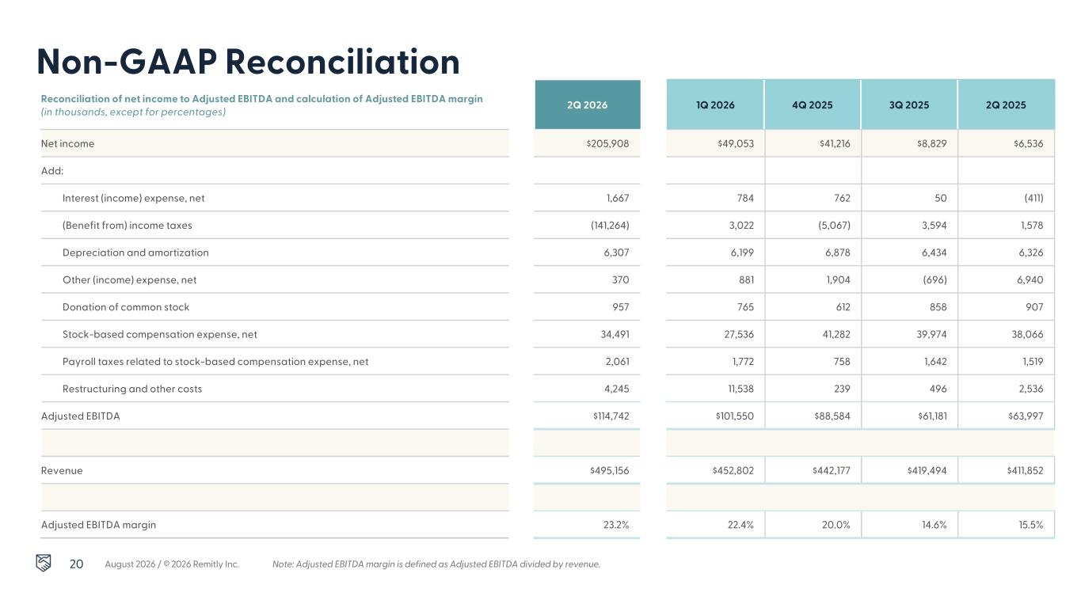
20 Non-GAAP Reconciliation Reconciliation of net income to Adjusted EBITDA and calculation of Adjusted EBITDA margin (in thousands, except for percentages) 2Q 2026 1Q 2026 4Q 2025 3Q 2025 2Q 2025 Net income $205,908 $49,053 $41,216 $8,829 $6,536 Add: Interest (income) expense, net 1,667 784 762 50 (411) (Benefit from) income taxes (141,264) 3,022 (5,067) 3,594 1,578 Depreciation and amortization 6,307 6,199 6,878 6,434 6,326 Other (income) expense, net 370 881 1,904 (696) 6,940 Donation of common stock 957 765 612 858 907 Stock-based compensation expense, net 34,491 27,536 41,282 39,974 38,066 Payroll taxes related to stock-based compensation expense, net 2,061 1,772 758 1,642 1,519 Restructuring and other costs 4,245 11,538 239 496 2,536 Adjusted EBITDA $114,742 $101,550 $88,584 $61,181 $63,997 Revenue $495,156 $452,802 $442,177 $419,494 $411,852 Adjusted EBITDA margin 23.2% 22.4% 20.0% 14.6% 15.5% Note: Adjusted EBITDA margin is defined as Adjusted EBITDA divided by revenue.August 2026 / © 2026 Remitly Inc.

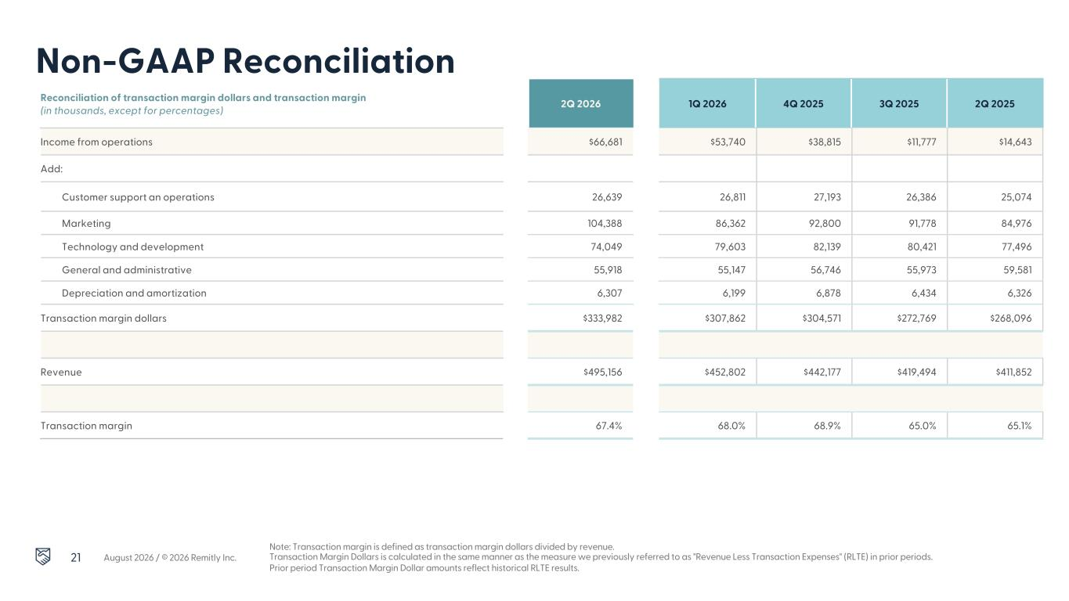
21 Non-GAAP Reconciliation Reconciliation of transaction margin dollars and transaction margin (in thousands, except for percentages) 2Q 2026 1Q 2026 4Q 2025 3Q 2025 2Q 2025 August 2026 / © 2026 Remitly Inc. Income from operations $66,681 $53,740 $38,815 $11,777 $14,643 Add: Customer support an operations 26,639 26,811 27,193 26,386 25,074 Marketing 104,388 86,362 92,800 91,778 84,976 Technology and development 74,049 79,603 82,139 80,421 77,496 General and administrative 55,918 55,147 56,746 55,973 59,581 Depreciation and amortization 6,307 6,199 6,878 6,434 6,326 Transaction margin dollars $333,982 $307,862 $304,571 $272,769 $268,096 Revenue $495,156 $452,802 $442,177 $419,494 $411,852 Transaction margin 67.4% 68.0% 68.9% 65.0% 65.1% Note: Transaction margin is defined as transaction margin dollars divided by revenue. Transaction Margin Dollars is calculated in the same manner as the measure we previously referred to as "Revenue Less Transaction Expenses" (RLTE) in prior periods. Prior period Transaction Margin Dollar amounts reflect historical RLTE results.

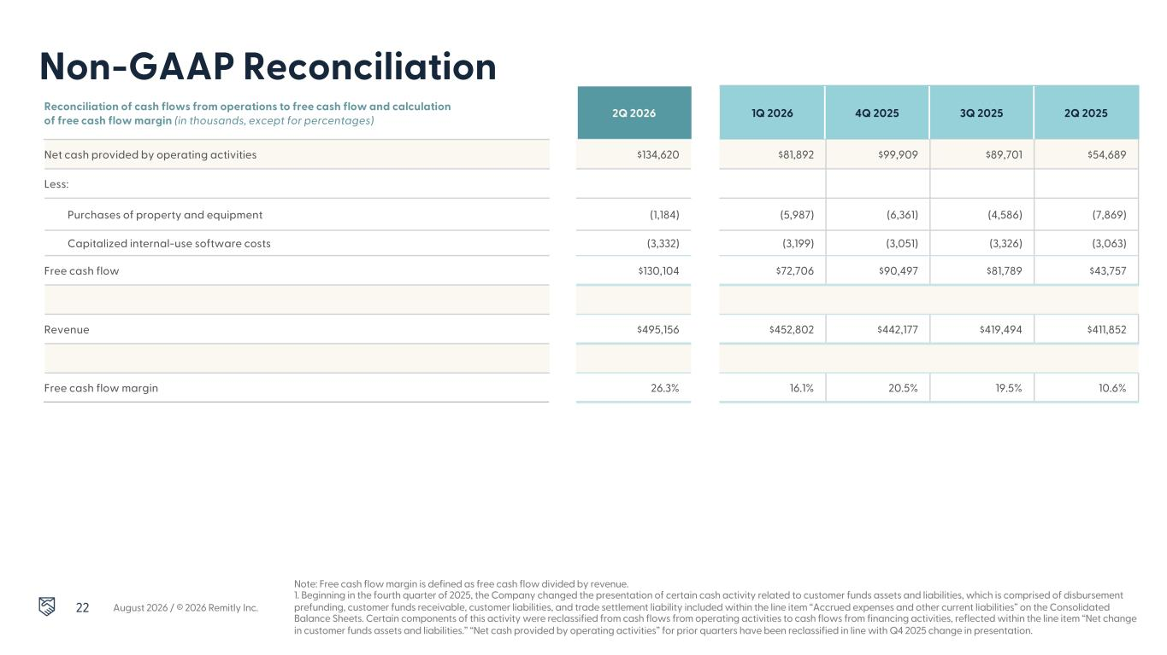
22 Non-GAAP Reconciliation Reconciliation of cash flows from operations to free cash flow and calculation of free cash flow margin (in thousands, except for percentages) 2Q 2026 1Q 2026 4Q 2025 3Q 2025 2Q 2025 August 2026 / © 2026 Remitly Inc. Note: Free cash flow margin is defined as free cash flow divided by revenue. 1. Beginning in the fourth quarter of 2025, the Company changed the presentation of certain cash activity related to customer funds assets and liabilities, which is comprised of disbursement prefunding, customer funds receivable, customer liabilities, and trade settlement liability included within the line item “Accrued expenses and other current liabilities” on the Consolidated Balance Sheets. Certain components of this activity were reclassified from cash flows from operating activities to cash flows from financing activities, reflected within the line item “Net change in customer funds assets and liabilities.” “Net cash provided by operating activities” for prior quarters have been reclassified in line with Q4 2025 change in presentation. Net cash provided by operating activities1 $134,620 $81,892 $99,909 $89,701 $54,689 Less: Purchases of property and equipment (1,184) (5,987) (6,361) (4,586) (7,869) Capitalized internal-use software costs (3,332) (3,199) (3,051) (3,326) (3,063) Free cash flow $130,104 $72,706 $90,497 $81,789 $43,757 Revenue $495,156 $452,802 $442,177 $419,494 $411,852 Free cash flow margin 26.3% 16.1% 20.5% 19.5% 10.6%

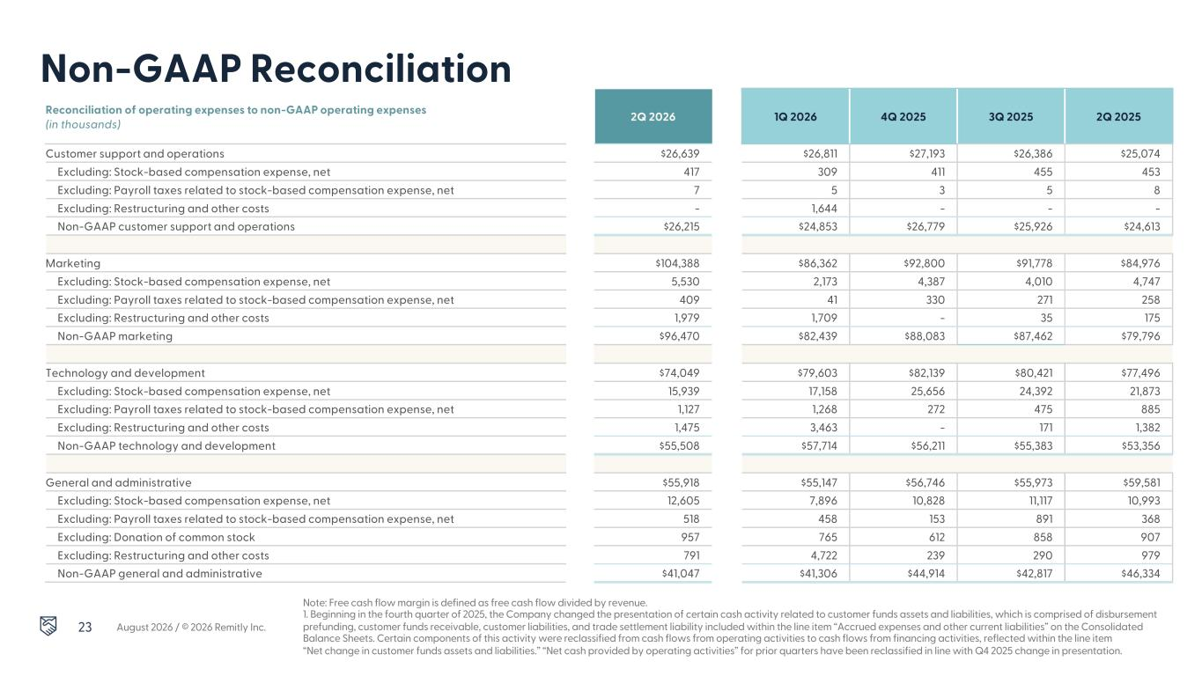
23 Non-GAAP Reconciliation Reconciliation of operating expenses to non-GAAP operating expenses (in thousands) 2Q 2026 1Q 2026 4Q 2025 3Q 2025 2Q 2025 August 2026 / © 2026 Remitly Inc. Note: Free cash flow margin is defined as free cash flow divided by revenue. 1. Beginning in the fourth quarter of 2025, the Company changed the presentation of certain cash activity related to customer funds assets and liabilities, which is comprised of disbursement prefunding, customer funds receivable, customer liabilities, and trade settlement liability included within the line item “Accrued expenses and other current liabilities” on the Consolidated Balance Sheets. Certain components of this activity were reclassified from cash flows from operating activities to cash flows from financing activities, reflected within the line item “Net change in customer funds assets and liabilities.” “Net cash provided by operating activities” for prior quarters have been reclassified in line with Q4 2025 change in presentation. Customer support and operations $26,639 $26,811 $27,193 $26,386 $25,074 Excluding: Stock-based compensation expense, net 417 309 411 455 453 Excluding: Payroll taxes related to stock-based compensation expense, net 7 5 3 5 8 Excluding: Restructuring and other costs - 1,644 - - - Non-GAAP customer support and operations $26,215 $24,853 $26,779 $25,926 $24,613 Marketing $104,388 $86,362 $92,800 $91,778 $84,976 Excluding: Stock-based compensation expense, net 5,530 2,173 4,387 4,010 4,747 Excluding: Payroll taxes related to stock-based compensation expense, net 409 41 330 271 258 Excluding: Restructuring and other costs 1,979 1,709 - 35 175 Non-GAAP marketing $96,470 $82,439 $88,083 $87,462 $79,796 Technology and development $74,049 $79,603 $82,139 $80,421 $77,496 Excluding: Stock-based compensation expense, net 15,939 17,158 25,656 24,392 21,873 Excluding: Payroll taxes related to stock-based compensation expense, net 1,127 1,268 272 475 885 Excluding: Restructuring and other costs 1,475 3,463 - 171 1,382 Non-GAAP technology and development $55,508 $57,714 $56,211 $55,383 $53,356 General and administrative $55,918 $55,147 $56,746 $55,973 $59,581 Excluding: Stock-based compensation expense, net 12,605 7,896 10,828 11,117 10,993 Excluding: Payroll taxes related to stock-based compensation expense, net 518 458 153 891 368 Excluding: Donation of common stock 957 765 612 858 907 Excluding: Restructuring and other costs 791 4,722 239 290 979 Non-GAAP general and administrative $41,047 $41,306 $44,914 $42,817 $46,334

